“The Autobott” An Automated Botanical System
Group 2:
Eric Velazquez
David Rooney
Steven Lo
Antonio Orosa

(Sponsored in part by Urban Sunshine)

EEL 4915 Summer 2015 Final Documentation
Senior Design II – Summer 2015


Table of Contents
Section # | Section Name | Page #
1 | Executive Summary | 1
2 | Project Description | 2
2.1 | Project Motivation | 2
2.2 | Initial Design Concept | 2
2.3 | Goals & Objectives | 3
2.4 | Project Requirements and Specifications | 3
2.4.1 | Hardware Requirements | 3
2.4.2 | Software Requirements | 8
3 | Research Related to Project Definition | 10
3.1 | Existing Similar Projects | 10
3.1.1 | The Grove | 11
3.1.2 | The Urban Cultivator | 11
3.2 | Prerequisite Concepts and Research | 12
3.2.1 | Environment conditions for plant growth | 13
3.2.2 | Grow Medium | 14
3.2.3 | Sensor Interaction | 16
3.2.3.1 | Environment Sensors | 16
3.2.3.2 | Hydroponic Sensors | 18
3.2.4 | Microcontrollers | 20
3.2.5 | Microprocessor Coding Environment | 23
3.2.6 | Inter-Integrated | 23
3.2.7 | UART | 24
3.2.8 | Serial Peripheral Interface | 24
3.2.9 | Web Servers | 24
3.2.10 | Botanics | 25
3.2.11 | Power Systems | 27
3.2.12 | Indoor Lighting | 30
3.2.13 | Basic Smart Garden Design | 34
3.3 | Relevant Technologies | 34
3.3.1 | Edyn | 35
3.3.2 | Parrot - Flower Power | 36
3.4 | Standards | 37
3.5 | Impact of Realistic Design Constraints | 38
4 | Design Summary of Hardware and Software | 38
4.1 | Initial Design Architectures and Related Diagrams | 38
4.1.1 | Environment Subsystem | 39
4.1.2 | Hydroponic Subsystem | 39
4.1.3 | Component Level Hardware Block Diagram | 49
4.1.3.1 | Description of Hardware Block Items | 50
4.1.4 | Software Block Diagrams | 51
4.1.4.1 | Description of Software Block Items | 52
4.2 | Motivation for Design Decisions | 53
4.2.1 | Hardware Decisions | 53
4.2.2 | Software Decisions | 56
5 | Project Hardware and Software Design Details | 57
5.1 | Hardware Design | 58
5.1.1 | Master Parts List/Discussion | 58
5.2 | Subsystems Summary | 58
5.2.1 | HVAC | 58
5.2.2 | Hydroponic Subsystem | 60
5.2.3 | LED Lights | 72
5.2.4 | Power | 73
5.2.5 | Sensors | 79
5.2.5.1 | PH Sensor | 79
5.2.5.2 | Temperature Sensor and Humidity Sensor | 81
5.2.5.3 | Electric Conductivity Sensor | 82
5.2.5.4 | Water Level Sensor | 84
5.2.5.5 | Carbon Dioxide Sensor | 85
5.2.6 | Physical Enclosure | 85
5.3 | Software Design | 88
5.3.1 | System Software Design | 89
5.3.2 | Web Server | 90
5.3.3 | Website | 94
5.3.4 | Database | 95
6 | Project Prototype Construction and Coding | 97
6.1 | Parts Acquisition and BOM | 98
6.2 | PCB Vendor and Assembly | 106
6.3 | Project Operation | 102
7 | Project Prototype Testing | 107
7.1 | Hardware Test Environment | 107
7.2 | Hardware Tests | 107
7.3 | Software Test Environment | 108
7.3.1 | System Testing | 108
7.3.2 | Server Testing | 110
7.3.3 | Website Testing | 111
7.3.4 | Database Testing | 112
7.4 | Integration Testing | 114
8 | Administrative Content | 115
8.1 | Milestone Discussion | 115
8.2 | Areas of Assigned Responsibility | 118
8.3 | Budget and Finance Discussion | 119
8.4 | Conclusion | 123
9 | Appendices | .
9.1 | Appendix A - Abbreviations/Acronyms | .
9.2 | Appendix B - Datasheets | .
9.3 | Appendix C - References | .
9.4 | Appendix D – Requests for Figure Consent | .

1. Executive Summary
The Autobott is an indoor smart garden sustained within an aesthetically pleasing wood cabinet. The Autobott is scalable and can grow a number of produce, flowers, or herbs based on the user’s needs. This system will be automated from top to bottom and controllable from a web and mobile application, so it gives the user freedom from anywhere in the world to manipulate the conditions of their environment. This product has improved existing designs by increasing the size of the enclosure and allowing for scalability within the environment, while still maintaining the efficiency of hydroponics as the feeding method for the plants.

The project was created with the mindset of scaling down an outdoor garden and fitting it inside a house. The Autobott resembles what looks like a wooden cabinet with two doors that open together on the top and a small drawer on the bottom to pull out. The cabinet is powered by a typical one hundred and twenty volt outlet that is the standard in most if not all homes. The circuitry portion of our project will convert the AC power into directed current utilizing the full amount of power from the outlet. Furthermore, the cabinet is made up of two sections: the enclosed environment (held within the top part of the cabinet), in which, the air and surroundings are controlled; and the hydroponics or water quality system (held in the drawer section of the cabinet) that will feed the plants the nutrients and water they need to grow efficiently. Within the environment, sensors are used to detect the humidity and temperature at all times to keep the growing conditions at optimal levels. Once a parameter is out of boundaries, then the system will correct itself by dehumidifying the environment or cooling the air inside the enclosure by circulating air through with an HVAC system. Likewise, the hydroponics system will contain sensors and meters that measure the water quality. In this form, the water will be treated if necessary after every full cycle of feeding the plants. Measurements such as, pH levels and electrical conductivity (EC) of the water, along with the environment parameters will be held in a database and relate to specific plants. This will give the user the capability to set the desired environment and water nutrient levels for the specific plant they are growing, enabling the plant to grow at its optimal conditions. The user will be able to access, add, and update this database to their likings through a web and mobile application. The web and mobile application will be intuitive and functional, giving a novice gardener the resources they need to learn about growing plants efficiently, as well as targeting the more experienced gardeners by providing them with every piece of data they need to grow an outstanding garden.

The final design of this project has cost more than expected at around a total of $600 per unit. Compared to the competitors that produce similar products, this price is substantially lower and with improvements in the near future of integrated technology, this product can eventually see near $450 per unit. During the design and modeling of this product, the group members did not secure outside sponsorships and is responsible for the full funding of this project. A budget was created for this project, where each component and part was researched carefully to keep the costs manageable between group members.

2. Project Description
This section will provide a brief description of the project, the motivation for designing the product, the goals and objectives, and the requirements and specifications of the overall project design. The importance of this section is to represent a high level description of what this project consists of and to do this in the manner of clarity.

2.1 Project Motivation
The motivation behind this project idea is very simply to allow people from anywhere in the world to have a garden. In many areas on earth, the environment conditions are not suitable to grow many types of plants and this product will allow people living in those conditions to grow a number of things inside their homes. For example, a person that lives in the desert cannot have normal plants or produce growing outside their homes because it is too hot and the plants will not be able to absorb water efficiently. This leads into the next statement of motivation, where water is not available all of the time. Many places from time to time go through a period of water droughts and the environment location takes on a massive heat wave that will last up to a few years. This product will give even the people living in those conditions the ability to regain their gardening power by growing plants inside, while conserving water at the same time with the use of the hydroponics system. One of the advantages this product has over a typical garden, indoors or outdoors, is the growing diversity, which ranges from a number of produce items to several flowers to even the beginning stages of a larger plant that will one day be transplanted outdoors. This product has implemented ways for a user to grow year round, in any location, and never have to worry about the conditions outside their home.

2.2 Initial Design Concept
At first, the group members of this current project were assigned to the general topic of “smart garden”. We all came in with different ideas and designs revolving around autonomous sprinkler systems, different types of indoor smart gardens and the components used for them, and lastly, a project was presented by a professor to us specifically dealing with the sensors used in smart gardens. As a group we decided to design an indoor smart garden. This design began with the thought of keeping it simple and placing an indoor garden inside a box, with all of the appropriate requirements to grow plants. We initially chose to grow the plants in soil and only control the conditions in the air and in the enclosed environment. In this environment contained LED lights to act as heat and sunlight, a carbon dioxide sensor, a temperature and humidity sensor, and an HVAC system to cycle air through the environment. The second part of the system was the reservoir and water pump to water the soil. The soil would provide most of the nutrients to the plants so there was no need to implement any water quality treatment, which kept the design basic and easy to work with. After revisiting past senior design projects and researching current products in this industry, we took another look at this design and decided to revamp it. We left much of the environment aspects the same, but instead of using soil we swapped the feeding system with hydroponics, and finally remodeled the infrastructure of the enclosure. This concept began to be a great first model for us and helped us in finalizing the design we have now, which appears like a classic cabinet furniture piece and functions like the next generation smart garden.

2.3 Goals and Objectives
The main two goals this projects focus is towards are portability and scalability. Our group sees more use and convenience in a garden that is portable, allowing the user to easily move it throughout an area of space in their home and allowing the user to bring it with them where ever they move. We can make this objective available to a user by using only the 120V AC outlet in a common household. Also, this project will concentrate on creating an environment that is scalable, given the limitations of the infrastructure. We will do this by creating multiple types of trays that hold anywhere from two plants up to ten plants, depending on the size of the matured size of the plant. This gives the user freedom to grow different types of plants and customize their indoor garden entirely. By tailoring our objectives to efficient space utilization, we are uniquely following the trend of the general market in a sense that we are creating a high tech product that is able to conveniently take up small space and use the limited amount of space the product offers to its full potential.

We believe our goals and objectives for this product will generate quality prospective ideas in the smart garden industry and create a new market for high tech gardeners. This product brings the new and improved smart garden technology to a new level in the current market. The design of this product has many benefits that target a residential market, such as, portability, scalability, low power, an intuitive user interface that can be controlled over the web and on mobile devices, and full control over the automation features. Giving users the ability to control such high tech devices and conditions at the touch of their fingertips not only gives them high self-esteem with newer technology but it also helps a skeptical clientele buy into the direction this product wants to go in the smart garden industry.

2.4 Project Requirements and Specifications
The project requirements and specifications are used to define the high level purpose of the subsystems, items, and all the way down to the wiring design of the PCB board. Each component in the Autobott is unique to a specific purpose and must meet certain requirements for the full system to operate at perfect conditions. For example, the water pump must have enough power to pump water vertically upward through a PVC pipe up to three feet and also pump the water into the plant trays at a certain rate. This is the extent to what the water pump will serve in our project, however, this is a very simple item in the full design and has a significant requirement to meet. Below are the rest of the components that are given a certain requirement and specification to meet so that the Autobott is able to operate flawlessly.

2.4.1 Hardware Requirements
Pump (hydro) - Our hydroponic system will incorporate the Nutrient Film Technique to deliver water and nutrients to our plants, which means there will be a lot of water constantly being moved. Since our entire design relies on a consistent flow of our water/nutrient solution, we need a reliable mechanism to put in the work of pushing our water. The best and most viable option is a submersible water pump. For optimum results and to keep the nutrient mix at its best, our pump must be able to cycle through 100% of the entire system's water supply at least once every two hours. It must be able to meet first requirement while also compensating for our system's built-in head height. Since the NFT hydroponic design calls for a constant flow of water, the pump must be able to run consistently and dependently. Any pump failures or breakdowns can and will kill our plants if we can’t restart or replace it in time. So our pump needs to be reliable enough to run all day and night for as long as possible.

Pump (nutrients/pH) - Must be low-power, and able to hook up to a relay that can switch it on and off. We also want these pumps to push small amounts of substance, only drops at a time. It would be ideal for anywhere from one to ten milliliters every few seconds. These pumps should also be low-cost. We won’t be placing these in water, but they may be in the same small space as liquids, so it would be ideal to have some that can operate in high humidity without being affected. Our design calls for one of these pumps per nutrient that we will be adding, one for pH up, and one for pH down. Since we will need a minimum of 5 of these nutrient pumps, we will be looking for smaller-sized units that we can incorporate easily into our nutrient delivery subsystem.

Physical Enclosure - Must first of all have ample grow space for the plants. We also want the enclosure to include a non-invasive opening that can be used to check on the plants and perform any needed plant maintenance. The physical enclosure should be made out of durable materials, with compartments on the bottom for the water reservoir and pump, on the side for electronics and water pipes, and room on the top for the lights, fan, and HVAC system. Preferably, the walls of our enclosure will be insulated to keep the temperature within our system close to our optimum temperature for the plants. The inner walls will also need to be covered with a reflective surface, most likely Mylar, to help all of the excess light bounce around until it becomes fully absorbed by the plants.

We anticipate building the enclosure to be a total of 6 feet tall, 3.5 feet wide, and 2.5 feet deep. It will be divided into three compartments. We will create one on the very bottom that will run the entire width of the cabinet, and be about 1.5 feet tall. Here is where we will put most of the machinery for our hydroponic system. This bottom cavity will hold our water pump, nutrient pumps, water reservoir, air stone, nutrient and pH reservoirs, and leave some room for the necessary piping. A few of our sensors will be present to accompany their corresponding parts, such as the EC Sensor, water level sensor, and pH sensor.

We also included a compartment on the side of our design to house most of the electronic equipment and part of the HVAC system. We originally saved 8 inches of width, and the entire height (minus the bottom compartment) for this section, but as our design has progressed, it seemed like we may need less and less space here. We may only be putting the PCB board, power supply circuit, and a couple other components here, which requires very little space. So our designed electric compartment may be as little as one-fourth of its original size. The third and final compartment we have in our design is our largest of the three cavities. It will take up all of the remaining area, which we need to house our plants. To hold the plants, we will be custom-building a system of pipes, and plant trays.

One of our objectives for our system is to make it mobile. One way we will achieve this objective is by fixing rotating wheels to the bottom of our cabinet. It's a simple addition to the design, but it will also add some good functionality and meet our goal. Shown in Figure 2.1 is our sketch for the cabinet’s first layout. It shows the three compartments: the Main compartment that will hold our plants, the Bottom compartment mainly used for the reservoir and nutrients, and the Side compartment we will use for some of our more delicate electronics.

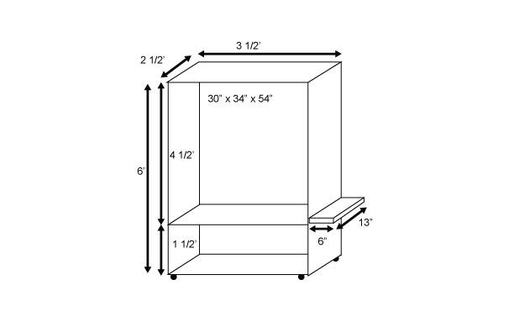
Figure 2.1: Diagram of the physical cabinet enclosure

Plant trays - Our plants will need a place to be housed while they grow over their lifespans. We plan on using basic trays that should be deep enough to hold water with enough room for the plant's roots, and shallow enough where the roots can reach the running water. There will be openings on the top surface of the trays where some small cups can be placed to hold our growing medium where the plants will live and grow. These plant trays need to be food-grade trays that won’t dissolve or leave any trace chemicals in the water that is running through it. This is important because any foreign chemicals or pathogens that may run off of the trays can severely harm whatever plants are present in our cabinet.

Our requirements for the plant trays are basic in nature, and these trays therefore can be custom-designed and ordered for our enclosure. The only constraints is that they need to fit in the fixed space provided, be deep enough for our water flow, and be a food-grade material that doesn’t give off harmful pathogens.

Pipes (Water) - For the water in our system to reach the plants, there needs to be a channel for them to travel through. The type of piping or hosing that we use to push the water up is important because our pump will be utilizing this. The first requirement for the hoses is that it must fit the dimensions of our pump. It must create a tight, waterproof seal around the lip of the pump, and be secure enough as to not be disturbed whenever the cabinet is moved. The 'upward-bound' pipe only needs to be between 4 and 5 feet to carry the water up to the plant trays.

The drainage pipe has a bit more flexibility in its design because it doesn't need to fit many specifications. These pipes will be catching the water as it is drained from each of the plant trays. Since there will be multiple trays, we will be using multiple drainage pipes; one attached to each tray. Down the line, these pipes will be combined back into one pipe using a connector joint. The final main drainage pipe will travel down to return the unused nutrient mix back to the water reservoir to complete the water cycle. In our initial design, the drainage pipes were pvc pipes, which can be attached simply in the manner that we need.

Pipes (nutrients/pH) - In order to deliver the nutrients, and pH adjusting chemicals into the water reservoir, we will be using small peristaltic pumps. The pumps have a tiny tube already built into them, to which we will be attaching another longer extension tube to assist in delivering the chemicals. We need these small hoses to be flexible, and attach to the peristaltic pump securely and snugly so as to prevent leakages that can lead to a lot of waste. As we finalize the pumps that our system is using, we will also finalize the hoses that will be attached to fit the exact dimensions. These tiny pipes will also be very inexpensive, making it extremely easy to replace in event of a ruptured hose.

pH - After the nutrients are all mixed into our water reservoir, we will take readings of the pH in the reservoir to see if it needs adjustment to get back to the optimum level. The design of our hydroponic system requires the pump to be running constantly, which means that our nutrient/water mix will be running over the plant roots all day and all night. Since the plants are receiving so much of the mix, it is crucial for our system to be able to precisely balance the pH in our water, or otherwise risk adverse effects on the growth of the specimens. The ideal pH range for most hydroponic plants is between 5.5 and 6.5. The pH sensors must be able to monitor the pH levels in the water so that it can communicate to the system to add a small amount of acid or alkali in order to restore the proper pH level. If we use pH Up and pH Down to help adjust the pH, our system should only need 1ml-2ml of pH Up/Down per gallon of water. After adjusting by small increments at a time, the system will wait 15-30 minutes to check again before making additional adjustments.

EC - After the nutrients are all mixed into our water reservoir, we will take readings of the pH in the reservoir to see if it needs adjustment to get back to the optimum level. The design of our hydroponic system requires the pump to be running constantly, which means that our nutrient/water mix will be running over the plant roots all day and all night. Since the plants are receiving so much of the mix, it is crucial for our system to be able to precisely balance the pH in our water, or otherwise risk adverse effects on the growth of the specimens. The ideal pH range for most hydroponic plants is between 5.5 and 6.5. The pH sensors must be able to monitor the pH levels in the water so that it can communicate to the system to add a small amount of acid or alkali in order to restore the proper pH level. If we use pH Up and pH Down to help adjust the pH, our system should only need 1ml-2ml of pH Up/Down per gallon of water. After adjusting by small increments at a time, the system will wait 15-30 minutes to check again before making additional adjustments.

Water Level - Unit must be able to send notification for the user to refill the water when water reservoir is low. The system should also be able to tell when the water level is rising too high, so that it will not overflow as it corrects itself for off-balance nutrient levels. Our unit should also be designed to have the proper amount of water pressure to ensure that the pump can provide every plant with the enriched water that it needs.

Physical Hydroponic System - Our configuration will be set up in such a way that keeps each row of plants slightly slanted. This will put the forces of gravity to work for us, and will aid in drainage during the low-tide part of the plant's water cycle. Our pump must be strong enough to push the water up from our reservoir up to the top plants, and the pump must use minimal energy in its process so that the total power usage stays low.

Oxygenated - An oxygen stone will be placed in the water reservoir in order to keep the water oxygenated. This will ensure that oxygen is mixed into our nutrient mix while it is collecting in the reservoir so that our plants can absorb their required oxygen straight from the water. The oxygen stone we put in the reservoir will also keep the nutrient mix from being too static, and will somewhat aid in keeping our nutrients mixed.

Lights - As with any plant system, we will need lighting to supply the plants with essential “Sunlight.” We will be requiring our system’s lighting to be intense so that it can actually provide the required amount of lumens to the plants. There is a vast array of different lights and setups to consider, each with varying voltages, efficiencies, and lumens provided. We are searching for a lamp to provide between 4000 and 5000 lumens per square foot to our system. This will supply plenty of light to our plants, especially with the diffracted light being reflected back to the plants from the reflective mylar coating we will put up around the inside of our enclosure.

We will choose between High intensity discharge (HID), High pressure sodium (HPS) or LED lights to incorporate into the lights system. Our sole plant light fixture will have the highest voltage and the highest power-consumption out of all the components in our entire design. This means that we will put a lot of value to lights that are more energy efficient, as long as our requirements are met. The light itself is also one of the more expensive parts of our project, so the price of each lamp is very important to consider and we will give preference to some of the cheaper lights, again as long as our predetermined lumens and power-consumption requirements are met.

Wireless Data Communication Module - In order for our cabinet to be fully automated, we will need a way for each of the subsystems to communicate to each other. Our subsystems will all have one or two various sensors embedded into it that will take readings on various things relating to that subsystem. For example, our nutrient mix reservoir will have an EC sensor, and our main enclosure will include a light sensor to monitor how much light the plants are getting. So to create a network where all of these sensors can share their data readings, we will need a Wireless Data Module.

There are many different wireless modules currently out on the market. Each has different specifications and functions, which makes it important to compare them and choose the one best fitted to our project. We need the module to be able to connect to all of our sensors simultaneously, which could be between 6 and 10 different connections at once. Each sensor will take readings from its surroundings and send the data, which, depending on the sensor, will only be about 10 bits per reading. The size of the data being transferred is tiny compared to other data transfers, so the Bit Rate of our wireless module isn’t much of a factor, as long as it can handle 50 bits/second which shouldn’t be any problem.
The wireless module we are looking for must be able to attach directly onto our pcb board. It will be surface mounted, and need to take up minimal space on the board, as to leave room for all of our sensors and relays. There will also be an antenna, either built in or connected to the module by a small wire. It is important to place the module in a way where there is no physical or electromagnetic interference with the antenna.
Like our other electrical components, we want our wireless module to be as power efficient as possible. Wireless modules, in general aren’t very power-hungry and some of them, like the Zigbee, have either rechargeable or non-rechargeable built-in batteries. A more important characteristic for the module is its wireless range. The range of wireless modules can vary from just a few centimeters, up to about a kilometer. Our cabinet won’t be needing a kilometer of range, but a minimum of 5 feet will do. It will need to be able to transmit the data far enough for our receiver to pick it up.

PCB Design Requirements - The printed circuit board will need to control and distribute power through the Autobott. It will incorporate relays to switch on and off power, up to 5 total, with LED indicator lights that show on or off. The board will be small enough to fit into the electronics compartment of the cabinet. It will gather information from the environment with the use of multiple sensors including; Temperature, humidity, CO2, and water quality sensors. The PCB will send this information to a mobile or web application using wifi/Bluetooth/zigbee. This will also allow a user to access the information as well as set certain requirements depending on the type of plant they want to grow. If the user is a new grower or would like to set the Autobott on autopilot, a database of preset values specified for certain plants would be available. Once selected, the grow information is sent back to the PCB where the sensors and Relays work together with the MCU to generate the specified environment numbers.

2.4.2 Software Requirements - For our project we will be using a microcontroller with an Arduino based microprocessor. Therefore, we will be using the Arduino IDE when coding for our sensors. We will also be using HTML,PHP, JavaScript, and CSS for website functionality with an SQL database and an Apache HTTP server. While there are no specific coding requirements for the Autobott, there are libraries required for the cabinet's functionality. Table 2.1 is shown below and lists the libraries that will be used. All libraries and APIs used in this project are open source.
Library | Function
EEPROM | Read and write to storage.
UART, SPI, I2C | Used for communication between the MCU and the sensors.
SoftwareSerial | Provides serial communication on serial pins.
FlexiTimer2 | Uses the timer 2 interrupt
uLogin PHP Authentication | Allows user authentication for login and logout.
Table 2.1: External Libraries Used

3. Research Related to Project Definition
The point of this section is to provide background of the products that are similar in design and theory to the Autobott, to explain the prerequisite concepts that needed understanding before the design phase, and finally discuss relevant technologies that aided us in completing the full vision and prototype design of this product. The Autobott was designed independently of existing product’s, however, all of them relate to the target market at hand and have paved the way for smart garden technology indoors. The similar products that are already on the market range from smaller systems that are placed on table tops to large industrial environments that are used in urban restaurant kitchens. The projects that will be portrayed in section 3.1will be the larger systems because the Autobott compares to them the most. This section is important for showing the advantages and disadvantages of some of the existing projects and how the Autobott will improve on the disabilities in prior projects. Also, before designing anything in this project, our group first had to understand the science behind smart gardening and hydroponic systems. For example, research in these areas included knowing the different components that make up a hydroponic system and the purpose for them. While learning what each component was capable of, the next step was to research the optimal way to implement them into our design and ensure that we do not use more conditions than needed. Furthermore and the last part of this section contains the relevant technologies that are going to be recorded as possibilities that can be implemented into our product. Some of these technologies are cost effective enough for our group to fund, but others that have multiple technologies compacted into one are just too expensive and will need sponsors for. These particular technologies can also make our design simpler and more efficient, reliable, and power conservative.

3.1 Existing Similar Projects
Countertop indoor smart gardens remain the most popular because of their low power and low cost characteristics, however, they are limited in growing capacity. The Autobott brings technology from a countertop smart garden into a larger environment where herbs, flowers, and even crops can be grown. Some of the existing projects on the market now are larger environments, similar to the Autobott, that allow the user to have larger growing capacity while maintaining a low power strategy.

3.1.1 The Grove - The first project was created by a company called Grove Labs, where they have released their first indoor smart garden. For the sake of keeping the wording consistent, we will call this product, the “Grove”, since that’s how the company refers to it on their website. The Grove is a hydroponic indoor smart garden that stands over six feet tall and is meant to be a built-in directly into your kitchen or another fitting space inside a residential home. The motivation of this project is exactly the same as Autobott, providing people with a year round growing garden in parts of the world that are not great climates for having a garden outside. The Grove resembles the Autobott almost exactly using an environment that is totally controlled by the user and a hydroponic system. The difference is the Grove’s hydroponic system is simply a form of the natural ecosystem, allowing a fish tank to provide fertilization to the water that is pumped to the roots of the plants. The advantages that the Grove has are: the use of ultra-efficient LED lights, an ecosystem like powered hydroponic system, and a web connected operating system created by Grove Labs themselves. The ultra-efficient LED lights were specially designed by electrical engineers at MIT. The full spectrum LED’s closely resemble the sun patterns allowing the plants to reach near realistic environment behaviors. The ecosystem powered hydroponic system is a new revolutionary, low cost form of providing nutrients to the plants. The fish wastes are fertilizer for the plants and while the plants feed off the fertilizer, the plants also release a form of food for the fish to eat. As the water is cycled through the hydroponic system, it is essentially supporting a full cycle ecosystem and that is what makes this design so unique and high tech. Lastly, the Grove has created their own operating system where users can access and control the fans, lights, and pumps and monitor its air and water temperature, humidity and water level from anywhere. This OS also offers a learning feature that teaches the user how to cultivate a healthy ecosystem and grow their plants, flowers, and crops to their full potential. The Grove is a powerful indoor smart garden that offers many unique and high tech features to users. This system however has a disadvantage to the market and that being the cost of a Grove is approximately $2,500. With the price this high, the Grove can easily be beaten by a lower cost system that uses the same technology and grows at the same optimal levels.

3.1.2 Urban Cultivator - The second existing project is another larger unit created by Urban Cultivator. This product again focuses on the motivation of providing gardeners and people living in inadequate conditions the ability to grow produce indoors using smart technology and a reliable system. The Urban Cultivator uses an Aerogarden method to run the growing process of plants and also uses other features like controlling the humidity and when the plants are watered. The system is connected to the water directly from the facility to ensure water at all times and making it easier on the user, keeping them from worrying about refilling reservoirs like in other products. The Urban Cultivator has two lines of products, the Residential and the Commercial. These two names are exactly what they sound like, giving the option of a larger company to buy one for their restaurant kitchen or a single family home to place one in their kitchen. The Commercial size is large taking up space of a whole wall, while the Residential only takes up as much space as a residential kitchens dishwasher. Since the Residential size fits conveniently inside a kitchen as another appliance, it is able to hook up right to the wall because of its low power system. It uses such low power that it actually saves more energy than a microwave year round. This “Kitchen Cultivator”, as stated by the company, is a self-sustaining household appliance. This high tech appliance has a control panel on the inside of the door where the user can control the light exposure to the plants, the water supply, and perfect humidity in the environment. Furthermore, the Commercial size Urban Cultivator works much like the Kitchen Cultivator, except it requires a large tank to be filled with water to feed the plants as well as clean the inside of the appliance. The disadvantage to both of the projects is that only water is used inside the appliance and nutrients have to be added directly by the user. The control panel on the inside of the door will let the user know when more nutrients are needed, but this part of the system is not automated. Although this product is low power, it is not low cost upfront. While the Autobott’s price is estimated to be less than $1,000, the Residential Cultivator cost as much as $3,168.33 and the Commercial approximately $11,000. With the price this high, the Autobott can easily sell more units than the Urban Cultivator given that it functions with the same quality and is efficient to the user.

3.2 Prerequisite Concepts and Research
This section is dedicated to defining the prerequisite concepts that our group needed to know and understand before designing our project. Most of these concepts deal with the science behind growing plants in optimal conditions, such as, the environment the plants grow in, the water and nutrition source for the plants, and the best hardware to use in a design such as ours. The topics not only cover hardware components but also the database structure and software design behind the front end mobile and web application, as well as the interactions between hardware and software for the microcontroller. The combination of every part in our project must be compatible allowing us to create an optimal environment and nutritional system for our plants.

3.2.1 Environment Conditions For Plant Growth - Light, air and water conditions vary between different types of plants that will be placed into the Autobott. By controlling each aspect of the environment we can optimize the growth of each plant. An advantage to this is being able to grow a variety of plants in areas where they would not survive, for example a very dry climate would not be able to flourish tomatoes because they require high humidity in their fruiting stage. Controlling when the LED light turns on and off allows the cabinet to simulate the normal light cycle a plant would experience if it were outside. There are three important parts of the cycle where the light must be set to be on or off for certain periods of time. During germination, when a seed becomes a seedling/sprout, no light is required. For the Autobott, germination will be done before placing the seedlings inside. Seedlings will require as much light as possible to become a young plant. During this stage, the lights can be on from 16 hours to 24 hours a day, allowing for the canopy and roots to develop. The plant can be kept in this stage, as long as the timing does not change, and will continue to grow larger. By reducing the amount of hours the LED is on from 16-24 hours to 10-12 hours, the plant will transition into the fruiting or flowering phase. To keep the transition natural and simulate the days getting shorter, the lights will be shut off earlier every day until the desired total of hours on is reached. However, this transition can be skipped and the lights can be set to 10-12 hours on without affecting the plants life cycle. Air in the Autobott will need to be circulated with the air inside being exhausted and fresh air entering. Since the environment is closed and sealed and the plant is continuously growing, the air quality inside fluctuates. Temperature humidity and Carbon dioxide levels are always changing throughout the lifecycle of the plant. Temperature is the most important variable in the system, if temperatures rise to high (typically over 85-90 degrees Fahrenheit) certain plants will not optimally grow and will not take in the nutrients it should. Humidity also affects the plants growth cycle. Plants that prefer dryer air but experience high humidity tend to become deficient, as well as develop mold or powdery mildew. On the other end, plants that prefer humid air will grow significantly slower in dryer environments. Plants adapt in natural environment, however for the cabinet a user would not want to spend time trying to revive a deficient plant when it can just be replaced. With the dehumidifier the Autobott will be able to keep humidity levels low. Most plants that prefer higher humidity tend to hold more water, such as cucumbers, which helps keeps humidity in the enclosure high. This is great, however we do not want our plant to sit in humid air that hasn’t been moved or circulated. The HVAC system is designed to pull the air out with the fan but when this fan is off, small circulating fans inside will keep the air moving, 120mm Personal computer fans are quiet and will be efficient at moving the air inside.

Plants consume high amounts carbon dioxide and low amounts of oxygen and expel high amounts of oxygen and very little carbon dioxide as waste. Controlling the carbon dioxide in the Autobott is an option we decided to eliminate. With the HVAC system running actively and pulling fresh air from where its located and exhausting the air inside out, our adjustments to the carbon dioxide levels would not make sense because it would be expelled when the fan turns on. Here is a list from ASHRAE and OSHA indicating normal carbon dioxide levels, measured in parts per million.

Normal outdoor level: 350 - 450 ppm
Acceptable levels: < 600 ppm
Complaints of stiffness and odors: 600 - 1000 ppm
ASHRAE and OSHA standards: 1000 ppm
General drowsiness: 1000 - 2500 ppm
Adverse health effects expected: 2500 - 5000 ppm
Maximum allowed concentration within an 8 hour working period: 5000 ppm

Autobott will use a hydroponics system where the plants will be placed into a growing medium and the roots will grow out into water. This water will consistently be monitored.

3.2.2 Grow Medium - In hydroponics, growing medium takes the place of soil, dirt, sand, and any other substance plants can grow in. The ground substance is used to support the plant by holding the roots firmly in place, allowing the plant to grow upright or towards its desired destination. There are hundreds of grow medium that can be used for a hydroponic or aeroponic system, ranging from manmade mixtures and resultants to organic and all natural mediums. Some mediums even provide nutrients within them, but most of the grow mediums are only used to support the roots with a strong backbone and hold moisture and oxygen for the plants from watering them on a cycle. Choosing a medium for a hydroponic garden can be difficult depending on the design of the system and how the water cycles through the trays and roots. Fortunately, there are so many mediums that it won’t be hard to find one that fits our projects design accordingly, however, finding a grow medium that fits certain requirements will increase the longevity of our product. For example, a grow medium that dissolves into the water can clog up the draining system or the water pump. Below is a clear description of a few different types of grow mediums that were considered for this project and the groups ultimate decision on choosing one that fits our system.

First, understand that our hydroponic system is an Ebb-Flow (flood and drain) system. There are other types of hydroponic systems, such as, drip systems, NFT systems, water culture systems, and wick systems. The Ebb-Flow system seemed the easiest to implement into our design especially with the infrastructure we designed for our product. In this type of hydroponic system, a reservoir large enough to fill all of the trays and still have reserved water in it must be used as the foundation of this system. Inside the reservoir filled with water will be a water pump that simply pumps water to our plant trays. The pump will fill the plant trays up to a fill line and then the pump will shut off. The trays are flooding and the water, which consists of nutrients from the peristaltic pump, will sit in the trays for a certain amount of time to allow the plants to feed and thrive. Once that time is up, the water will drain from the plant trays and back into the reservoir. This cycle repeats non-stop and is the most convenient and efficient system to implement into our project.

The first grow medium is coconut fiber, which is rapidly becoming the most popular grow medium in the world. The reason being is it is the first totally organic substance that is extracted from coconuts. In fact, coconut fiber is the waste product of the coconut industry and can be found in a powdered form from the coconut husks. This product is becoming so popular because it is resulting in the best performance for hydroponic systems and growing plants. The main advantages to the hydroponic garden that coconut fiber offers is it maintains a larger oxygen capacity than any other medium while also holding water exceptionally well. This source of grow medium is made perfect for a drip or wick hydroponic system because it can hold the moisture of water for long periods of time. If this grow medium was implemented into an Ebb-Flow hydroponic system, like the Autobott, then the substance would have to be mixed with another grow medium that drains easily and holds the coconut fiber in place. This would ensure that the coconut fiber does not wash away with the water as it drains. Another advantage to coconut fiber is its protective nature, containing root stimulating hormones. These hormones protect the roots from diseases and fungus that can grow from an unhealthy environment and a bad water source that contains harmful chemicals. The one disadvantage to this grow medium is that it breaks down quickly after several uses. This would severely impact an Ebb-Flow system because water is cycling through the plant trays many times each day. This would permit the user of this particular system to constantly resupply their grow medium and replenish the grow trays for the plants to thrive. This can be irritating, inconvenient, and costly to the user.

The next two grow mediums are separate substances that are often mixed together to form an optimal solution. The first of these two substances is called Perlite. Perlite is another hydroponic growing medium used widely across the world. It has been around for years acting as a soil additive, increasing the aeration and draining of soil. Perlite comes from volcanic glass that when heated to extreme temperatures, will pop like popcorn as the water held within it is vaporized. Perlite can be used by itself in a hydroponic system, but is more commonly seen mixed in with vermiculite. The mixture between these two substances is a 50-50 mix that is very popular amongst people in the hydroponic market. The main advantage to perlite is its wicking action which makes it a great choice for wick hydroponic systems. A wick hydroponics system is one where the watering supply is directly placed onto the individual plant, either above the substance where the roots are growing or right at the heart of the roots inside the grow medium. Another advantage for perlite is its low cost nature, which is good use for people on a strict budget. The biggest drawbacks about Perlite is that it does not retain water well which means that it will dry up quickly if used in a recyclable watering system like an Ebb-Flow. Another and possibly the more important drawback is that the dust from Perlite is bad for a persons health and one is advised to wear a dust mask when handling it.

The next substance is Vermiculite and is another mined mineral like Perlite. Like Perlite, when heated, Vermiculite expands due to its chemical nature. Vermiculite is most commonly seen paired with Perlite because the two substances complement each other well, making up for the drawbacks of each other. While Perlite does not retain water well, Vermiculite can retain moisture up to about 200%-300% its natural weight. In some cases, this is a drawback because if this substance is used alone then it can possibly expand too much by retaining moisture and suffocate the roots of the plants. This is another reason why it is mixed in with Perlite. Since Perlite aerates its surroundings well and Vermiculite holds moisture in large amounts, these two substances are matched together very well. The mixture grow medium these two substances create is good for a drip and Ebb-Flow hydroponic system. A great advantage to Vermiculite is that it is also inexpensive which can benefit the user. The mixed grow medium of Vermiculite and Perlite is cheap and can last longer than coconut fiber in a hydroponic system, giving it a greater economic benefit.

In conclusion, the three grow mediums described above all will work in some fashion into an Ebb-Flow hydroponic system. The conditions and goals that the Autobott is striving for is low cost and low power, relative to the existing products like this on the market. Even though coconut fiber is low cost, it washes away too easy which will make it a burden to the user to resupply and replenish the material. We want this system to be as automated and self-run as possible which means that we would need to find a certain type of mixture that uses coconut oil and preserves the use of it for longer periods of time. The other option that looks like a stronger option for the Autobott is the Perlite and Vermiculite mixture grow medium. This medium is lower cost than coconut fiber and last longer too. During research into these two substances, we found that even mixed together, both tend to float when water is present and flooding an area. This means that to use this mixture in particular, we would need to add a third ingredient to weigh down the medium. This will keep the grow medium stable in the grow trays and keep the roots of the plant firm in place.

3.2.3 Sensor Interaction - Sensor interaction with the MCU is vital for the functionality of the enclosure. This section covers the different sensors and how they will be used within the system to help aid in plant growth. Sensors will be placed in two different areas. The temperature and humidity sensor as well as the CO2 sensor will be placed in the enclosure. These will be called the environment sensors. The EC, pH, and water level sensors will be placed in the reservoir underneath the system. These will be called the hydroponic sensors.

3.2.3.1 Environment sensors - The Autobott will take readings from the multiple sensors located around the interior. In order to efficiently control the environment and hydroponic system, these sensors will take the readings and send them to the microcontroller, which will then turn on or off other subsystems. Each sensor must also be placed in a location where it will be most utilized.

Temperature and Humidity sensor - Most plants prefer to grow in temperatures of 65-85 degrees Fahrenheit, and depending on the plants stage these number can vary. Temperature of the air inside the cabinet will be kept under control by switching on the exhaust fan to expel the warm air inside. The temperature sensor is the first step for the fan to be triggered if necessary. A thermistor inside the sensor measures the air inside the cabinet. Thermistors are resistors made from semiconductor materials that change value based on a change in temperature, as temperature increases the resistance decreases. Resistivity of the thermistors around the Autobotts target temperature is sensitive enough to provide accurate readings, which provides more consistent temperature values. This resistance is always constant for a constant temperature, if we know the resistance we then in turn know the temperature. These sensors are very low cost because of the semiconductor materials used to create them and are made for various temperature-reading scales. The sensor will be place below the light and around the plant canopy; this is around the center of the interior chamber. Placing the sensor here will allow the sensor to take temperature readings of what the plant is experiencing, including heat from the light and air that is drawn from the intake.

Humidity inside the cabinet is measured using the same sensor that measures the inside temperature. Humidity control is important in all stages of the plant cycle, starting from seed until harvest. Starting from seed a plant needs as much water and light as possible to survive. This water mainly comes from the relative humidity around the plant because the root structure has not yet developed enough to supply enough water. Lack of humidity in this stage will slow growth almost to a stop. In the vegetative stage most plants prefer higher humidity as well, since this allows for quicker growth. As plants mature, fruit or flower, depending on the type the humidity can range from low(30%) to very high (up to 100%). As the plant takes in water from the roots, it takes whatever nutrients and water it need and perpetrates the rest, which raises humidity. For the Autobott humidity will tend to be a bit higher so cucumbers, tomatoes and peppers will be perfect options when humidity becomes difficult to control. Humidity is also affected by temperature, as temperature increases so does the amount of moisture that the air can contain, so controlling the air temperature will assist in controlling humidity. This will help reduce chances of mold and mildew as well since the moisture wont be still for extended periods. Most humidity sensors are capacitive and as the voltage across the plates change due to moisture collecting then the signal sent to the microprocessor changes. Since the humidity sensor and temperature sensor are the same, it will place in the center of the interior of the plant chamber. Here it will be able to effectively detect relative humidity and moisture given off the plant, allowing for the fan in the HVAC system or the dehumidifier to trigger and control the moisture. This level is selected by the user or dependent on plant type from the database.

Carbon Dioxide Sensor (Not Used in Final Design) - Plants main gas intake is carbon dioxide. During light hours when the plant is awake carbon dioxide is very high. An optional feature, not yet decided yet, that the Autobott will have is to be able to measure Co2 levels inside the growing chamber and if the amount of carbon dioxide present, measured in parts per million, is lower than desired then carbon dioxide will be supplemented into the system. This can be done using multiple methods which include a carbon dioxide tank and pump that releases gas when triggered known as a CO2 regulator, or using organic carbon dioxide which comes bottled or in a jar (Figure 3.1). Both of these options are available through www.urbansunshine.com. Organic carbon dioxide is a bottled fungus which slowly releases carbon dioxide into its surroundings, the problem however is there is no way to regulate the amount of carbon dioxide being release. CO2 regulators solve this by using a CO2 tank and a pump that releases the carbon dioxide when the carbon dioxide sensors measure low levels. CO2 regulators tend to be more expensive as well, with most systems that do not include a tank costing $100 or more. The sensor will be placed the same level as the temperature and humidity sensor, measuring the carbon dioxide around the plants canopy. We decided carbon dioxide control to be optional due to our system as well. Since we have an exhaust, when the fan turns on most of the carbon dioxide added would be expelled which will trigger more carbon dioxide to be introduced to the system just to be expelled again in the cycle. Figure 3.1 below shows an example of a CO2 bucket and regulator.
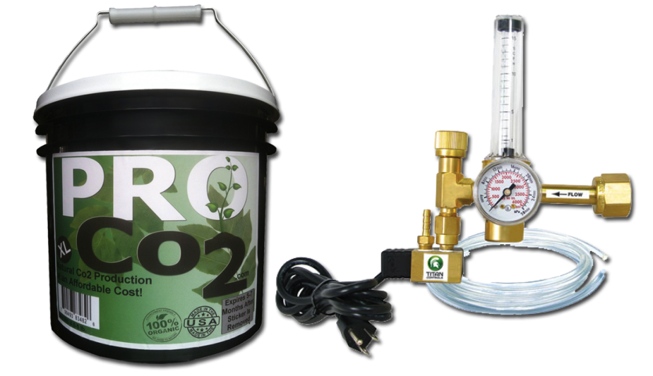
Figure 3.1: Pro CO2 bucket and CO2 regulator available at urbansunshine
3.2.3.2 Hydroponics sensors - The hydroponics subsystem will require sensors that measure temperature, pH, electric conductivity and water level. Supplying quality water to the plant will increase growth and health. Just like the environment, the hydroponics system will use a thermistor to measure temperature, and will be submerged in the reservoir. Water temperature must be kept between 70-85 degrees Fahrenheit to ensure efficient nutrient uptake by the plant. Nutrients require oxygen in the water to activate and the cooler the water the higher potential oxygen capacity (1).

pH sensor - Plants prefer water that is between a pH range of 5.5-6.5. Based on a scale of 0-14, where pure water is 7, anything less than 7 is an acid, and greater than 7 is alkaline. These numbers affect how much of a nutrient and how effective it is at being absorbed and represents the number of available hydronium ions. The pH sensor uses a glass diode that remains submerged in the reservoir. Inside the diode is an electrode that measures the difference in voltage of both sides and creates a pH reading. Figure 3.2 from explainthatstuff.com shows the diode submerged and measuring the potential difference of the hydronium ions.
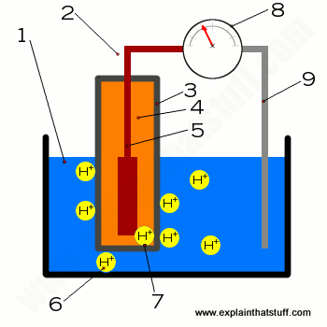
Figure 3.2: pH diode (Consent to reproduce requested)

1. Solution being tested (reservoir water with nutrients)
2. Glass electrode containing (3, 4 and 5)
3. Thin silica glass layer
4. Internal electrode
5. Silver inside internal electrode.
6. Hydrogen ions
7. Hydrogen ions interacting with diode
8. Meter, converts value to pH
9. Reference probe

It is important to keep the diode submerged in a solution or test solution to maintain accurate readings. In the hydroponic subsystem the pH probe containing the diode will remain submerged in the water containing the nutrients for the plants. It will check the pH of the water every 30 minutes – 1 hour. Based on the value, it will trigger the peristaltic pump, which will dispense pH up making the solution more alkaline, or dispensing pH down making the solution more acidic.

Electric Conductivity and Water Level Sensors - As the plants inside get bigger they will require more water and nutrients to survive and continue to grow. Nutrients in the water will be measured by an electric conductivity sensor, which like the pH probe, measures ions in the water, however the ions from dissolved salts, acids and bases. These dissolved particles come from the nutrients dispensed into the reservoir. The number generated from the sensor can be converted into total dissolved solvents, or TDS which displays the parts per million in the reservoir. If the number is below the desired result the peristaltic pump containing nutrients is triggered, dispensing them into the reservoir. Along with this sensor is a water level sensor, which will notify the user if the probe is not submerged in water. The Electric conductivity sensor and water level sensor will remain submerged in the water in the reservoir. The sensor will also check the electric conductivity of the water every 30 minutes - 1 hour and will consistently measure water level.

Table 3.1 shows each sensor and what action it will take after the measurements it send to the Microcontroller

Sensor: | Measurement: | Action:
Temperature sensor | Temperature of cabinet in Fahrenheit | Exhaust fan turns on or off
Humidity sensor | Relative humidity in % | Exhaust fan and dehumidifier turns on or off
CO2 sensor | Carbon dioxide in air in ppm | Dispense CO2 gas from tank
pH sensor | pH of water (0-14) | Dispense pH up or pH down based on measurement
Electric conductivity sensor | EC/ppm of reservoir water  (EC can be converted to ppm) | Dispense liquid nutrients if below desired value.
Water level sensor | Water level of reservoir | Notifies user if water level falls below certain level
Table 3.1 : Sensor Action

3.2.4 Microcontrollers

The microcontroller is one of the main components of the overall project. It is the central processing hub for the entire cabinet. Because the cabinet uses many sensors, many different aspects must be considered. The power consumption, clock rate, memory, pin count, and analog to digital pin count are heavily considered in deciding which microcontroller to use. The MCU's up for consideration are the MSP430, ATMega328, and ATMega2560.

MSP430 - The first microcontroller being considered is the MSP430F5659. This microcontroller is manufactured and distributed by TI and the MSP430 models are known for their low power consumption of 1.8V to 3.6V DC. This makes it ideal for use in a hydroponic system such as this. The MSP430F5659 can operate in two different modes, normal and low power. Basic power testing can be implemented during low power mode, as sensor readings will not be able occur. This MCU has a clock frequency of 20 MHz, 16KB flash memory, and 512kB of program memory. It also has 74 I/O pins which greatly exceeds the number for the sensors being used. The pinout for the MSP430 is shown below in Figure 3.3.

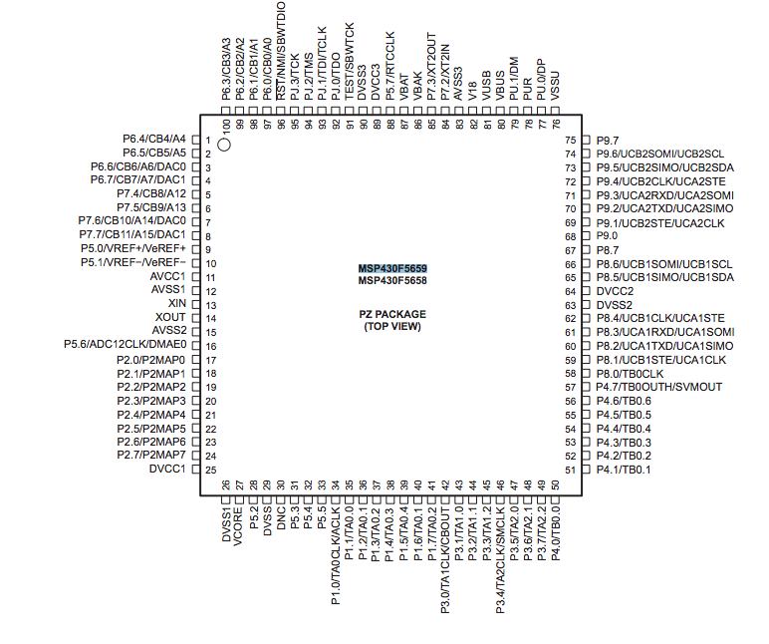
Figure 3.3: MSP430F5659 Pin Layout

The board contains serial communication interfacing for Serial Communication Interface (SCI), Inter-Integrated Circuits (I²C), Serial Peripheral Interface (SPI), and Universal Asynchronous Receiver/Transmitter (UART).
The MSP430 architecture has been used in previous courses such as Embedded Systems. It is known that the MSP430 contains no Wi-Fi module and requires an external program for serial monitoring. There are a lack of easily accessible libraries for sensor interaction available through C and Assembly Language for these boards as well compared to other microntrollers.

ATMega328 - The ATMega328 is made by Atmel and is an 8-bit RISC based microcontroller. The ATMega328 microprocessor is used in the Arduino Uno development board, which includes sensor testing. This microprocessor contains 32KB of flash memory, operates at 20MHz, has 2KB of RAM and contains a maximum of 23 I/O pins. The operating voltage is slightly higher than the MSP430 boards, ranging from 1.8V to 5V DC. The main communication interfaces used by the ATMega328 are Asynchronous Serial Receiver and Transmitter (USART), Two-wire Serial Interface (TWI), and the SPI.

The group is unfamiliar with the ATMega328 chip. Research has shown that it is compatible with the Arduino IDE and that it can use its extensive libraries that are open source. Compared to the MSP430, coding will be easier for sensor interactions.

ATMega2560- The ATMega2560 is another development board created by Atmel and is similar to the ATMega328. Even though the ATMega2560 is a more powerful microprocessor than the ATMega328, it operates at a lower frequency of 16MHz compared to the other's 20MHz. Despite this, the rest of the specifications are rated higher on the 2560. This microprocessor has 256KB of flash memory. This is eight times larger than the 328's flash memory size. It also has 8 KB of RAM and 76 digital I/O ports. Figure 3.4 shows the pinout for the ATMega2560.

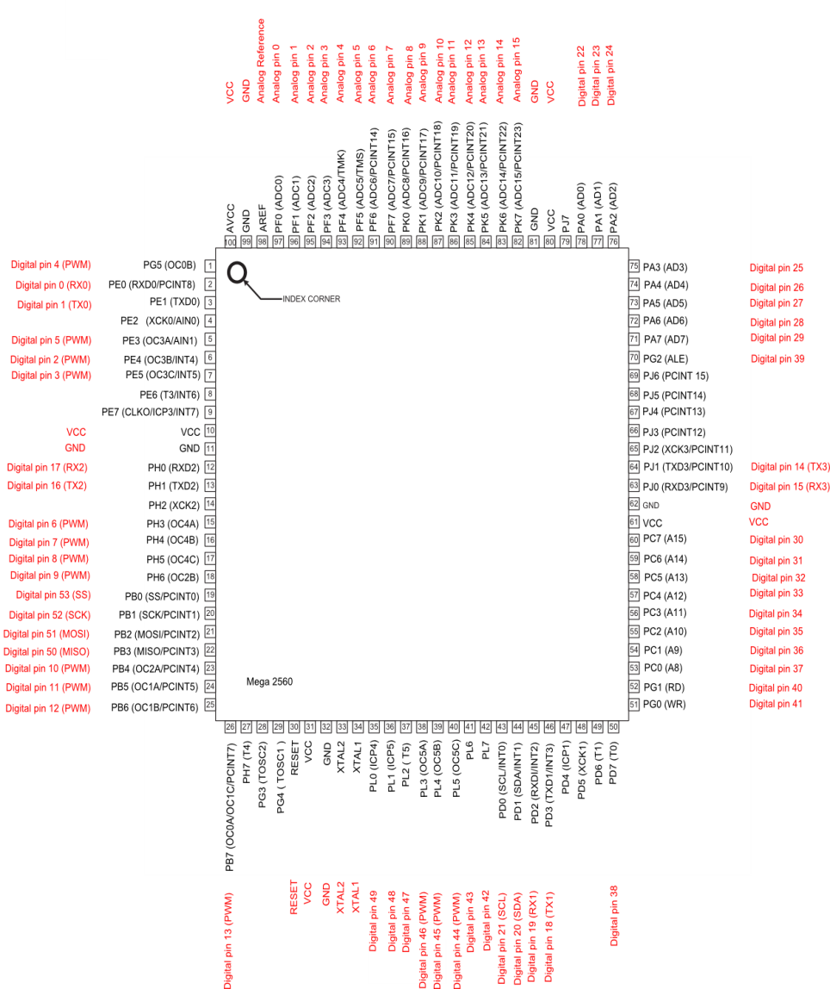
Figure 3.4: ATMega328 Pin Layout

The only downside of this microprocessor to the ATMega328 is that it operates at a slightly lower frequency. However, the advantages of the ATMega2560 more than make up for that. Like the ATMega328, the ATMega2560 uses USART, TWI, and SPI as its main communication interfaces.

3.2.5 Microprocessor Coding Environment - The software component of the microcontroller is vital. It allows the system to be as fully autonomous as possible. Two different IDEs were explored during research. The first is Code Composer Studio, which is used by Texas Instruments (TI) for their microprocessors. The second, the Arduino IDE, is used for Atmel microprocessors. Further analysis is provided below. The main

Code Composer Studio (CCS) - The Code Composer Studio IDE supports TI's Microcontrollers and has been used in previous courses like Embedded Systems for the MSP430. CCS operates on both Windows and Linux, which could be problematic to those using Macs. There are both free and purchasable versions of this IDE, with the free version allowing for up to 16Kb of coding space. The program can run on top of the Eclipse environment, which aids in software development because it adds features such as debugging and memory browsers. Programs for the MSP430 are written in C or Assembly Language. There is no internal serial monitor program for CCS, and an external one must be used in conjunction with it. These includes Putty, Terminal, or Energia and Processing. There are few existing external libraries to easily code and support sensor communication or a Wi-Fi module.

Arduino IDE - The Arduino IDE is mostly used for Arduino based projects. Amtel microprocessors can be loaded with an Arduino bootloader to run code written in the Arduino IDE. The Arduino language is based on C, but resembles Java or C++ in its object-oriented behavior. This IDE can be used on Windows, Linux, and OSX, thus making it easy accessible by all. There are numerous external libraries for sensor communication and Wi-Fi modules, as well as reading and translating values received by sensors and pins. Because Arduino is open-source, there is no hindering limitations for coding space like the free version of CCS.

3.2.6 Inter-Integrated (I²C) - The Inter-Integrated Circuit, or I²C, is a common synchronous serial communication protocol used in modern microcontrollers. It consists of a two-wire interface containing bidirectional lines of data transmission. These are shared between the master and slave devices. For the scope of this project, the microcontroller would act as the master device and the sensors would act as the slave devices.

I²C connections are half duplex, which means data must flow in one single direction during each clock cycle. Because of this, the standard transmission rate is 100Kbps. However, I²C has a fast mode that transmits at 400Kbps, a fast mode plus that transmits at 1Mbps, and a speed mode that transmits at 3.4 Mbps. The normal I²C design consists of either a 7-bit or 10-bit address space, meaning it can support up both 7-bit and 10-bit devices under varying voltages.

3.2.7 Universal Asynchronous Receiver/Transmitter (UART) - The Universal Asynchronous Receiver/Transmitter, or UART, is another common serial communication protocol. In contrast to I²C, which synchronous, UART can be both synchronous and asynchronous. Therefore, communication may be simplex, half duplex, or full duplex. Simplex refers to data being transmitted in only one direction, and full duplex refers to data being sent both directions at the same time. The data format and transmission speeds are both configurable. The UART generally requires separate interface devices to convert logic level to the external signaling levels. This is because it converts the bytes it receives into a single serial bit stream for outbound transmission.

3.2.8 Serial Peripheral Interface (SPI) - The Serial Peripheral Interface was a communication interface originally developed by Motorola and has been adopted by many different companies. SPI operates in full duplex mode, using a master-slave architecture. This architecture uses a single master but can have multiple slave devices.

The SPI interface is made up of four logic signals:

- Serial Clock (SCLK) - This is a signal generated by the master to synchronize with the slave device(s).

- Master Output, Slave Input (MOSI) - This represents a signal that is sent only from the master device to the slave device.

- Master Input, Slave Output (MISO) - This represents a signal that is sent only from the slave device to the master device.

- Slave Select (SS) - This represents a signal that is generated by the master device to choose a specific slave device.

The SPI interface with microcontroller interface by using the microcontroller as the master device. Each sensor would be considered a slave device. The microcontroller uses the logic "0" and "1" to the slave select pins depending on which sensor it wishes to use.

3.2.9 Web Servers - In order to run a custom website on any network, a dedicated web server is needed. The web server will store all the website's information as well as the information from the database.Our research led us to two web servers in particular, Node.js and Apache HTTP.

Node.js - Node.js is commonly used in a MEAN Stack, and allows users to create and serve webpages in a single environment. Node.js is growing larger as a server-side platform, and is now used by major companies such as Microsoft, Yahoo, PayPal, and LindIn. In order to start and run a web server project, the user only needs Node.js. This is because Node.js contains a built-in library to allow applications to act as a Web server, such as Apache HTTP. Node.js is similar to PHP and Python because it is primarily used to build network programs like web pages. However, unlike PHP, Node.js is a non-blocking language. This means that it executes commands in parallel and are asynchronous. This means that the server can handle multiple requests concurrently without having to create a new thread. This works out, because Node.js operates on a single thread which allows it to support many concurrent connections simultaneously. The disadvantage of this threading approach means Node.js doesn’t allow scaling with the number of CPU cores of the machine it is running without an additional module.
Apache HTTP Server - More commonly referred to as just Apache, this is the world’s most popularly used web server. It is most commonly used with PHP, and both technologies are open source. Apache servers implements many compiled modules that extend the core functionality of each server. Most web pages use HTML web pages that are embedded with PHP to deliver its dynamic content. In contrast to Node.js, Apache web server projects require the use of some server-side programming language like PHP, Perl, or Python. Set up requires downloading Apache HTTP server and a server-side programming language module, storing the server at the root level of a computer and modifying the configuration file to add the server-side language module, host, and port, and then finally starting the server.
PHP cannot run alone; it requires a server, such as Apache HTTP Server, to be able to run. As previously mentioned, Node.js uses a non-blocking language which is the exact opposite of PHP. PHP uses a blocking language, which means that requests sent to the server from clients are handled one at a time. Each new request creates a new thread, and there is a limit to how many requests a server can handle.

3.2.10 Botanics - Going from seed to harvest involves many cycles, each cycle having to be controlled with different conditions. A normal plant cycle follows these steps:
1. Germination
2. Seedling
3. Vegetative
4. Fruiting or Flowering
5. Harvest

Germination - Germination can vary depending on the type of seed, but generally, the seed or seeds need to be introduced to water to start the process. A small cup of water with the seeds inside or a moist paper towel wrapped around the seed is enough to start germination. Complete darkness helps simulate nature, where the seed would be naturally planted underground. Within 24 to 48 hours the seeds will break their shell and reveal a taproot, it is now ready to be placed into a grow medium, taproot down so it can push itself up.

Seedling - When the plant breaks the surface and begins growing leaves, it is in the seedling stage. This stage can last up to two weeks and is the most fragile part of the cycle. Seedlings have little to no roots so depend heavily on high humidity to for moisture intake. Leaves on the seedling are very scarce, so maximum lighting is required for the smaller leaves to absorb energy. During the two weeks the seedling quickly grows leaves to help in gathering light, and stretches up towards the light source, sun or indoor grow light. It is then transplanted, moved to a different growing container usually larger, to its new home, in our case the hydroponic system, to continue growing.

Vegetative - After two weeks and becoming significantly larger with more leaves, the plant is now in vegetative stage. The plant will continue to grow, sprouting new leaves and creating new nodes where the plant will branch out to grow even larger and strengthening its stems. During the night hours the plant is not taking in light but using the energy it gathered to take in water and nutrients through the roots. These roots are also growing, mainly during the dark hours. Typically, most plants grow their roots and canopy’s at the same rate. Depending on plant type, high humidity is still desired to promote continued rapid growth. In nature, spring and fall would be the preferred time of year for the vegetative stage, where equal amounts of day and night are experienced, allowing for roots and canopy to grow together. With rapid growth occurring in this stage, it might be necessary for the grower to provide maintenance to the plants, trimming and shaping the plant for efficient growth. As the plant grows upward, the lower nodes are still growing and can often be shaded or completed shadowed by the higher canopy. This top growth can be managed to allow for light to pass through the top layers and penetrate to the lower nodes. Vegetative stage can last 4-6 weeks, depending on season and plant type. The longer the vegetative stage the more nodes the plant will have, and depending on if it produces fruits or flowers, results in a larger yield.

Fruiting or Flowering - As the plant matures and the number of light hours decreases, it begins to produce flowers and fruits, depending on the plant; we will use a tomato plant as reference as seen in Figure 3.5. The first three plants from the left show the tomato plant in its early seedling and vegetative phases. Once mature and as the light cycle changes, the tomato plant begins to produce flowers, which will then become tomatoes. The fruit will continue to grow and ripen while on the plant, where the tricky part of choosing when to harvest comes in. If harvested too early the risk of a premature fruit is high and yields will be low. Waiting too long could cause the fruits to over ripen while still on the plant. Harvest time is the most fulfilling part of the growing cycle because soon enough, usually a few days to a week, the grower will get to enjoy the fruits of their labor.

Figure 3.5: Stages of tomato growth, seedling to mature fruiting plant

Deficiencies - Sometimes when a plant receives too much of a nutrient or too little, plant deficiencies can occur. In the early stages and vegetative stage, plants need to intake plenty of nitrogen, magnesium, calcium and other trace elements to maintain nodal and stem growth. During fruiting and flowering, potassium and phosphorus are important nutrients on top of the other nutrients mentioned before. Pests can also cause deficiencies to occur, draining the plant of its valuable nutrients. In nature the plant will fight to survive, however in a home garden a grower can choose to fix the problem with nutrient supplements. Recovery is possible but can be lengthy for a grower who wants to see results quickly. Luckily in an indoor system, plants can just be removed and replaced to save time. The downside is since it is all one system, it is very likely that all plants have the same deficiencies and will need to all be replaced

3.2.11 Power Systems - The Autobott will need to have constant power and control for 24 hours everyday. Even when the lights inside the cabinet are off there are still other components, which include the hydroponic system and HVAC system that may still need to be on. The printed circuit board will allow us to distribute power the each sensor to gather data and also trigger the relays, which will use mains electricity for each load. The sensors are very low power and require a small voltage to run. Voltage regulators on the printed circuit board will provide output voltage for the sensor loads.

AC-DC - Autobott will need to always be plugged into an outlet when in use, which uses mains electricity to provide up to 120 Volts AC at 60Hz. This voltage is much more than needed so a power supply will be implemented to reduce this voltage. Linear power supplies use a transformer to reduce the voltage depending on the windings on the primary and secondary sides. Increasing the number of windings on the primary side will reduce the output voltage on the secondary side, which will be connected to the Autobott. First stage of the power supply is a rectifier, which are diodes that allow the current to flow one direction but not back. Since AC signals range from positive to negative, the rectifier allows the positive portion of the signal pass and adds the negative portion to produce a signal that is only positive. Although all positive, the signal still goes to zero, and from 60Hz this can be calculated at 120 time per second. The signal needs to be smoothed out in order to provide a consistent signal. To do this, a capacitor is used, which is charged and then discharged. Discharge time will happen when the signal dips to zero to compensate for the 0 value, and then will recharge as the signal approaches peak value. Using an integrated circuit the signal is then regulated to the voltage desired. It is also important to choose components that can handle voltages higher than regulated values to manage heat. Figure 3.6 shows the steps taken on how a power supply functions, reducing 240 Volts AC to 12V DC.
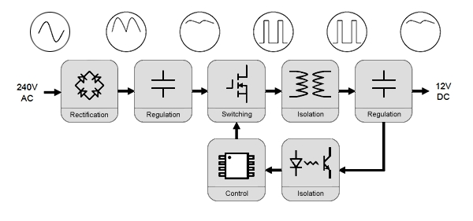
Figure 3.6: How a power supply works [5]
We will be using Texas instruments’ webench online application to design and find our materials for the power supply. Since we are using household outlets as our main source of power input will be 120 Volts AC at 60 Hz, and our output will be 12 Volts. Webench also allows for management of efficiency, footprint size, as well as cost. In order to produce as little heat as possible, we will be going for the most efficient power supply while keeping a small footprint.

DC-DC - The 12 Volts DC coming from the power supply will need to be reduced even further to power the smaller components which include each sensor, the microcontroller unit and the relays. These voltages include; 12Volts, 10Volts, 5Volts and 3.3Volts. Voltage regulators are small components that can regulate and change an input voltage to a constant output voltage larger or smaller than the original value.

Linear Voltage regulator - Linear voltage regulators can only step down voltage, using resistive voltage drops to change the voltage. This voltage drop across the voltage regulator is a loss of power in the form of heat and if the output voltage is much lower than the input voltage, too much heat may be released. This could be a problem if the amount of heat released is higher than the operating temperature of the device and connections. A simple power dissipated equation can be used to determine the amount of heat;
The output power is directly proportional to the difference of voltages. If needed, control of external circuit temperature can be cooled using a small fan or reducing the ambient room temperature. If temperatures cannot be controlled, heat sinks can be used to help dissipate the excess heat. These regulators are also inexpensive and, if heat can be managed, are easier to use.
Switched mode regulator - Like the power supply, DC to DC conversion can be achieved by using a switched mode voltage regulator. They work by using storage elements to store charge from the input and then release it to the output. Switched mode regulators consist of a capacitor for storing charge, an inductor, switch and a control circuit. These components work together to control whether the output voltage is lower or higher than the input. Unlike linear regulators, switched mode regulators can step down as well as step up voltage. In our application we do not need to step up the voltage from the source so a step up, or boost regulator, is not needed. Figure 3.7 shows a step down Buck convertor with an input of 12 Volts and output of 5 Volts and 3Amps. It uses TI’s LM25096 component and is also available in 12 Volts, 5 Volts, and 3.3 Volts, the values that we need to control our board.
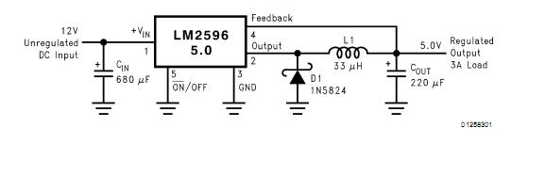
Figure 3.7: Switch mode step down (buck) regulator circuit (example)
Relays - Relays are electrical switches, for high current high voltage loads. The switch is an electromagnet which triggers when current is supplied through the coils and the magnetic switch latches closed completing the circuit. We will be focusing on solid state relays, which contain no moving parts. Solid state relays operate by using an LED and a photo transistor. When the LED is illuminated by a small signal from the processor, the circuit is complete and power is supplied to the load. Two separate power sources are involved in operating the relay, the power signal to activate the relay, and the power source which connects the main power to the load. We will be using a relay for each component in the cabinet that will need to be switch on or off depending on the conditions.
Safety using mains power - Since our project involves the use of household outlets, certain safety measures must be take to ensure proper operation and no injuries. While working on the circuit or Autobott we must ensure it is unplugged and no power sources are connected. we have also dedicated an enclosure for all electronics to isolate them from the working and growing environments.
3.2.12 Indoor Lighting- The device that consumes the most power in the Autobott is the light, which is why the most energy efficient light must be selected. Indoor gardens today use fluorescent, High intensity discharge (HID), High pressure sodium (HPS) or LED lights to grow their plants. Depending on the system, budget, environment and also which part of the plant cycle the plant is in different lights can be used. Efficiency is measure in lumens per watt and foot print of the light is measured in lumens per square feet. We will be aiming for about 4000-5000 lumens per square feet, which will provide optimal coverage to the plant

Fluorescent lights - With the Autobott’s dimensions, T5 grow lights would be the fluorescent light of choice. According to plantzoid, they are also the most efficient and effective Fluorescent grow light on the market right now, measuring at a tube diameter of 5/8 of an inch. These tubes are placed inside a reflective casing (Figure 3.8) where they are lined up and mounted inside. These casings come in a variety of sizes to accommodate different grow room configurations. Since the bulbs are all lined in parallel, if one were to fail, the entire fixture will continue to function. They give off very little heat, operating at around 95 degrees Fahrenheit when on, and are long lasting, up to 20,000 hours of light. Cooling the lights requires circulating fans blowing away the hot air from the lamps. T5 fixtures do not come enclosed so the heat released it expelled into the grow environment, the aluminum metal fixture also helps dissipate the heat. They also simulate the spectrum of natural sunlight, with 6500 K T5 lamps simulating white light and 3000 K T5 lamps simulating warmer orange light. During the plant vegetative stage the cooler 6500 K lamps will be used and in the mature plant phase or flowering phase the warm 3000 K lamps will be used. Grow rooms often use T5 lamps to supplement other sources, for example a greenhouse would supplement light using the T5 bulbs if it were a cloudy day. Most T5 fluorescent lights available today have an efficiency of 100 lumens per watt. Since the Autobott has a 3 feet by 2 feet growing area, if we wanted about 5000 lumens per square feet(30,000 total) we would need to use 300 Watts worth of T5 lighting.
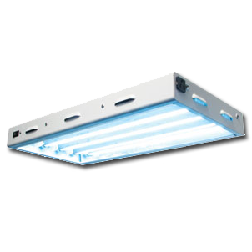
Figure 3.8: 2 Foot, 4 fluorescent T5 Lamp fixtures available at urbansunshine (shown with 6500K lamp)
HID – Metal Halide - Metal halide (MH) high intensity discharge lamps produce light by passing current through a glass tube filled with gas to emit an intense light up to 125 lumens per watt. This light is a bright white color, due to the mixture of gas inside the tube, and popular uses include lighting for; sports stadiums, parking lots, streetlights and of course indoor gardening. This white color is on the blue end of the light spectrum, around 450nanometers – 460nanometers, which triggers the plant to produce more compact leafy growth and would be the light of choice when the plant is in it vegetative stage. Better Homes and Gardens provides a formula to determine how much wattage is needed to cover a certain square footage. Using a 1000-Watt bulb as an example, they recommend 20-40 watts per square foot, and concluded that this 1000-Watt bulb can illuminate 25-50 square feet of floor space. For more sensitive plants we may decide to use the lower end of 20 watts per square foot, to assure the plant is not stressed by the intensity or heat from the light, which metal halide bulbs can emit up to 600 degrees Fahrenheit. Recommended distance from plants is between 6 inches to 10 inches. With a lifespan of around 10,000 hours, and leaving the light on for 12 hours a day, metal halide bulbs will last 2.5 years or more.

HID – High Pressure Sodium - High Pressure Sodium (HPS) lamps produce light exactly the same as metal halides but using a mixture of different gasses, and are slightly more efficient at 140 lumens per watt. High pressure sodium lamps fall into the high intensity discharge category and are used for street lights, outdoor lighting, and indoor grow light. The bulb emits a reddish orange light, 630 nanometers to 650 nanometers, which is ideal for the fruiting and flowering phase of plants. These bulbs also reach temperatures of around 500 degrees Fahrenheit and can be kept closer to the plants canopy with a recommended distance of 4 inches to 6 inches. With a lifespan of around 20,000 hours, and leaving the light on for 12 hours a day, high pressure sodium bulbs will last 4.5 years or more.

HID – The Ballast - When a high intensity discharge bulb is turned on, current passes through the gasses inside the tube emitting light and the bulb can take several minutes to warm up and reach maximum power. In order to initially turn on, a very high voltage spike is needed to spark the contents in the glass tubes, and once on the current and voltage must be maintained and regulated. HID electrical Ballasts are AC-DC converters that increase voltage during the lights ignition phase, and also regulates the voltage and current to provide consistent output power. Figure 3.9 shows an HID lamp’s startup phases and also shows how the electrical ballast controls the voltage and current. Initial spark voltages depend on if the light is being activated when it is cool or warm. Lights will be on 12 hours at a time in an indoor garden; by the time the light turns on again it is cool, requiring 3000 Volts to 5000 Volts depending on the type of HID bulb. Warm-up times can be as long as 6 minutes and once running the ballast will keep all values consistent for the bulb.

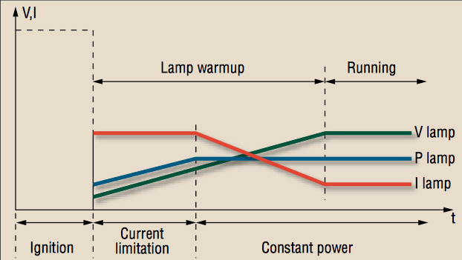
Figure 3.9: Graph from powerelectronics.com showing phases and values of HID bulb

HID – Reflector and Hood - Metal halides and high pressure sodium lights generate a lot of excess heat and must be cooled to not harm the plants. These bulbs are typically placed inside an aluminum, reflective housing that helps direct the light downward towards the plants canopy. The reflective housing, or hood, is also sealed with a tempered glass and has holes on each side. This creates a tunnel that allows a fan to push the excess hot air out of the hood and outside the growing environment. Depending on the wattage of the bulb, these hoods tend to be large and may not be ideal unless we increase the size of the Autobott.

LED Grow Light - Low power, very little heat, and effective spectrums, LED lights are the newest and potentially best option for grow lights. Small LED diodes, typically 3 Watts each, cover board and are angled downward to provide the plants with high intensity light. The LED diodes range from blue to red to ultraviolet light to provide a broad spectrum the plant needs. The lens angle also determines the footprint of the light, with lower angles like 30 degrees focusing the light straight down, and wider angles up to 90 degrees to spread out the light. Figure 3.10 shows a typical LED grow light spectrum, focusing mainly on blues; which promote vegetative growth, and reds; which promote flowing or fruiting.

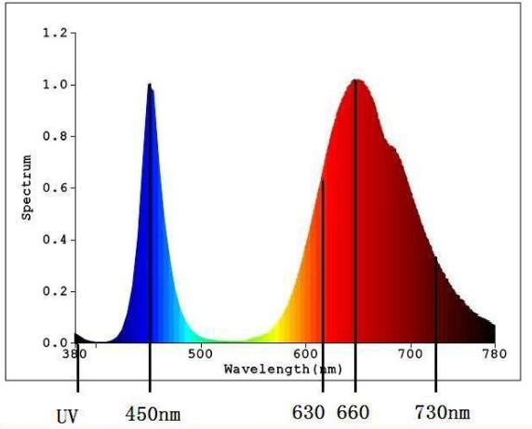
Figure 3.10: Typical LED grow light spectrum, varies by brand

As seen in Table 3.2, LED lights should be the choice for many indoor gardens, however some indoor growers prefer the natural light of the HID bulbs. When was the last time you stepped outside and the spectrum of lights appeared purple (the red and blue lights appear purple)?

Light  Type | Lifespan | Operating  Temperature | Distance from plant canopy | Light  Efficiency
Metal Halide | 10,000 hours | 600 degrees F | 6”-10” | 125 lumens/watt
HPS | 20,000 hours | 500 degrees F | 4”-6” | 140 lumens/watt
Fluorescent T5 | 35,000 hours | 95 degrees F | 2”-4” | 110 lumens/watt
LED | 50,000+ hours | 70 degrees F | 10” | 25 lumens/watt
Table 3.2: Table comparing operating values of major grow lights, information from platzoid

3.2.13 Basic Smart Garden Design - Gardening and farming has been around since the beginning of civilization, but the concept of smart gardening, in comparison, is fairly new. What makes a garden “smart” is the integration of technology into the system. Obviously, there are billions of different designs and ways to utilize all kinds of electronics, sensors, and other technologies; some of which may get extremely complex and expensive. When talking about “Basic” Smart gardens, one can get very basic. Plants essentially only need a few things to grow and survive; Light, Water, and Nutrients. Coincidentally, there are millions of ways to provide these basic necessities to plants with varying amounts of technology incorporated into the systems.

Some of the simplest smart garden designs only incorporate one or two smart systems that use “smart” components; the two most common being lighting system and a watering system. Many smart gardens have high-intensity lighting that can be automatically controlled by a timer that is set to a certain cycle, usually a twelve-hour cycle. Another thing that is common to many smart gardens is a watering system. For hydroponic systems, this usually consists of just a water pump to either consistently move and aerate the water, or rely on a timer to switch the pump on and off as desired. Wireless connectivity is increasingly being used in new smart gardens. There is also an increasing amount of smart garden designs that use either wi-fi or Bluetooth modules in order to wirelessly link their garden’s sensors to a computer. This can allow the users to get up-to-the-second updates and details about the plants like the water’s EC level, light intensity, water pH, and other data. Others have also connected webcams and cameras so they can watch their plants grow remotely.

As new technologies emerge, and other technologies develop further, it becomes cheaper to incorporate higher integrated components into the design. With our cabinet, we plan to use and improve on many of these smart garden techniques while seamlessly incorporating them all together into our system. Our plan will be integrating an automated lighting system, a fan and HVAC system, a pump and hydroponics system, and a nutrient delivery system all into one all-encompassing smart garden.

3.3 Relevant Technologies

Smart garden technology has become the new fad of this day in age. The range of products starts from small compact sensor systems and stops at the full ecosystem garden. Much of the smaller products are very popular because of their simplicity, ease of use, and functionality. They do not take up space like the Autobott would and still produce quality results in a garden indoors or outdoors. They are popular among people who are looking for a couple features to add to their garden that would make the environment more automated and less work and maintenance for them. Below are a few products that use these smart technologies and perform at high level for the user giving them a great experience and great results in their garden.

3.3.1 Edyn - Edyn is a smart garden system that monitors and tracks environmental conditions, helping the user create a stable and thriving garden for their plants. This system contains many features within it, such as, sensors, an intuitive interface for the user that is backed by a database, a watering subsystem, and even solar power which makes it autonomous (no batteries or power outlet needed). The solar power feature even works with ambient or indoor lighting, such as, LED’s that would be used in the Autobott. This would benefit the Autobott in such a way that it would save power and space in the enclosure. Furthermore, The Garden Sensor is the specific product that contains all of the sensors. The sensors in this design all work adjacent to one another and all serve an individual purpose. The sensors include, tracking light, humidity in the air, the temperature, and even soil nutrition and soil humidity. Even though the Autobott does not use soil because of its hydroponic design, it can still benefit from the other sensors that are tied together in a compact design. Depending on the grow medium that is used in the Autobott, the soil nutrition and humidity sensor can still function to some degree because the technology is based off of a probe that is stuck into a substance (soil, clay, sand, grow medium, etc.). A unique feature the sensors provide is the capability to gather all of the information and cross-reference it to a plant and weather database, giving the user the exact type of plant that will thrive in that environment and garden. This feature would not be used in the Autobott because there is not a specific environment growing in the enclosure. The Autobott’s benefit is the ability to create whatever environment the user wants. Nonetheless, the user can still inquire through Edyn to ensure that the environment they created is accurate with what they want to grow.

Another product from Edyn is called the Edyn Water Valve. The Edyn Water Valve is a sprinkler system based on when the users plants need water and even gives the plants the right amount of water. This subsystem is linked together with the Garden Sensor so the information passing back and forth between the two products and the information sending back to the database are accurate, giving the entire system a reliable high tech quality. Unlike most automated sprinkler systems that are preset, Edyn’s Water Valve and Garden Sensor cooperate together in creating a dynamic way of getting water to the plants. This system will change the watering cycle based on the amount of existing water already given to the plants and how the grow medium or soil in this case has absorbed the moisture. This great way of watering would be beneficial and efficient in the Green Garden because it would preserve water in the reservoir if the grow medium is too moist and it would save power for the entire system, only turning on the water pump, peristaltic pump, and drain mechanism only when the plants need water.

Finally, Edyn’s intuitive user interface is great for controlling the conditions of a garden, learning the different components of a sufficient garden, and creating a high tech autonomous garden. While the user can access their garden from anywhere in the world through the internet, the one drawback from Edyn products is that they have to be in range of a wireless router. The hardware implemented in this compact design uses wireless internet, thus needing the capability to connect to the internet. The application is a great tool for the user to understand the condition their garden is in. Edyn has a clear visual layout of all the conditions and information that is showcased to the user at their own disposal. Overall, Edyn is a great product with many useful high tech features that the Autobott uses and makes for a great addition to the design of the Autobott, simplifying the systems high tech features and providing an entire new learning environment for the user.

3.3.2 Parrot – Flower Power - Another valuable product that has been introduced to the smart garden technology is Parrot’s Flower-Power sensor probe. This compacted probe contains multiple sensors, such as, detecting sunlight, air temperature, fertilizer in the soil, and moisture in the soil. The probe acts as a constant reminder to gardener when conditions of the plant are out of shape and need to be tended to. The Flower-Power does not actually change the environment or conditions to help the plant thrive, it only serves the purpose as a reminder to the user. Even though Flower-Power seems simple and useless because of the other options that are available on the market that actually do work for the gardener, this product has become one of the most accurate sensor systems that detects the conditions in soil. Although this feature does not pertain to a hydroponics system, it still is something to keep into consideration for lower cost systems that use soil and a simple watering system rather than a hydroponics or aeroponics system. The more relevant technologies to the Autobott are the fertilizer, air temperature, and sunlight sensors. Something so compact and accurate gave our group direction for the placement of the sensors in our projects design. Our intentions and project motivation was not geared towards enhancing compact sensor systems, but it is something to take into consideration for more complex and professional products on the market. If the Autobott ever became successful among the smart garden technology, then compact sensor design would definitely benefit the overall design, quality, productivity, and accuracy in the system.

Flower-Power not only has created a compact and powerful sensor device, but also has made an easy to use mobile application for both iOS and Android operating systems. The mobile application notifies the user when their attention is needed. For example, when the plant needs to be watered because there is not enough moisture in the soil, then the device will send an alert to the users phone notifying them that they need to water the plant. This feature is extremely useful given that Flower-Power is not an automated system, it will always need attention from the user. The one major drawback is that the device uses Bluetooth technology. Logically, this makes sense because the user must be home to even attend to their plants, however, if the user has a larger than normal house then their mobile device may not be in distance for the Bluetooth to connect. Also, Bluetooth technology has not been mastered yet and tends to drop the connection more frequently. Wireless internet would have been just as easy to implement both in the hardware and software. Wi-Fi could have also served the purpose of letting the user, that is out of town, know when their plants are unhealthy and possibly have a friend or neighbor stop by to tend to it. The backend of Flower-Power’s software is a large database containing over 7,000 factsheets about different types of plants. This gives the user knowledge about the plant they are growing, which can help treat it right and establishing a longer and stronger growth. Flower-Power is so simple and offers such an easy method of teaching the users how to grow plants and become an experienced indoor or outdoor gardener. Another drawback, though, that could hurt the luxurious design of the product is that it runs on batteries. The batteries in this system can last up to six months, but must be replaced. Flower-Power can benefit so much more from using another method of power, at least for its outdoor uses or near indoor outlet uses, that would make it more reliable.

3.4 Standards

Standards are published documents that establish both procedures and specifications to ensure consistency and compatibility among technologies. In this section we will list standards that the Autobott will follow. These standards will be used while considering different parts and design aspects for the project.

Air Quality for CO₂₋ The following ranges are found to be acceptable for CO₂ levels.
- normal outdoor level: 350 - 450 ppm
- acceptable levels: < 600 ppm
- complaints of stiffness and odors: 600 - 1000 ppm
- ASHRAE and OSHA standards: 1000 ppm
- general drowsiness: 1000 - 2500 ppm
- adverse health effects expected: 2500 - 5000 ppm
- maximum allowed concentration within a 8 hour working period: 5000 ppm
The following ranges are found to be extreme and therefore harmful levels of CO₂.
- slightly intoxicating, breathing and pulse rate increase, nausea: 30,000 ppm
- above plus headaches and sight impairment: 50,000 ppm
- unconscious, further exposure death: 100,000 ppm
Wi-Fi (802.11)- The following list shows the three different types of 802.11 Wireless LANs and their standard specifications.
- 802.11: Supports a maximum network bandwidth of 2Mbps and is no longer manufactured.
- 802.11b: Supports up to 11Mbps and uses a 2.4GHz frequency.
- 802.11a: Supports up to 54Mbps and uses a frequency around 5GHz.
- 802.11g: Supports up to 54Mbps and uses a 2.4GHz frequency.
- 802.11n: Supports up to 300Mbps and uses either a 2.4GHz or 5GHz frequency.
- 802.11ac: Uses dual band technology. On 2.4GHz frequency can support up to 500Mbps and on 5GHz frequency can support up to 1300Mbps.
Mains Electricity- The standard for Mains electricity varies by country. Therefore, only the standard for the United States is given in Table 3.3 below.
Plug Type | Plug Standard | Residential Voltage | Frequency
A  B | NEMA 1-15 P  NEMA 5-15 P | 120V | 60Hz
Table 3.3: Mains Electricty Standard for the United States
Plug Type A refers to the normal two prong power cord we are used to seeing and Plug Type B refers to a normal three prong cord, such as a computer power cable.

Hydroponics system - The hydroponics system standard is owned and ran by the National Organic Standards Board (NOSB). This standard targets gardening regarding ‘soil-less growing systems’, such as hydroponics and aquaponics. Some of the questions or requirements that are issued from the NOSB for “organic” hydroponics systems are:

1. The over-riding question of whether soil-less systems are compatible with organic production (which is relevant to all of the systems discussed in this document).
2. Source of fertilizers:
3. Leaching problems with open systems
4. Source of media for aggregate systems
5. Composition of inert ingredients
6. Disposal of wastes

An operating hydroponic system used either for commercial or residential use must pass certain specifications and requirements to become a legal product on the market. Although the specifics of these requirements are not mandatory, they are frowned upon if not followed because the overall goal of a garden is to grow plants. It would be useless to make an attempt to grow plants in a garden without doing everything necessary to create an optimal atmosphere for the plants to grow in. Every system must provide the client with the necessary resources to create a thriving environment for their Autobott garden.

3.5 Impact of Realistic Design Constraints

Autobott has the potential to provide beneficial services to people around the world, such as, monetary value, environmental value, and sustainability in a wide variety of cultures. The Autobott is a system that will give people the opportunity to keep their garden alive in any climate or weather condition and remain comfortable about the energy they are using to keep their plants fresh and healthy. First of all, the Autobott is a low power and low cost system. The Autobott will be affordable to many cultures that need this type of system in their home or restaurant. Unfortunately, there is more than just the initial cost of the system, as the Autobott has maintenance cost tied into it. The maintenance cost consists of replenishing the nutrient bottles that the hydroponics uses to keep the plants inside the enclosure thriving. Furthermore, this system is low power which means that the energy used by this machine will not determine a high electric bill at the end of the month. The Autobott was designed to keep all costs as low as possible while still maintaining a clean and fresh environment for the garden inside. Also, the system is fully automated and almost fully autonomous because of its sensor interaction behavior with the environment and hydroponics system. This enables the device to be sustainable in almost any place and culture it is placed in. The only necessary and mandatory requirement and major constraint is that a 120AC volt outlet must be available to power the system.

4. Design Summary of Hardware and Software

The Autobott consists of many components that create the full system. Hardware is included in both the environment subsystem as well as the hydroponics, which creates more than one diagram to account for. The hardware parts in each subsystem serve their own purpose but are also all connected to the same microcontroller chip. As a result, all of the hardware is wired up to the same microcontroller chip. Our group found it was easier to have everything go to the same place where we can control it rather than multiple microcontroller units because we were able to find a chip that was large enough to fit everything in our system. This chip came with more features too, such as, allowing us to easily connect power, I/O devices if we needed to, and an easy platform for our software to be coded in. The software side of the Autobott contains a database in the back end and a web interface for the user to control their system. The chip had a built in wireless internet connector which made it easy for us to hook up the wireless shield and move forward in the code, spending less time worrying about how to wire for a connectivity solution. Although the printed circuit board is complex due to the amount of hardware components necessary to run this system, it will result in an organized and compact design.

4.1 Initial Design Architectures and Related Diagrams

In our initial approach to design an indoor smart garden, we conducted research on prior projects to understand the layout and architecture of such a system. Not only were we uninformed and unknowledgeable about the functionality and design of hydroponic systems but also how to integrate them into an environment, in this case an enclosed environment. From this research, we learned the different types of hydroponic systems and discussed which one would fit the best for the objective of the Autobott. This allowed us to begin designing the structure of the environment and determine what we wanted it to look like or what appeal we wanted to bring to people. The motivation of our project which is to bring a thriving garden indoors to people who live in urban areas or bad environments, really set the tone for the design of the Autobott. As far as the exterior look, we wanted the Autobott to be homey and traditional looking, like a cabinet that a television would go into, with a drawer on the bottom where a person might stash blankets or tapes and movie films. This exterior design would appeal to the typical homeowners because this “furniture” would fit nicely in many of the common rooms of a house. Furthermore, one of the major benefits of this product is its low power ability. This also serves a purpose for allowing the user to place it anywhere in their homes using only the outlet from the wall.

While the exterior of the Autobott looks like a normal wooden cabinet furniture piece, it opens like one as well. The doors on the top open up to the environment allowing access to the plants and roots, and the drawer door on the bottom folds down so the user has access to the reservoir and hydroponics. The architecture of the interior of this project was geared towards maximizing the amount of space the plants grow in. From existing projects, we noticed that some of the spaces were very limited, keeping the size of plants that can grow in that environment to herbs and smaller shrubbery types. Other projects that allowed for larger plants to grow still kept the environment small and only making room for one root, one plant to grow there. The Autobott opens up an entire new way of growing plants in an environment. The Autobott has a large room on the inside of the cabinet that gives access to larger plants, flowers, and produce, while still maintaining the same efficiency of growing herbs and smaller plant types. In this environment, multiple tomato plants can grow side by side and have enough room to breathe and grow in the best conditions. The space is so large that an experienced gardener can even begin the growth of a tree in this environment and grow it for a long period of time before transferring it outside.

The object of the interior architecture was to create a large environment while keeping the hydroponics and electronics space easy enough to access and get your hands into. The bottom drawer, stated above, contains the reservoir and the hydroponics system along with all of the necessary equipment to keep the subsystem running (pumps, power systems, tubes and piping, etc.). The drawer door does not pull out like a regular drawer would, but instead folds down because we did not want the user to pull the tubes and pipes out of other components in the process of maintenance to the lower subsystem. The electronics panel is located on the side of the cabinet. The user can access this panel by opening the tabs on the left side of the cabinet and simply pulling the whole panel off the cabinet. The user will find the motherboard, the wires and cabling, and extra electronic parts that run the system. By taking the whole panel off the cabinet, it gives the user a wide open space to work in case something electronically malfunctions. In the end, the architecture and design of the infrastructure and subsystems of the Autobott were ease of access, convenient to the user, and optimizing the space that was allocated in this environment.

4.1.1 Environment Subsystem - Lights and air are the variables inside the environment subsystem. Each must be controlled to grow a healthy plant. These conditions also vary depending on the phase of the plants cycle. The next steps will be in general and for most plants that we would be able to grow inside the Autobotts environments.
A plant wont be placed inside the Autobott until it has become a small seedling. Explained in section 3.2.9, seedling requires high humidity to ensure healthy and rapid growth. During this phase lights will be on for 18 or more hours every day and kept as close to the plant as possible, temperature will be kept on the warmer side with humidity levels reaching 70% or more. It is also important for the grower to keep track of the seedling, as this is its most delicate phase. When in vegetative stage, lights remain on for the same amount of hours, however temperature and humidity are adjusted depending on the plant. The HVAC exhaust fan will expel warm air when the environment gets too hot, and the dehumidifier will turn on if humidity is too high.

Light cycle changes as the plant enters its flowering and fruiting stage. During this stage the Light in the environment is on for less hours every day, until it is on for 12 hours ad off for 12 hours a day. This promotes fruiting in the plant, and with indoor controlled environment, we can achieve this phase at any time of the year. Temperature and humidity is also controlled and changed depending on the type of plant. At any time during the plants life cycle inside the Autobott, the user can experiment and change values, or adjust previous values to ensure a higher yielding grow until the perfect configuration is reached.

4.1.2 Hydroponic Subsystem
Main Pump - The plants in our cabinet will need some way to receive water and their nutrient mix that we will prepare beforehand. Our system is designed in a way where the water reservoir is underneath the main compartment holding the plants and plant trays. This means that in order to deliver the water to the plants, we will need a pump to push the water and nutrients up and out to the plant trays. One huge thing to consider while choosing the right water pump is the head-height. This is how high up the pump will be pushing water, measured in the distance from the top of the water in the reservoir to the highest point that our plants are situated. If the head height is greater, the pump will have a harder time and be able to produce fewer gallons per minute than if it was pumping through a flat line. Shown below in Figure 4.1, is a plot showing how the line of Active Aqua’s Submersible Pumps perform against various head heights. As you can see, the performance drops significantly with every added foot of head height.

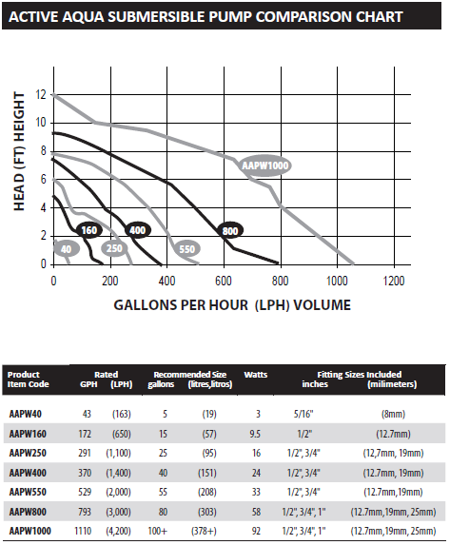
Figure 4.1: Submersible Pump Comparison Chart

For a hydroponic system, it's recommended to turn over 100% of the system's water every 2 hours. Because we anticipate having about 20 gallons of water flowing through the system, we need a pump that can push at least 10 gallons per hour, even with the head height that our design requires.

Nutrient and pH Pumps - Along with the main water pump, we will also need several smaller pumps to deliver the nutrients to the water reservoir, and a couple smaller pumps to regulate the system’s pH. We only need small doses of these inputs in order to alter the nutrient concentrations and pH, so we will require some smaller pumps that only pump milliliters at a time.

After some research, we found small peristaltic pumps that meet our requirements. These are small 12 volt motors that, when activated, rotate a shaft that in turn rotates three small rollers to physically squeeze a substance up and through a tiny tube. The mechanics of these peristaltic pumps are shown below in Figure 4.2. These low-power peristaltic pumps push out about 1 milliliter per second, and can push more or less depending on if the input voltage is increased or decreased.

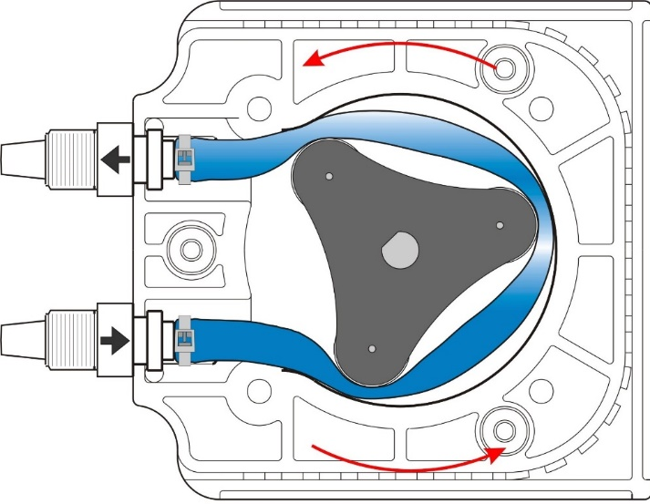
Figure 4.2: An inner diagram of a Peristaltic Pump

One thing to keep in mind with these small peristaltic pumps, is that they have limited lifespans. As the pump runs, the internal rollers push down on the flexible silicone tubing inside to pump the liquids. This motion, over time, can wear down on the tubing and eventually split it. The actual lifespan of the pump will vary on how much we need to adjust the nutrient mix, and the environment the pumps will be placed in. Another thing that may go wrong, is when the pumps burn out. They are brushed motors, and after enough use, can break down and stop delivering nutrients to the system. To help deal with this problem, we may monitor the current through each pump to see if it’s running at its full potential or not.

Hydroponic System - One of the most important factors to our design was the actual hydro system that will be carrying water and nutrients to our plants. There is a broad spectrum of hydroponic designs with differing mechanics, and each one takes up different amounts of space and materials. We know that space is valuable, since we want a fairly compact design, and we need cheap but effective materials in order to keep the project low-cost. After much research was conducted, we were able to take some solid features from various designs and use those to inspire our system. Another thing to consider is the type of hydroponic system that will be implemented into the design. We considered two different methods: the “Ebb and Flow” technique, and the “Nutrient Film Technique.”

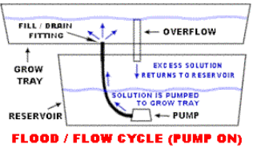
Figure 4.3: Basic Flood (flow) Cycle with Pump On

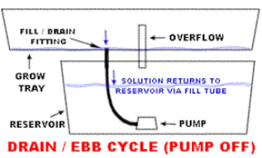
Figure 4.4: Basic Ebb and Flow Draining (Ebb) Method with Pump Off

The first technique we deliberated about was the two-phase "Ebb and Flow" method, where the pump is run on a two-part cycle. The two cycles are shown above; the Flow Cycle in Figure 4.3 and the Ebb Cycle in Figure 4.4. During Flow, the first phase of the cycle, the pump is switched on and the plant tray would be filled with nutrient-filled water. After only a few minutes of soaking, the pump cuts off and the tray is drained through an overflow tube back to the reservoir underneath the plant compartment. In the second stage, labeled “Ebb,” the tray is empty while the plants sit in the grow medium we placed them in. The cycle is repeated periodically, for about 5 times every day.

The “Ebb and Flow” system was a considerable option because of its low cost nature and simplicity, but there were some disadvantages to this system that made it somewhat undesirable. Many plants can’t handle being exposed without water for too long. Strawberries, for example, have a vulnerable corona and are susceptible to drying out easily in this system. This technique requires the pump to be started and stopped multiple times each day, which can wear down the system faster. Consequently, the Ebb and Flow system is more prone to problems and breakdowns.

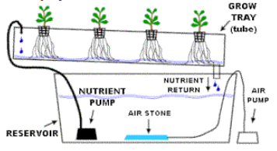
Figure 4.5: The Nutrient Film Technique

The second option we considered as our Hydroponic System was the “Nutrient Film Technique.” This design is shown above in Figure 4.5, where a constant, shallow supply of nutrient-rich water is fed to the plants, which are individually potted in series. In this system, the pump is ran constantly, which makes sure that each plant is always supplied with everything it needs to thrive. Generally, each plant tray should have a flow rate of 1 liter per minute. During the planting stage, the rate may be half of that, and the more water-hungry plants may require almost 2 liters per minute. Like the other system, a reservoir is used to house the nutrient-infused water, along with a water pump to move the water, and an air stone to aerate the reservoir. Over time, as the system runs, the plants grow longer roots that eventually can run along the bottom of the trays to soak up the nutrient solution. In addition to the mat of roots, an abundant supply of oxygen will also be provided directly to the roots of the plants. There are a couple things that we would need to pay special attention to with the Nutrient Film Technique. Since the pump is running constantly, it is advised to ensure the pump is quality enough to run dependently, otherwise risk a result of pump failures. In the case of a pump failure or a power outage, the roots of the plants in the tray at the time will dry out very quickly, if not treated in time. Special attention will also be needed for the nutrient mixture. The plants will be sitting in a running flow of the mixture for almost the entirety of their lives, and if we want good yields in the optimum amount of time, it is important to have a proper nutrient mixture for each plant. An imbalanced supply of nutrients can result in smaller yield. The slope of the channels are important design characteristics as well, and slopes of 1:30 to 1:40 are recommended; sometimes even slopes of 1:1000 are used.

Nutrients & Nutrient Delivery Subsystem - The plants will not thrive without the basic nutrients they need, or without an effective way to deliver these nutrients. We will have a pump pushing water through our system, but water alone isn’t enough to keep a collection of plants growing and budding. So to provide a proper mix of nutrients to our subjects, we will create a nutrient delivery subsystem.

There are about sixteen different elements that have been generally considered to be responsible for good, healthy plant growth. Some of these elements, called Macro-elements in this case, are needed in higher concentrations within our nutrient mix. These Macro-elements are Carbon (C), Hydrogen (H), Nitrogen (N), Oxygen (O), Phosphorous (P), Potassium (K), Calcium (Ca), Sulfur (S), and Magnesium (Mg). The counterpart to these elements are Micro-elements, which are also essential for growth, but required in smaller concentrations. There is still some debate and disagreement since it may vary from plant to plant, but generally the micro elements are thought to be: Iron (Fe), Chlorine (Cl), Manganese (Mn), Boron (B), Zinc (Zn), Copper (Cu), and Molybdenum (Mo). Certain plant species may need others for good growth: Silica (Si), Aluminum (Al), Cobalt (Co), Vanadium (V), and Selenium (Se). The goal of our nutrient delivery system is to provide all of these elements for our plants.

While all of these elements are necessary for plant growth, not all of them need to be provided by our nutrient delivery system. Carbon, for example, must be absorbed by the plants as Carbon Dioxide (CO₂), which in a well-aerated system is very abundant. Hydrogen is already present in the atmosphere and is readily absorbed by the plants. Oxygen is another essential nutrient that can be readily provided by our system; it is present in well-aerated nutrient mixes, and our air-stone should be able to inject plenty of air into our reservoir.

For large-scale plant facilities and giant greenhouses, it is pretty common for their botanists to mix and supply their plants’ custom nutrient mixes themselves. This may take some time, and the solutions added to the mix have to be done so in a precise manner. For smaller greenhouses and individual projects, it is way more commonplace to buy and use ready-made nutrient solutions. We are planning on supplying our plant subjects with a pre-mixed nutrient mixture and diluting it into the cabinet’s water reservoir.

The nutrient delivery system will be automated and controlled in a similar fashion to the other automated components in our project. The nutrient solution will be supplied through our small peristaltic dosing pumps, and dripped little by little into the reservoir water as it is moved past the nutrient system by the main water pump. We will have one peristaltic pump for each nutrient solution needed, as different plants require different concentrations of mixtures. Even the same plant will require different concentrations of nutrients at different stages of its life. The crop demand for nutrients will change from season to season. During its beginning stages, it will require smaller amounts of nutrients

pH Levels - As our nutrients are added to the system, the pH of the mixture as a whole will change drastically. If left unchecked, the plants will suffer in the acetic or basic water. First, it is important to mention that we will begin with distilled water. If plain tap water is used, it can have a negative effect towards our subjects, because tap water contains trace elements that will be absorbed by the plants in the cabinet. Since the pH has such a huge impact on our plants and their growth, we will include a pH sensor in the system to constantly check and recheck our nutrient mix’s pH at regular intervals. If the reading on the sensor becomes higher or lower than our predetermined values, our system will have to automatically adjust.

It is a huge chemical feat to be able to alter the pH of any amount of water, but thanks to the great minds in our society, there are products on the market that are meant to do just that. Two compounds are currently produced by many companies: pH Up, and pH Down. As expected, they perform just as their names suggest; the Up increases the mixture’s pH, and the Down decreases the pH. It is suggested not to saturate the water with either of these compounds, as they will change the mix itself. So to safely alter the pH, we will do so slowly, adding only a few milliliters of either mix at a time and rechecking our pH sensor’s reading. This will be repeated again and again over an hour or so until the nutrient mix is within the acceptable pH range.

That acceptable range for plants varies when we talk about different plants. Even though they’re all different, most plants have a livable pH range somewhere between 5 and 7, as shown below in Table 4.1. As the pH rises or falls, it can become harder to absorb each of the essential nutrients. Each element has a range in which it becomes more readily available to be taken in by the plant roots, and some of these ranges are illustrated below in Figure 4.6.
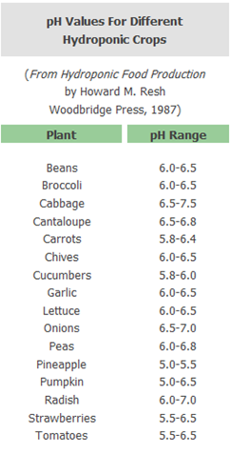
Table 4.1: pH Values for various hydroponic crops

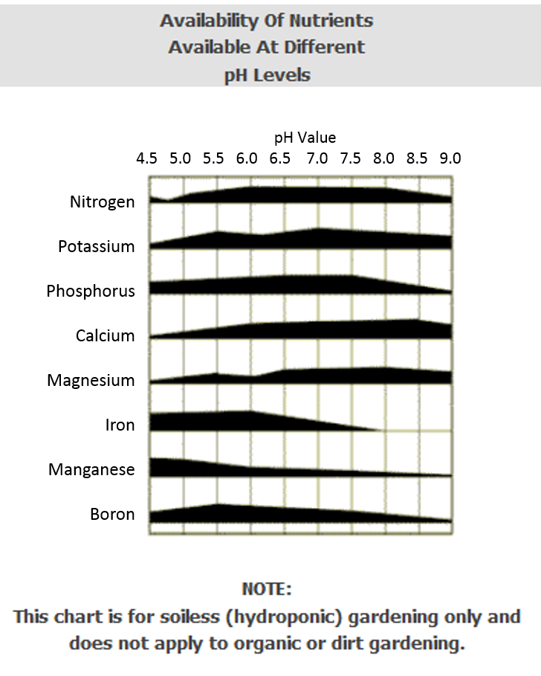
Figure 4.6: Availability of nutrients at different pH levels

4.1.3 Component Level Hardware Block Diagrams - The hardware block diagram is designed to represent every component and part that is used in the Autobott’s layout. It provides the key parts that allow the system to function properly and operate under the objective of the project. Below is the full hardware block diagram of the whole design represented in Figure 4.7. Figure 1 includes all of the sensors, the printed circuit board, the power supply, the wireless network router, and the motors, containers, and reservoir. The flow of the arrows from each component shows how the system works, for example, every component underneath the Sensors section is wired to the microcontroller, using a half-duplex like communication.

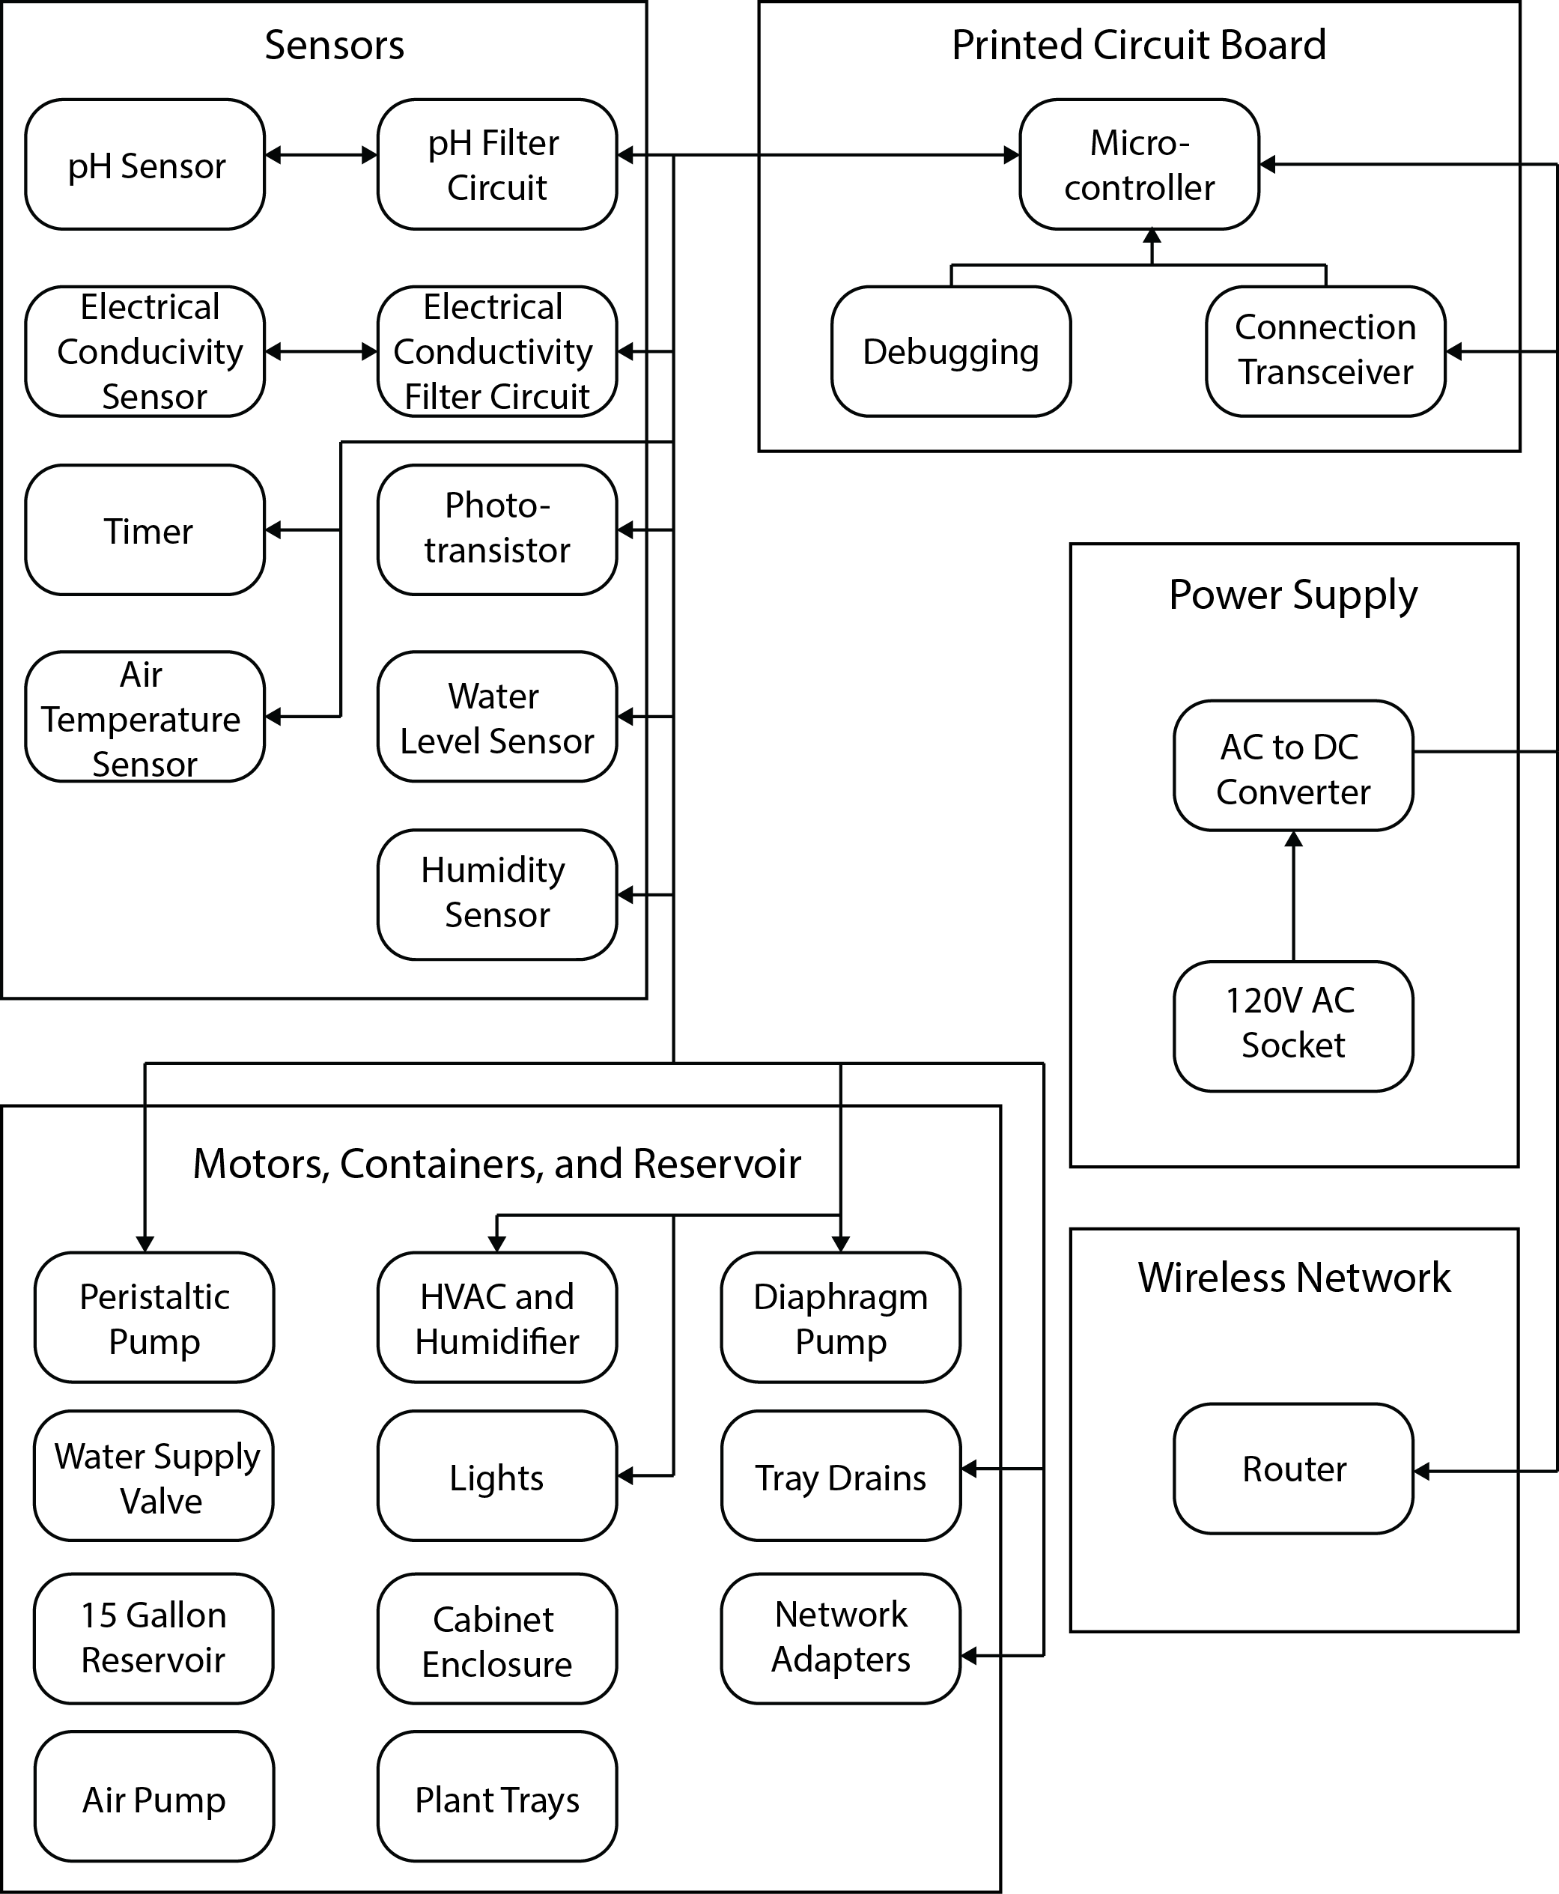
Figure 4.7: Hardware Block Diagram

4.1.3.1 Description of Hardware Block Items - Each component in this design serves a unique purpose that completes the overall vision for the Autobott. Further sections will explain each component in more detail, such as, the units we are measuring conditions in and how much power we need from one part to complete a task. For example, the HVAC system needs to be strong enough to circulate air into the environment and have a venting system that releases the older air out of the enclosure. This section will give an overview of the purpose of each component shown in the above block diagram. The system contains power supply, sensors, a printed circuit board, a wireless network router, and the operational pieces like the motors, containers, reservoir, and extra plant materials.

To begin with, the power supply is the portion of the project where a 120V AC power outlet is used to give power to the entire system. This outlet can be found in typical infrastructure locations, such as, residential homes, apartments and condominiums, restaurants, and on park and school facilities. The next component is created by the electrical members of our project, where they will create a circuit that converts the AC power outlet to direct current (DC). This will help us direct current to certain parts of the product, always ensuring they have power to switch on or off. Various parts, such as, the HVAC and the humidifier will always need power to turn on when they are called to do so based on the conditions of the environment. By controlling where the current goes, we can control the power usage and can eliminate the waste of power in our system. This creates a low power product that benefits users because they will be able to run a system such as the Autobott and not have to worry about how much power it is consuming. Lastly, the power source and the AC to DC converter circuit will power everything mentioned above in Figure 1, which leads us into two separate components, the printed circuit board and the wireless network hardware.

The wireless network hardware is a router that connects to the power supply. The router's main purpose is to connect the devices and sensors in the product to the web. The purpose of this product is to keep track of data from the sensors so that the environment can adjust itself when it is not at optimal conditions. Without the router, the sensors would simply just be detecting information and would not do anything with that data. Furthermore, the router can only connect to the devices in the environment by placing network adapters on them. This enables the sensors wired to the printed circuit board to communicate information back to the internet and the web application. By doing this, the user is able to see the conditions of their environment from anywhere in the world since it is available through the internet. Through the software that will be implemented in the back end database and the front end application, the user can adjust conditions when they begin growing a new type of plant. The Autobott contains a fully customizable environment and is first supported by the network adapters and router, before the software is even created.

The other component that attaches directly to the power supply is the printed circuit board, where everything in the system is wired into. The printed circuit board contains everything this system needs to run, if designed and wired efficiently. Within the printed circuit board is the microcontroller, the debugger (also used for coding purposes), and the connection transceiver or one of the network adapters in the system. The microcontroller serves the purpose of doing all of the computations for detecting and tracking information from the sensors. Also, the sensor information that is returned to the circuit board will determine if the peristaltic pump will be turned on to fix the water quality or if the HVAC system needs to pull in fresh air into the environment. The printed circuit board will have ports for sensors that use digital or analog signals. Based on the size of the microcontroller, we will be able to allocate enough room for both analog and digital ports, as well as, the communication technology that will be integrated onto the board and the power source.

The sensors are probably the most important hardware devices implemented into the design of the Autobott. They monitor and track the conditions of the environment which is essential to optimizing the growth of plants within the enclosure. There are two different subsystems that the sensors cover. The first subsystem is the environment and the second is the hydroponics. In the environment subsystem, which will be explained more in the section below, are three sensors that are used to keep the environment in perfect conditions. The first sensor is a phototransistor that is used to detect the amount of light the plants are getting. A phototransistor is a device that converts light energy into electrical energy. We can incorporate this into the environment by converting the light energy into the amount of lumens per second that the plants are receiving. This unit is known to plant growth because certain plants get a specific range of lumens they need to grow efficiently. The sensor will guarantee that the plants are getting the right amount of light by dimming or shutting off the LED lights when the plants have had enough light for that day. The user can monitor this parameter through the web application and even create a timed cycle that will represent the sun. The second and third sensor, air temperature and humidity, are integrated into one device which makes it easier for us to implement into the environment, only having to worry about wiring for one sensor instead of two separate. This also creates more space for other uses on the printed circuit board. Air temperature and humidity is very important to the growth of plants. Although some indoor gardeners care more about the hydroponics and nutrients the roots of the plants are getting, the environment itself is also just as important because particular plants can only grow in climates where the temperature is kept above 70 degrees Fahrenheit and the humidity is 75%. The humidity data that is gathered in the environment is independent of all other sensors, simply used to track the humidity and correct it by humidifying or dehumidifying the environment. The air temperature in the environment is controlled in a very unique way. The air temperature sensor is used to track the amount of heat and coolness in the environment. If the air temperature is too hot, then that means one of two things, that the LED lights have been left on too long resulting in light heat or the air inside the enclosure is old and hasn’t been cycled with fresher air. Also, the humidity can affect how hot or cool it is inside the enclosure. The data collected from the sensor will simply shut off or dim the LED lights to get the air temperature back to optimal levels.

The next set of sensors are involved in the hydroponics system. These sensors are used to manage the water quality of the hydroponics and they include the pH level sensor, the electrical conductivity, and water level sensor. The hydroponics system is a continuous flow of water that is on a timer and cycle. All of the water quality sensors only track levels of the water when it is in the reservoir. The pH level sensor detects the pH levels of the water that sits in the reservoir and will use the peristaltic pump to inject the right chemicals to balance the water for optimal nutrition. The pH is different for every plant so if there are different types of plants growing in the environment simultaneously, then the average pH level will be used to support all of the plants growing at the time. Obviously, if the user is growing one type of plant, then the ideal pH level will be used for that type of plant. The electrical conductivity (EC) sensor is used in the similar way that the pH level sensor is used. It will detect the EC level of the water that sits in the reservoir before it is cycled through the plant trays in the enclosed environment. Both the pH and EC level sensors will make sure that the water quality is accurate and ideal for the plants in the environment before it is pumped to the plant strays. The last sensor in the hydroponics system is the water level sensor which simply measures how much water is left in the reservoir. This is a very important sensor that must be perfectly accurate because this sensor determines when the reservoir needs to be refilled with more water. If the hydroponics system runs out of water, then the pumps will be running dry and wasting power, which will be the least of the users worries. The more important issue is that the plants in their environment will not be getting water or nutrition which will create a drought in their garden and starve the plants. If all of the sensors in both the enclosed environment and the hydroponics system operate efficiently and accurately, then the Autobott will be the most steady environment to grow plants in.

The last section of the hardware block diagram is the physical parts that are used to change how the environment acts and treats the plants. The essential parts that are used in this regard are the water pump, the peristaltic pump, the LED lights, and the HVAC and humidifier system. The water or diaphragm pump sits inside the reservoir at the lowest level of the tank and pushes the water through a tube up to the plant trays. This pump will remain on for the majority of the time because the hydroponics system will cycle fresh water constantly into the plant trays. The other type of pump used in the hydroponics system is the peristaltic pump or in other words the nutrient pump. This pump contains holding cells for nutrients that are injected into the water when the water quality is unbalanced. This pump is very important to the Autobott because it feeds the plants with nutrients they need to thrive. Another feature this pump must contain is to alert the user when nutrient levels are low within the holding cells, prompting them to add more nutrients. The pump will only turn on when the sensors detect that the water needs to be treated, so this particular product aids in the low power design of this project. The last three essential items that are used in the Autobott are located in the enclosed environment subsystem. The LED lights are used to give off heat and light to the plants growing in the environment. This is crucial for the growth of the plants because the LED lights replace the purpose of the sun in an outdoor situation. The two remaining devices are the HVAC system and the humidifier. The HVAC system will be used to filter the old air out of the enclosure and pull in fresh air from outside the enclosure. This process is important because over time the plants will give off carbon dioxide and the air inside the enclosure will become filled with this gas. Plants need oxygen to breathe and when the air is filled with carbon dioxide, then the plants will suffocate. The HVAC system is set on a timer to filter the air inside the enclosure based on an algorithm that was calculated on the rate at which carbon dioxide is produced from a plant. This process was also a lower cost solution to using a carbon dioxide or oxygen sensor to determine how much carbon dioxide is in the environment. Lastly, a humidifier will be used to create an ideal environment in adjacent to the humidity sensor and other parameters. The humidity in the environment will constantly be eliminated at a certain rate to keep conditions as normal as possible. A solution is still on the table as to the type of humidifier we can find on the market that can be used in conjunction with the sensor. If the user wants more or less humidity, then the type of humidifier we want will adjust the rate at which it is humidifying or dehumidifying the air in the environment.

The remaining hardware items in the Autobott are used to build the design and infrastructure of the full system. Starting from the bottom inside the drawer door that folds down, where the hydroponics system is located, sits the reservoir. The reservoir is used to hold the entire water source for the hydroponics. Inside the reservoir is the diaphragm pump as well as the air stone. The air stone acts like an air pump and keeps the water oxygenated. It simply adds bubbles in the water and keeps it constantly moving so the water particles are kept clean from bacteria and hold strong the oxygen that is being regulated through it. Moving further up the system are the drains that connect to the bottom of the plant trays. There will be drains that relieve water from the plant trays back into the reservoir. The drains will be a certain size, only allowing a certain rate of water to exit at a given amount of time. Since the hydroponics system used in the Autobott is continuous, there needs to be water fully cycling through the plant trays at all times while still holding a certain level of water in the plant trays for the roots to thrive from. While it is okay to leave the roots in open air for a little while, that is not the design of this particular project. Furthermore, the plant trays act as the basin that the water cycles through while the plants get their nutrients from the water. There will be a tube that is attached to the water pump at the higher end of the plant trays and this is where the water will filter in from. The plant trays are set on a small decline so that the water can drain freely out of the other end with the help from gravity. Inside the plant trays are a set of trays called grow trays. These grow trays will be interchangeable with different sizes, giving the user the option to put more or less into one plant tray. This makes the enclosed environment somewhat scalable and allows the user to grow smaller or larger plants beside each other in the plant trays, making more use of the space that is provided to them. The grow trays will contain grow medium in the top two thirds of the tray and rock in the bottom third. The rocks are in the bottom of the grow tray to add weight and keep the tray in place, while also allowing for the water to fill up the plant tray and freely move past the grow trays to the drain. In conclusion, this section gives a brief description of the entire list of hardware block items used in the Autobott. The smaller materials that were not mentioned here will be added into the budget section where the bill of materials will be described in detail so that nothing is unaccounted for.

4.1.4 Software Block Diagram - The software block diagram is designed to give a basic representation of how the software used for the automated Hydroponic system will be used. The figure below (Figure 4.8) shows the checks and corrections for the sensors, as well as their data being uploaded to the website. The flow of the arrows represent how the system works. For example, after there is a call for sensor data readings, two separate processes are called for the two different environments– water settings and environment settings.
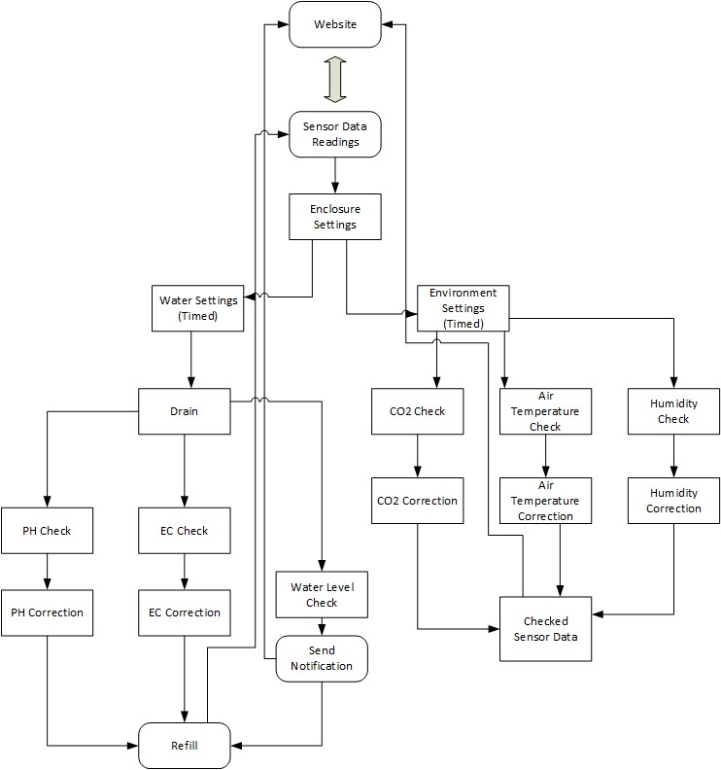
Figure 4.8: Software Block Diagram
4.1.4.1 Description of Software Block Items - Each item of the software block is a component of the system that needs to be measured. The first block item, Sensor Data Readings, stores the current readings of all the sensors in the system. When it is time to collect new sensor data, two separate processes occur for the two different parts of the system, the water settings and the environment settings.

The water settings are based on a timer. Every thirty minutes, the system will be instructed to drain the water from the plant reservoir and cycle it to the reserve reservoir below. After the water has drained, the system will be instructed to check the pH level, electrical conductivity, and water level. If the pH is too low, the system will add a base to the water until the pH levels are in the correct range. If the pH is too high, the system will add an acid to the water until the pH levels are in the correct range. The normal range of pH for most plants will be a level of 5.5 - 6.5. If the EC is too low, the system will add nutrients to the water until the EC is in the correct range. If the EC is too high, no nutrients will be added until it becomes too low. If the water level is too low, a notification will be sent to the website instructing the user to add more water. It will also be up to the user to monitor the amount additives available for pH and EC correction. After the corrections are made, the system is then instructed to refill the plant reservoir and send the updated results to the website to be viewed. On the website, the pH and EC ranges of acceptable values will also be editable based on the type of plant used.

The environment settings are also based on a timer. This timer will be synchronous with the water timer so that all sensor readings are taken at once and all values are consistently accurate. Every thirty minutes to an hour the environment system will be instructed to check the carbon dioxide levels, air temperature, and humidity. If the carbon dioxide levels are too high, the exhaust vent of the enclosure will open to let it out until the levels are within the accepted range. If the carbon dioxide levels are too low, a CO2 tank will be instructed to release more into the enclosure. Temperature and humidity are measured on the same sensor, but the corrections for each are different. A fan will regulate the temperature if conditions get too hot or cold. A dehumidifier will be used to regulate the humidity if conditions get too moist or dry. After all the sensors have been checked and corrected, the sensor data will be sent to the website so it can be viewed by the user. If the user believes that the sensor data should changed to fit different values, the user may edit that and the sensors data will be updated. On the next iteration of sensor readings and correction, the sensors will use the new data.

4.2 Motivation for Design Decisions
The motivation for design decisions is a section dedicated to convincing the reader why our group designed a subsystem or component a certain way. Since there are four subsystems, the hydroponics, the enclosed environment, the electronics, and the physical enclosure, there were many brainstorming meetings that were conducted to form a unanimous decision about the design of these various sections of the project. Below are the decisions we made on certain components of the project based on requirements and objectives we wanted to accomplish though the Autobott. The final designs, for now, may not be the best solution to accomplishing the specific tasks, but we will learn better and more efficient solutions once we reach the prototype and building phase of this project.

4.2.1 Hardware Decisions (ZigBee changed to Wi-Fi) - Our very first design decision was whether to use a hydroponic or a soil-based system. With this decision comes many different aspects to consider, including the goals of the system we will build. Our main goal is to have an automated system. Hydroponic systems are much more conducive for an automated environment, with the assumption that we have a long-lasting growing medium and that we will pump the proper mixture of nutrients into the plants’ water so that the plants will grow and flourish. A soil-based system would require maintenance and replacement of the soil every time we switch out plants, and would generally be messier. Both pests and weeds are much more prevalent in soil, and would take a great deal of time and effort in order to eradicate them. After our research, it became apparent that the only benefits to a soil-based garden are its low-cost tendency, and how the soil holds some essential nutrients that can act as a buffer if the plants aren’t getting everything they need to survive. Hydroponic systems have actually been seen to grow bigger, healthier plants in a shorter amount of time. This is due to how the optimum mix of nutrients is constantly pumped through each plant. So through this comparison, we were able to decide on a hydroponic system over soil-based.

The next decision we made was how big to make our system. As inspiration for the design, we looked at cabinets, wall units, and other cabinet-type furnishings. We sketched the entire box out on a big wall of white-board so that our group can get a better feel of the size of our design. After drawing a few different sized cabinets, we decided on an entire enclosure 6 feet tall, 2.5 feet deep, and 3.5 feet wide. This will give us plenty of space for all of the hydroponic, HVAC, and electrical components while staying a manageable size. We wanted to make the cabinet mobile, which turned out to be easier than expected. To facilitate our cabinet’s mobility, we will be fixing wheels to the bottom of the box. These wheels will most likely be similar to those on the bottom of rolling A/V carts or those on the bottom of rolling office chairs. This way ended up being a very inexpensive addition to add a huge functionality to the design.

Another design decision that needed to be made was what type of module to use in our system to wirelessly transfer data from the sensors to our database. We saw a few options become apparent after some research into the subject: Wi-Fi, Bluetooth, UWB, and Zigbee modules. All four of these types of modules will work for our project, but each has its advantages and pitfalls. From an application point of view, Bluetooth is intended for a cordless mouse, keyboard, and hands-free headset, UWB is oriented to high-bandwidth multimedia links, ZigBee is designed for reliable wirelessly networked monitoring and control networks, and Wi-Fi is directed at computer-to-computer connections as either an extension or substitution of cabled networks. All of these modules are low-cost, and have low power consumption, so the big differences are in bandwidth, range, network size, and signal rate.

Below, Table 4.2 summarizes the main differences between these four protocols, which are all based on different IEEE standards. WiFi is intended for use in WLAN communication within 100 meters, while Bluetooth, UWB, and ZigBee are all intended for WPAN communications within 10 meters. However, in some applications, and with the right antenna, the ZigBee module can reach up to 100 meters. All of these protocols have spread spectrum techniques in the 2.4 GHz band, which is known as the industrial, scientific, and medical (ISM) band.

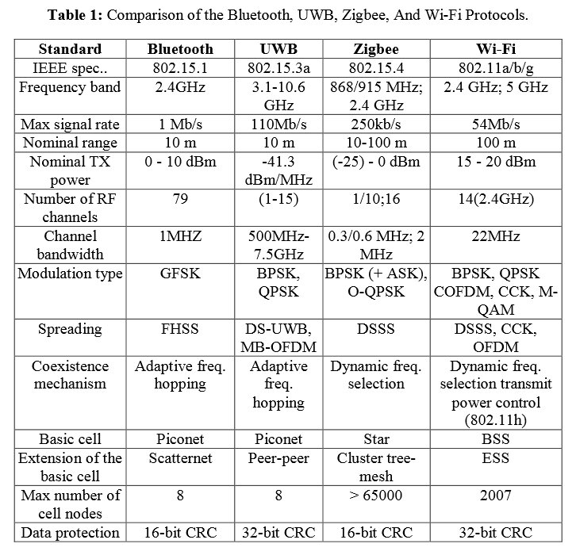
Table 4.2: Comparison of the Bluetooth, UWB, ZigBEE, and WiFi protocols
The network size is important, since we will be creating our own network of sensors. We will be implementing about ten different sensors in our network, with a possibility of adding more. The maximum number of additional devices belonging to a network’s building cell is 7 for Bluetooth and UWB, 2007 for a structured WiFi, and over 65,000 for a ZigBee star network.

As far as security goes, all four protocols have encryption and authentication mechanisms. Bluetooth uses an E0 stream cipher and shared secret with 16-bit redundancy, while the UWB and ZigBee use CTR with CBC-MAC with 32-bit and 16-bit CRC, respectively. Our system isn’t in need of top notch security, but in any event, we will be able to protect it.

Looking at a power consumption aspect, the Bluetooth and ZigBee modules are more desirable. They are intended for more portable products, smaller bandwidths, and shorter ranges. For that reason, they offer very low power consumption and will not affect battery life too greatly. On the other hand, WiFi is designed for a longer connection and supports devices with substantial power supply, and UWB deals with high data rate applications. Therefore, WiFi and UWB modules have much greater energy consumption. Shown in Figure 4.9 below is the normalized energy consumption for each of these protocols. It’s easy to see that WiFi and UWB both have almost 7 times the power consumption that Bluetooth and ZigBee have. Both ZigBee and Bluetooth have batteries onboard; the Bluetooth battery doesn’t last too long, but is rechargeable, while the ZigBee battery isn’t rechargeable, but can last between 3-5 years.

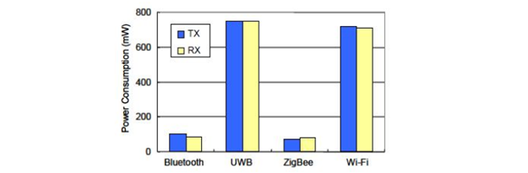
Figure 4.9: Normalized energy consumption for Wireless Modules

We concluded that WiFi and UWB are too power-hungry, and way more powerful than what our system really needs. We will mainly be connecting these only to our multiple sensors, which use up only small data rates. Looking at ZigBee and Bluetooth strengths and weaknesses for industrial applications, ZigBee can meet a wider variety of real industrial needs than Bluetooth due to its long-term battery operation, greater useful range, flexibility in a number of dimensions, and reliability of the mesh networking architecture. ZigBee is preferred for use with networks comprised of many sensors and low-power components with low-sized data rates. The network provided is also very robust and makes it easy to add and remove nodes from the network. From our comparison analysis, we were able to narrow down our choices and prefer ZigBee for our Autobott.

After trying to set up ZigBee to work with the Autobott and having difficulties with testing the wireless connections, the group decided to switch to a Wi-Fi module instead. There are more libraries available, and we recognized that the tx and rx pins were switched on the zigbee chip, along with a couple other complications. The Wi-Fi module chosen was the Hi-Link HLK RM04 Wi-Fi Module. It follows the IEEE Wireless Standards 802.11n, 802.11g, and 802.11b while running on 5 volts. It covers a range of up to 100 meters and can connect up to twenty devices simultaneously.

4.2.2 Software Decisions - The first software decision was dealt with creating a web app using a MEAN Stack, which consists of MongoDB, Express, AngularJS, and Node.js, or create a simple website using Hypertext Markup Language (HTML), Cascading Style Sheet (CSS), JavaScript (JS), and Hypertext Preprocessor (PHP) to integrate the database of plants with the website. Group members were familiar with both technologies, so the decision was based on preference and ease. A MEAN Stack would allow for dynamic web pages that could display an assortment of data through Node.js, but for the scope of the project that is too much. It would be easier and more efficient to make a static website with a few pages of data.

The next software decision dealt with which choosing a web server. Typically an Apache HTTP server is used when HTML and PHP are. No group members have experience with web servers so the Apache server was chosen. This server can be run directly from a group member's laptop or computer as long as it is connected to a public network.

The second decision was deciding which database to use. The two choices were MongoDB and SQL because there was familiarity with both technologies among the group. Ultimately we chose to create the database using SQL because we would not be using a MEAN Stack.

The third decision dealt with which microprocessor IDE to use. We were indecisive about the MSP430 microprocessor and the ATmega2560 processor used for Arduinos. Depending on which microprocessor, we would either be using Code Composer Studio or the Arduino IDE respectively. After extensive research, we found that the MSP430 board does not have enough memory to support all the sensors, nor does it have an internal Wi-Fi module. Therefore we decided to use the ATmega2560 microprocessor and the Arduino IDE, which is open source and contains an extensive library of functions for various sensors.

5. Project Hardware and Software Design Details

The project hardware and software design details are a summary of the content listed in section 3 and 4 mentioned above, but also goes into depth of the design issues faced during this project and what was accomplished through our design. The components are described in further detail with actual numbers and specifications that back up the design decisions. The reader will learn about the science behind gardening, the mechanics behind the hydroponics system, and what makes the Autobott a high tech indoor smart garden. All research, diagrams, tables, figures, and datasheets related to the components specifications for the project will be available in the necessary sub-section and also Appendix B.

5.1 Hardware Design

The Hardware Design dictates what the cabinet will look like and part parts will be functional to interact with the software. In this section the different hardware components are listed and each subsystem is explained in detail.

5.1.1 Master Parts List/Discussion - Below is a table of the master parts list, Table 5.1. This table holds information about the different sub-sections of the Autobott and the parts and materials that are associated with them. We also have provided the description or part number so a manufacturer and user will know where to find it. All of these items are also listed in the budget and bill of materials section of the paper.

Sections | Parts and Materials | Description/Part number
Sensors | pH sensor | LINK
 | EC sensor | Conductivity Kit
 | Water level sensor | ^
 | Air temp. sensor | LINK
 | Humidity sensor | ^
 | CO2 sensor | SainSmart MG811 (Optional)
Infrastructure | Plywood, lumber | Purchased through hardware store
 | Plexi glass | Purchased through hardware store
 | Glue/tape/staples | Purchased through hardware store
 | Screws/nails | Purchased through hardware store
 | Wires, cables, tubing | Purchased through hardware store
 | PVC pipes | Misc sizes
 | Wheels | RH-9005-SET-A
Components | MCU's (msp430) | MSP430G2553
 | Solid StateRelays (4) | SRD-05VDC-SL-C
 | Darington driver 8 channel | ULN2803
 | Wifi Module | Hi-Link HLK RM04 Wi-Fi module
 | LED lights | AeroGarden 300W(180W actual) Light
 | Power materials * | Designed in webench
 | Air pump, air stone | Active Aqua AAPA15L
 | Water pump | submersible
 | HVAC | 4 inch inline fan- 23FAN008-4-160
 | De-humidifier | Eva-Dry EDV1100 (pettite)
 | Reservoir | 20 Gallon Bucket
 | Nutrient pump | Item# 7374941 (includes 3)
 | Grow pots | 3-5 inch netpots
 | Plant trays | Plastic hydroponic tray
 | Misc. PCB components | Capacitors, resistors, voltage regulators..etc
Extra | Nutrients | General Hydroponics Flora Series
 | Mylar | 50 x 25 Standard 2mil Mylar dl-111025
 | Grow rocks | hydorton pebbles
 | Unaccounted materials | Misc parts
Table 5.1: Master Parts List

5.2 Subsystems

5.2.1 HVAC - To cool the Autobott a strong exhaust fan will be used to expel the warm air inside and bring in cooler air from the room it is in. The air will be brought in through the lower portion of the grow chamber through a backdraft damper. Hot air that builds up inside the cabinet will tend to rise towards the top, this is also where the light, the main source of heat is located. The exhaust fan will be placed towards the top of the enclosure expelling the heat up and out. This fan must also generate enough pressure to open the backdraft dampers to pull the air in.

Movement of air is measured in cubic feet per minute, or CFM. Most fans are also rated with a CFM allowing the user to determine if the fan is strong enough for their needs. in our case and from research from other grow rooms, we decided that the cabinet should circulate the air inside three times every minute. To calculate we determined the volume of our grow chamber, rounded up to be 32 cubic feet, then multiply by 3 since we want to move 32 cubic feet 3 times, resulting in 96. Now we want to move 96 cubic feet of air every minute so a fan rated at 96 CFM will be needed. However, this number does not take into account air resistance encountered from the backdraft dampers or obstacles such as the plant growing inside or any air filters in the intake and exhaust. Considering these variables, a 50% increase to 140 CFM was decided.

Axial, squirrel cage, and inline are the three types of exhaust fans available for our cabinet. Axial fans are traditional fan blades that spin on an axel. They are small and very quiet however most that fit our design size are too weak, ranging from the low 60CFM up to 110 CFM. To achieve a higher cfm, several axial fans must be stacked in series with each other to increase CFM, or increase the total size of the fan, which is not an option for our cabinet size. Squirrel cage fans, or centrifugal fans, are shaped like a squirrel tail with an intake and exhaust. These fans pull in air through the circular intake, which is then pushed and expelled by multiple blades along the wheel. Squirrel cage fans range from small CPU fans up to 800+ CFM for grow rooms. These fans while very efficient tend to be very loud for their size and CFM rating.

Inline fans are the fan of choice by many grow rooms and cabinets. Their circular tunnel design allows air to enter through one end and exit the other with very low noise during operation. These fans can also be connected in series with ducting to guide airflow in the desired direction as well as air filters to filter out unwanted particles. For our calculated rating of 140 CFM, a 4 inch flange inline fan is the perfect choice. This also gives us extra power if we decide to include the filter in our final design. Figure 5.1 shows a squirrel cage fan next to an inline fan, both rated at 120-150CFM and available from Urban Sunshine. The Autobott will utilize the inline fan, which will be located towards the top, to expel warm air and keep the growing chamber cool.
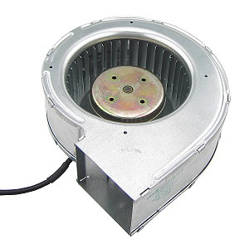
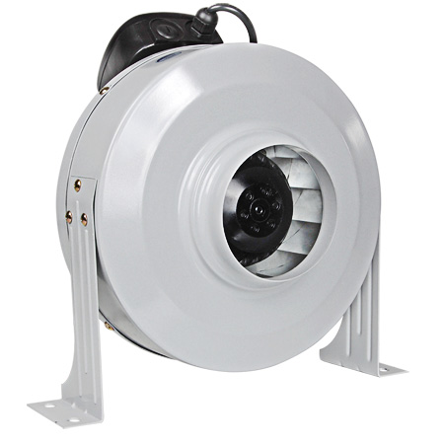
Figure 5.1: Inline Fan (left), squirrel cage fan (right)

5.2.2 Hydroponic Subsystem Summary - The Hydroponic Subsystem is the largest-spanning part of the Autobott. Its components will be housed in all three of the cabinet’s enclosures, and will have to all work seamlessly in order for the project to work properly. This subsystem will cycle through a reservoir of a water and nutrient mix that is pumped through a system of pipes and plant trays to nourish our plant subjects. Our main objective here is to have a low-power, water-efficient cycle that brings the proper amount of nutrients to flourish the plants. In this section, we will delve deeper into our hydroponic design. To do so, we will discuss how all of the parts in this system interact and fit together, we’ll talk about some of the design obstacles we will overcome, and we will give further details into each of the subsystem’s components. As we discuss each part here, we will follow the planned hydroponic cycle around our design, beginning and ending at the water reservoir. Below in Figure 5.2, you can find the design of our hydroponics system.

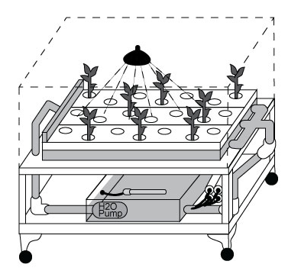
Figure 5.2: Picture of the hydroponic system design

Water Reservoir - The biggest component to our bottom compartment is the water reservoir. This can simply be any large tub or bin that can hold at least 20 gallons. The reservoir must have a lid to cover the entire water and nutrient supply. By covering our water reservoir, we will greatly slow down the expected water evaporation, and will block any light from getting in to the box to prevent any algae or fungus from forming inside. We found countless plastic storage bins that fit all of our requirements, along with being free of carcinogens and harmful chemicals that may wash off into our water supply. The water reservoir is large enough to hold our 20 gallon water supply, along with an extra 10 gallons if needed due to the system’s scalability.
H2O Submersible Pump - One of the most important parts of our Autobott is the submersible water pump that we will be placing within our water reservoir. If our water cycle is a circulatory system, then this pump will be acting as the system’s heart because we are relying on it to push our nutrient mix throughout the cabinet. It’s crucial to have a pump that can push enough water to cycle through the reservoir’s contents once every two hours, while also compensating for the upwards head height (between the reservoir and the plant trays) that the water needs to be brought up to. Like we mentioned earlier in section 4.1.1.3, the head height played a big part in choosing which pump we use because we would need more powerful torque for larger head heights. According to our current design, we are anticipating somewhere from 2.5 to 3 feet or so of head height, and to compensate, we are looking at using the Active Aqua 400GPH Submersible Pump. The owner’s manual included with this pump depicts in Figure 5.3 the head heights for the entire line of pumps made by Active Aqua. As shown in the table, we can expect around 250 gallons per hour being pumped.

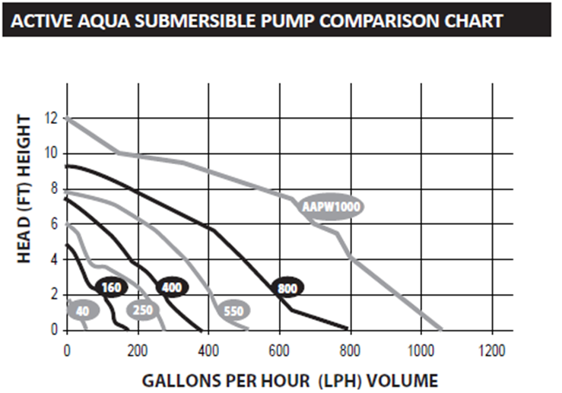
Figure 5.3: Actual Gallons per hour at various head heights

While we needed a powerful pump to overcome the head height, we don’t want something too powerful, or risk flooding and overflowing in our system. This pump fits us well though, because it includes in its functionalities a way to reduce the water flow. There is a flow control knob that, when turned, will reduce the flow if needed. We will be placing this unit on the bottom of our water supply in a location that theoretically won’t interfere with the sensors we are also positioning within our reservoir.

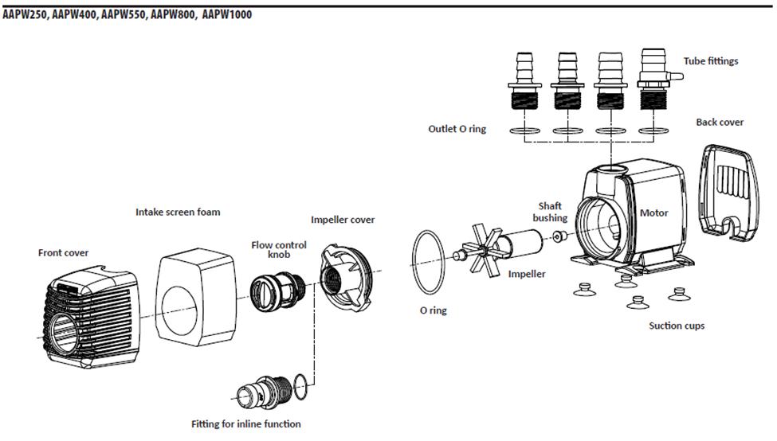
Figure 5.4: Complete Physical Teardown of the AAPW400 Submersible Pump
Shown above, in Figure 5.4, is a teardown of the pump we are choosing. One can see the inner mechanics of the pump, the impeller that pulls water through, the flow control knob, intake screen, and the physical outer casing for the pump. Also shown in the breakdown, are the three different-sized tube fittings that can be swapped out to accommodate a large array of tubes and hoses. This is perfect for our cabinet, and allows us to pick and choose our water hoses without worrying what will fit on our pump. We will more likely be choosing the hose size due to the plant trays and our connections we are fitting on them.
The AAPW400 submersible pump runs on 120 Volts of power, to be supplied by a standard electrical wall outlet. This unit also comes built with a standard power cord that will fit any American electrical socket. It will be using 25 watts, and has a maximum amperage of 0.22 amps. Our pump weighs only one pound and fits into our water reservoir with no problem, standing at 8.4 inches long, 3.5 inches wide, and 5.8 inches tall.
This is a great pump and a quality machine, but there are many stresses that it may be placed under. First of all, it is a submersible pump, meaning that it is to be run underwater. Major damage will be sustained by the motor if it’s ran dry, but this shouldn’t be a factor at the bottom of our reservoir, unless the user fails to replenish the water on the rare occasions that it’s needed. Our “Nutrient Film Technique” hydroponic system calls for a constant flow of nutrient mix. This requires the pump to be powered on the entire time that plants are in the cabinet in order to supply water and minerals. If the pump breaks down or fails for any reason, the plant trays will end up draining and the crops will begin to suffer while sitting in a dry grow tray. This can leave a lot of stress on our solitary pump, so it requires some monitoring just in case it ceases to run. We will use caution in our cabinet, and we chose this pump because of the great reviews it received and how people labeled it reliable and dependable.

Water Pump Hose and Water Splitter Connection - Our pump will be sitting at the bottom of our reservoir, submerged within our nutrient mix. To bring the water its pumping to our plant trays above it, we will be attaching a water tube directly to our unit. The pump comes with a variety of different-sized hose fittings, which can accommodate for 1/2 inch, 5/8 inch, or 3/4 inch diameter tubes. Thanks to the adaptability of our pump, we are left with a ton of options regarding how we will split the water flow into the separate plant trays. Our primary viable option is to hook up a 3/4 inch diameter tube to the pump, and run the water up to the main plant enclosure where it can be attached to a multi-way hose connector similar to the one shown below in Figure 5.5. Once connected to the splitter, the water flow will be divided into however many directions we choose. The splitter featured below has on/off valves fashioned to it, which will either block or open the flow into the corresponding valve. According to our design, we anticipate only using two or three plant trays at first, and possibly adding more. This 4-way connector is perfect for the cabinet because of how easy it is to add on a tray or take one off. The on/off valves also allow us to take out a plant tray in order to replace, harvest, or tinker with individual plant containers without turning off the pump or disruptions to the other plant trays.

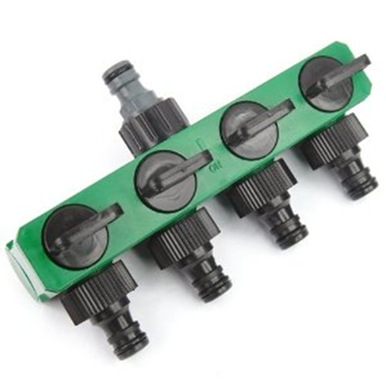
Figure 5.5: The Four-way hose connector splitter
Our cabinet design’s goals revolve around a low-cost design that allows for scalability in the number of plants and trays we can place inside. The above hose connector splitter is listed online for more than we were hoping to spend on a connector. It turns out to be on the higher end of what we want it to cost, but still well within our range. It will most likely be featured as part of our final product, but if budgeting problems or other unseen things arise, we have other low-cost and highly viable options.

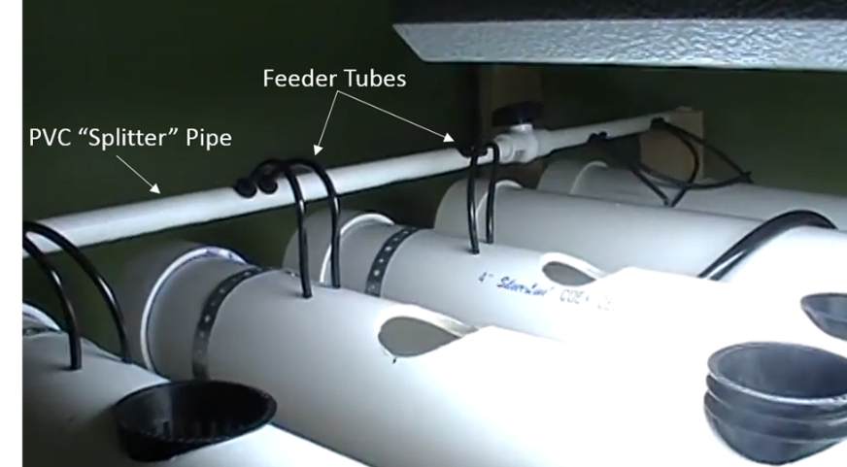
Figure 5.6: An easily created PVC water splitter layout

Shown in Figure 5.6 above is a structure that is very similar to our secondary plan if any problems arise with our first. In this configuration, our water pump tube is connected to a thin PVC pipe that is ran across perpendicularly to the growing channels. Water sent from the reservoir fills this thin pipe, and just like the hose splitter, we will have small feeder tubes protruding from strategic positions that will deliver the nutrient mix to each plant channel, just as our first option did. It’s also very easy to add flow control valves to control individual sections of the thin PVC pipe to help with the scalability of our interior cabinet. Both of these configurations are relatively inexpensive, and fully functioning viable options for our system.

Multipurpose Grow Trays and Plant Nets - After our pump pushes up the nutrient mix to the main enclosure, the flow is split into individual channels that are fed into each of our grow trays. This is where our plants will be housed and where the nutrient mix will be a constant flow to deliver the proper minerals and life-giving substances to our plants. From our design, we gave the grow channels three and a half feet to run across the cabinet. To maximize our yield, we will place as many multiple channels side-by-side that the enclosure’s depth will accommodate.

This configuration calls for grow channels that are long and narrow. Shown below in Figure 5.7 is one of our potential grow trays. Since the design is narrow and long, it is susceptible to bending once our plants and water are inside. The grow medium that holds the plants will absorb some of the running water, which will add greatly to the weight of the nutrient mix flowing through the grow channels. It’s important to note that it is constructed from thick, durable, high-impact ABS that prevents the tray from bowing or sagging under this added weight.

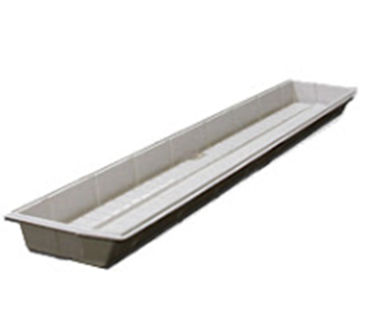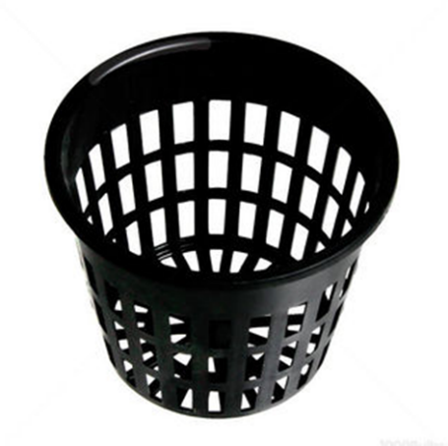
Figure 5.7: Our narrow growth channels Figure 5.8: The plant grow nets

These channels will be covered by a lid in which we will drill 2-inch holes to place our plant’s grow net cups, which are shown above in Figure 5.8. These grow nets are positioned in series along the top of our grow channels. After placement, they will hang inside the tray, just above where the nutrient mix is streaming by. We must note that before placing the plants into these grow channels, we must germinate the seeds so that the roots are already protruding. Otherwise, the seedling will be unable to reach its life-sustaining nutrient mix. The plant grow nets have plenty of openings and holes in it to allow the roots to grow outwards and downwards. We will fill the inside of each grow cup with the plant’s grow medium, along with the germinated seedling.

Drain Fittings and Drainage Pipes - As our nutrient mix is run through the grow channels, it will need an outlet. At the bottom end of each grow channel, we will drill another smaller hole. In this hole, we will fix a drain fitting, shown in Figure 5.9. These drain fittings come with the actual drain hole, two o-rings to prevent leaks out of our system, and a riser so that we can adjust how high the nutrient mix stream runs before it is drained out.

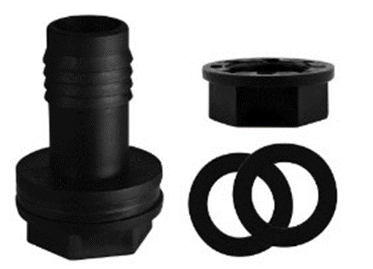
Figure 5.9: Drainage fitting with riser and o-rings
There are a couple concerns that arise with this design, both of which can be avoided or easily dealt with. One is the plant roots. Throughout our plant specimens’ lives, their roots will continue to grow along the nutrient-rich bottom of our plant growth channels. While it is an extreme case, these roots may grow too much and cause some blockage to the drainage pipes or other parts of the system. This can be avoided by checking on the roots, and doing some strategic trimming if needed. Another concern is the outflow of our nutrient mix. We need to make sure that the inflow isn’t too much greater than the amount of water escaping. If this is the case, the channels can become flooded and eventually overflow. This problem can be overcome by either reducing the pump’s power, or adding an overflow channel on the sides of the plant trays to catch any excess water before the tray fills up.
These drain fittings will be positioned in the holes we drilled in a similar fashion to the one shown below in Figure 5.10 that is placed at the bottom of the grow channel. As one can see, the drain hole is only slightly above the tray’s bottom. We can adjust this using risers if we so choose. Underneath the tray’s bottom is an o-ring to prevent leakage, and a plastic nut to keep the drain in place. There is also a one-inch diameter extension that runs out for an outlet tube to be attached.

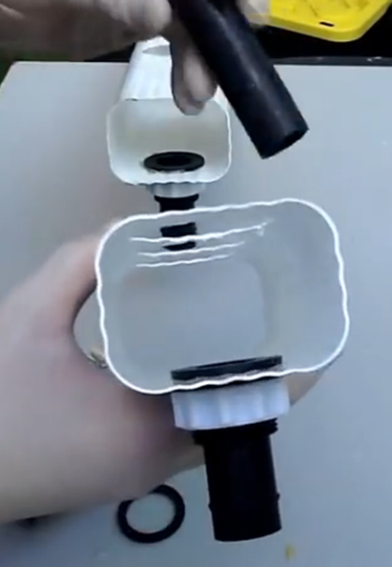
Figure 5.10: Configuration in which we will place our drainage fittings

Our planned design calls for each channel’s drainage extension to be fitted with either a PVC pipe connection, or another water flow tube. With either fitting, it will be leak-proof and snug with the 1-inch diameter drain outlet. As shown in the Figure 5.11 below, each outlet will travel back downwards towards the reservoir and connected back together by either a PVC pipe T-junction, or a tube junction connector.
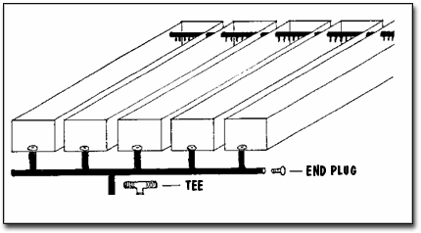
Figure 5.11: Configuration of drainage pipes that will lead back to the bottom enclosure
Nutrient Pumps / Nutrient Reservoir - The drainage pipes coming from the grow channels will travel down out of the primary plant enclosure, and into the bottom compartment that contains our reservoir, nutrients, and pH up/down solutions. Along the way back to the water reservoir, these drainage pipes will pass by the nutrient reservoirs. At this point, we will have small tubes running from the nutrient solutions, being injected into the stream of draining water. In doing so, we have an extremely simple and viable way of fully mixing the minerals and pH-altering solutions into our huge water reservoir. This configuration is fairly simple, and is illustrated and shown below in the Figure 5.12. According to our design, this will help us avoid having a poorly-mixed nutrient supply for the plants.

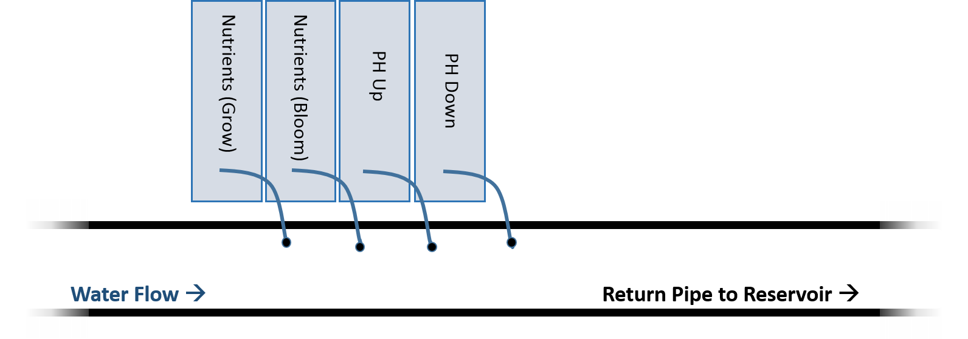
Figure 5.12: A simple illustration of the Nutrient Delivery System into the return drainage pipe. Tiny holes will need to be drilled into the PVC pipe to fit the small delivery tubes

Also within the bottom compartment, we will fix some closed, upside-down dripper containers in order to house the plant nutrient mixes and pH Up/Down. From these, we will run tiny, flexible 5 millimeter-diameter tubes that will connect to small peristaltic pumps, shown in Figure 5.13.

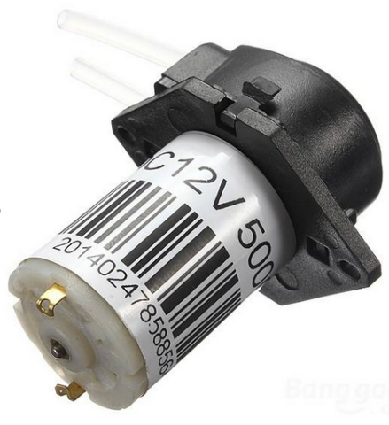
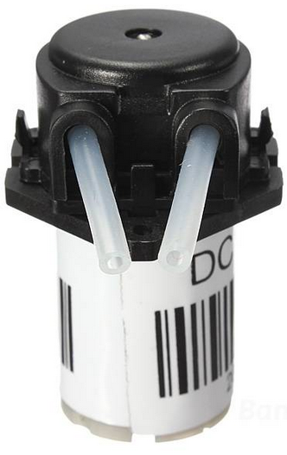
Figure 5.13: Peristaltic pumps we will be using to drip our nutrients and pH-altering solutions into the water mix
These small low-power pumps run on a 12V DC supply, and when running, will output about 1 milliliter of solution per second, and can push more or less depending on if the input voltage is increased or decreased. We will attach a positive and negative wire to the small metal nodes positioned at the bottom of the pumps shown in the figure. We can alter the amount of flow per second that these pumps push by increasing or decreasing the voltage across these two nodes. It is also possible to reverse the flow simply by switching the positive and negative wires on the pumps.
Our peristaltic pumps will all be fixed to a small stand inside the bottom enclosure to keep them from shifting around. Also fixed in the bottom enclosure, will be the nutrient reservoirs. This will be simple containers in which we can insert the tiny dosing pump tubes to suck out the nutrient solutions.

Sensors and Airstone - While the physical hydroponic system and water cycle is crucial to our project, it is only half of the entire system. Our cycle can run by itself, but it will need help maintaining itself. That is where the sensors, relay switches, and other electric components come into play. We will be positioning various sensors within each of the different compartments. A signal is sent from the Microcontroller to each sensor. The sensors then measure their respective data types and then send those results back to the MCU to be interpreted and stored.
Within the water reservoir, we will be placing three sensors: a pH Sensor, a water level sensor, and an Electro-Conductivity sensor. We will adhere each of these sensors along the walls of the reservoir, each spaced out from one another so that there won’t be any interference between them.
Our first sensor, the pH Sensor, will measure the level of acidity of the reservoir. Generally the livable range for crops is anywhere between 5.5 and 6.5, but before adding this meter to our system, it must be calibrated by being placed into a standard, 7.00 pH solution. The proper level of nutrient mix will also be added to the reservoir, since adding elements and minerals will have alter the pH level in our water. The pH meter will be submerged entirely into our mix, which is not a problem since it is waterproof, and made out of glass so it won’t rust or corrode. The pH sensor we chose, the Analog pH Meter by DFRobot can accurately measure the pH at varying degrees of water temperature, so that won’t be a factor in the placement of our sensor.
This sensor will be programmed to send data about the pH to our microcontroller in regular intervals. The sensor will connect to one of the I/O pins on the microcontroller sitting inside the electronics compartment, which will recognize the pH meter’s data and calculate the water reservoir’s pH level to be compared with our range of accepted values. If the value received is out of our provided acceptable range, then the microcontroller will turn on the proper relay switches connected to the nutrient delivery subsystem. At this point, the peristaltic pump connected to either the pH Up or pH Down supply will be activated for only a few seconds. During that time, just a few milliliters of the solution will be injected into the water reservoir in an attempt to correct the pH. Since it takes some time for the entire water supply to mix, the pH reading will be taken again after 15 minutes have passed. This process will repeat several times until our pH is back into the acceptable living range. Shown below in Figure 5.14 is the pH sensor itself, and in Table 5.2 are the specifications for the sensor.

Module Power | 5.00 V
Measuring Range | 0 – 14 pH
Temperature Range | 0 C – 60 C
Accuracy | Accuracy ± 0.1pH
Response Time | ≤ 1min
Table 5.2: Specifications for the pH meter

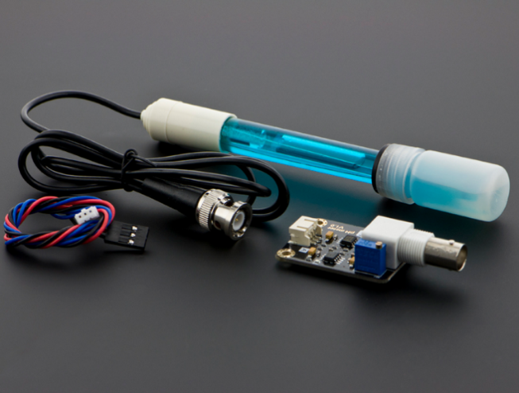
Figure 5.14: Analog pH Meter
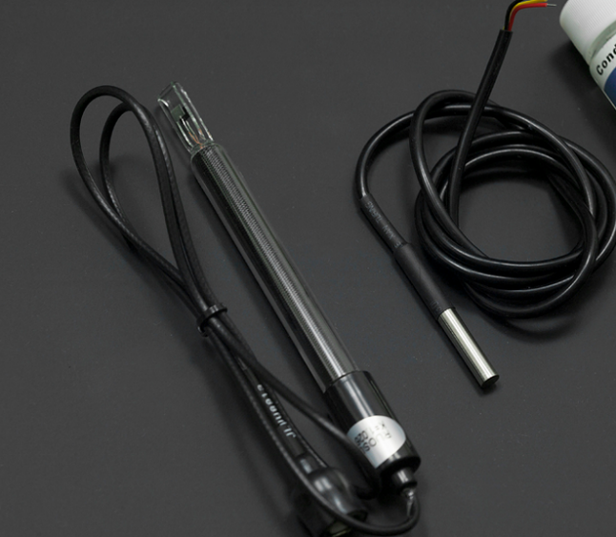
Figure 5.15: Analog EC Sensor
The next sensor we are including inside the reservoir is the Electrical Conductivity (EC) Sensor. This, like the pH meter, is a probe that is inserted into the water and is shown above in Figure 5.15. The EC sensor is different though, in the fact that it will measure the total dissolved nutrients in the water, measured in Siemens per meter (S/m). This reading is taken as the current between the sensor’s two prongs. The value of this current will change and alter as more or less nutrients are present in the water.
Also similarly to the pH meter, this EC sensor will be connected to our microcontroller via analog I/O pins, where it will send its readings in regular intervals. If the microcontroller reads the data for the water’s conductivity and determines it’s out of our acceptable range, it will switch on the relay pertaining to one of the peristaltic pump. This pump will be hooked up to the proper nutrient solution, and will run for a few seconds, dripping a regulated amount of our nutrients into the water reservoir. The system will wait fifteen minutes as our solution mixes, and the Electric Conductivity reading will be taken again. The process will repeat until our EC is within the acceptable range.
There isn’t an apparent way to remove nutrients from the water, but we can add more distilled water to the system to lower the nutrient density. The problem of flooding and overflowing would arise though, if we were to keep adding water whenever the nutrients become too abundant. Luckily, the plants will be taking nutrients out. To help keep the solution at its optimum level without having to add purified water, we will calibrate the range to have the pumps stop at lower levels of nutrient mix so this will not pose as a future problem.
Before we insert the EC probe into our system, we must calibrate it. This is done by stirring the probe around a test solution, included in the EC Sensor Kit. Once both the temperature and conductivity are stable, then a measurement will be taken. Shown below are the specifications for the DFRobot Analog Electrical Conductivity Meter in Table 5.3.

Operating Voltage | +5.00 V
Measuring Range | 1ms/cm - 20ms/cm
Operating Temperatures | 5 - 40℃
Accuracy | <±10% F.S (specific accuracy depends on the accuracy of calibration solution
Table 5.3: Specifications for the Analog EC Sensor
The final sensors that will be housed by our water reservoir is the water level sensor. These Water Level Sensor Switches are shown below in Figure 5.16, and will be used to notify the user when the reservoir’s water level is too high, or too low. To monitor the water level, we will attach two liquid water level sensor switches: one will be placed towards the top of our reservoir, and the other will be placed at about one-fourth water level in the reservoir. The water level sensors have cables built in that will run out of the reservoir, and directly connect to our microcontroller. These sensors include a moving floater that, when the water rises past it, will rise up and send a signal through the wires to our microcontroller. The bottom sensor should always be submerged, and it will be noted as “regular” for this signal to be coming through. We will have the system alert the user to refill the reservoir when this signal ceases. The top sensor shouldn’t ever be submerged. If this sensor starts sending its signal, our microcontroller will alert the user to either empty the reservoir or take some water out. These sensors will just be used for passive system alerts; no electric components will be activated due to these water level sensors.

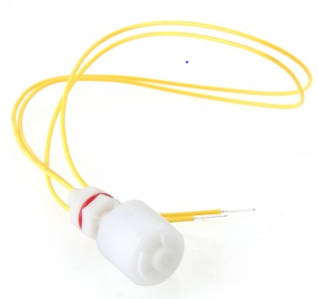
Figure 5.16: Water Level Sensor with floaer head
These sensors are low-power machines, extremely cost-effective, and get the job done of monitoring water level. They are designed to be in contact with water and shouldn’t have any problem running. The only downside is that a manual inspection will need to be done in order to check if they’re still functioning. Shown below in Table 5.4 are the specifications for our water level sensors.

Cable length | 30.5cm
Maximum load | 50W
Max switching voltage | 100V DC
Minimum voltage | 250V DC
Maximum switching current | 0.5A
Max load current | 1.0A
Temperature range | -20°C - +80°C
Table 5.4: Specifications for Water Level Sensors

5.2.3 LED Lights - The light of choice for the Autobott is the 300Watt (180 actualy watt) LED grow panel light from mars hydro. This is a full spectrum grow light and will be used from start to finish. It consists of 100, 3 watt led diodes ranging in full spectrum. This light covers a footprint of 7.5 square feet, which is perfect coverage for our growing chamber. The LED lenses are angled at 90 degrees, which helps in the distribution of light for the footprint. Built in PC fans help keep the already low temperature grow light cool. operating with minimum noise. it is recommended to test the light for 24 hours to ensure proper function and that each LED diode is illuminated. Figure 5.17 shows the MarsHydro 300 watt LED grow panel light.

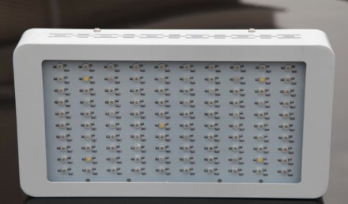
Figure 5.17: MarsHydro 300 Watt LED light (off)

5.2.4 Power - The Autobott will be connected to a home outlet at all times, which will power the lights, fans, pumps, sensors and MCU. The LED light, HVAC fan and water/air pumps will be powered directly from the outlet, being triggered on or off through relays controlled by the MCU, while the AC voltage from the outlet will need to be transformed to DC and regulated to lower voltages for the printed circuit board. Figure 5.18 shows how a power strip can be controlled with a relay circuit connected to the MCU. The last socket is "Always on" and will be the one we use to power the PCB. Once regulated, other integrated circuits within the PCB use this voltage to regulate the voltage for other components.
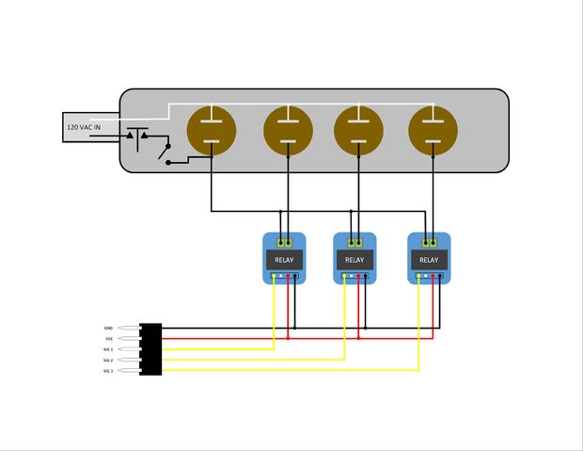
Figure 5.18: Relay controlled pwer strip

AC-DC - Using Texas instruments webench power designer, the input voltage is set to 110V-130V, output voltage set to 12V and output current of 2Amps. This will be the external power supply that will supply the PCB with 12V DC, which will then be regulated different values for other components. After choosing a small footprint design and high efficiency, Figure 5.19 shows the circuit schematic of the external power supply. A 2.1mm barrel power jack will be used to connect the power supply to the PCB. the 12V output will be used as the main power rail on the PCB and will use star distribution to branch out to other voltages.

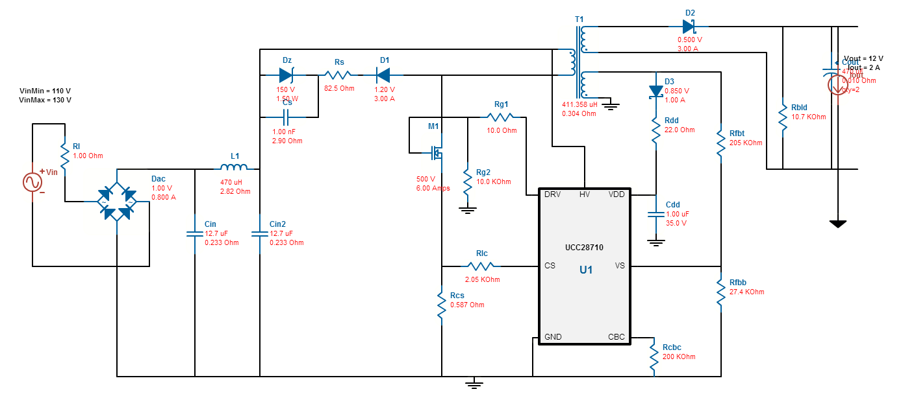
Figure 5.19: Power supply circuit, designed in webench
Table 5.5 shows the bill of materials from Texas instruments for the power supply, some components being custom.

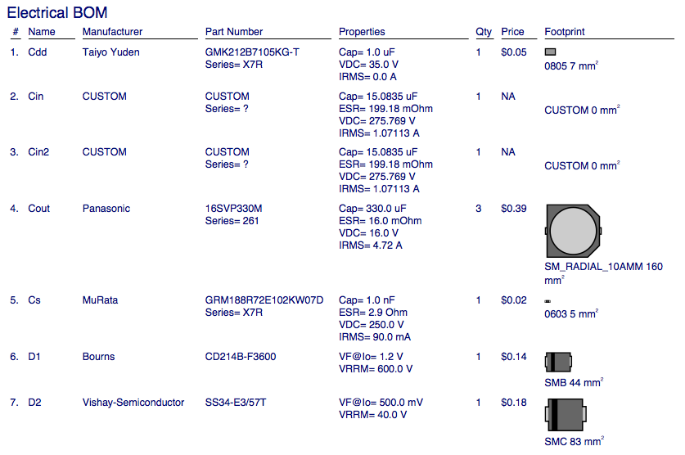
Table 5.5: BOM for power supply

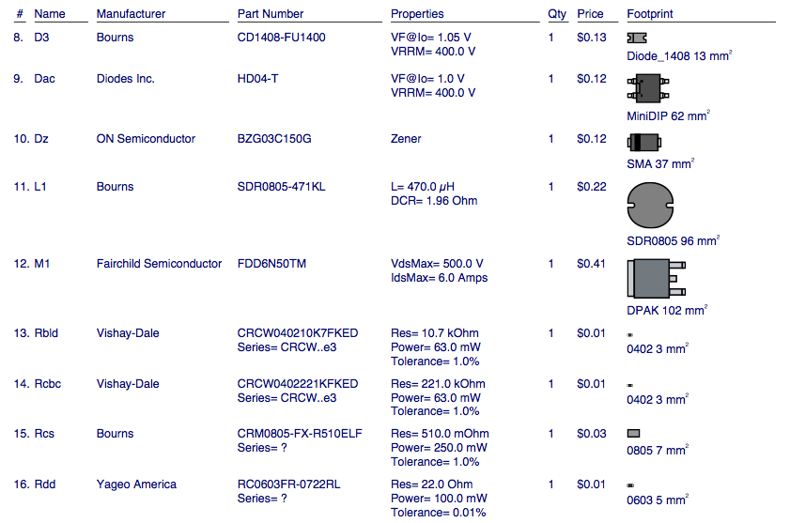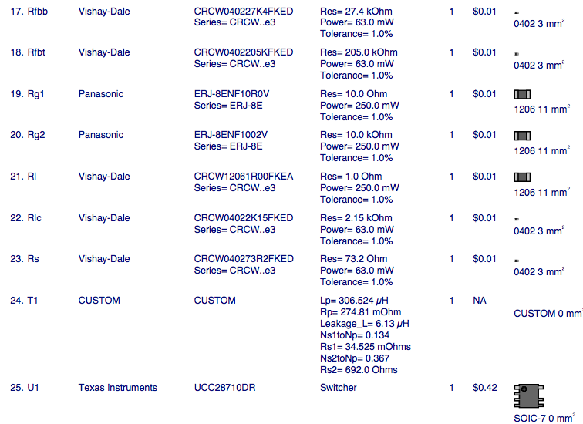
Table 5.5 continued: BOM for power supply

DC to DC - The 12V from the power supply will be used as a main power supply and branch out to other regulated voltages. We will use this 12V rail but also need 3.3V power supply for the microcontroller and electric conductivity circuit, and 5V power supplies for the temperature sensor and pH circuit.

From the power supply, the 12V is passed through the step down (buck converter) and regulated down to 3.3V to supply to the loads. Figure 5.20 shows the circuit schematic for this switching regulator.
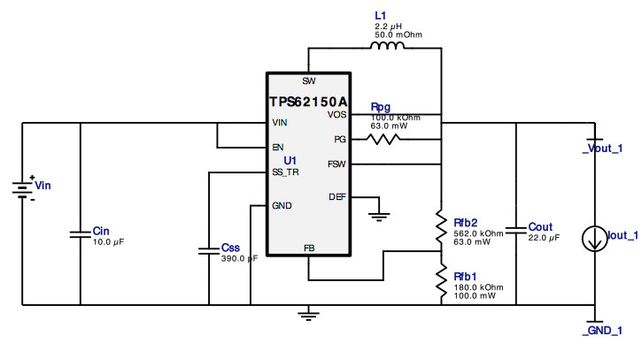
Figure 5.20: 12V-3.3V voltage regulator circuit designed in webench

Table 5.6 shows the bill of materials from Texas Instruments for the 12V-3.3V voltage regulator circuit.

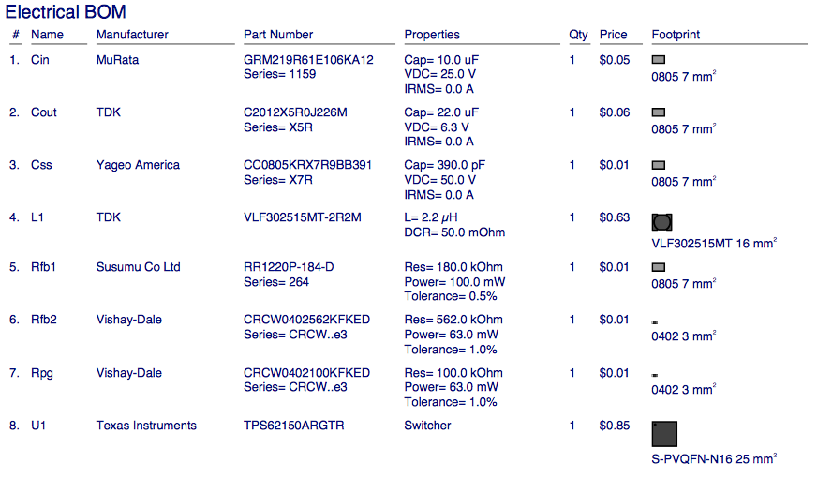
Table 5.6: BOM for 3.3V regulator circuit

From the same 12V rail, we designed a regulator circuit to output 5 Volts to power the temperature sensor, pH circuit and drive the relays. Figure 5.21 shows the schematic for this regulator.

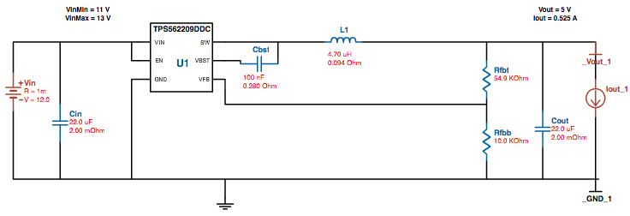
Figure 5.21: 12V to 5V voltage regulator circuit designed in webench

Table 5.7 shows the bill of materials from Texas Instruments for the 12V-5V voltage regulator circuit.

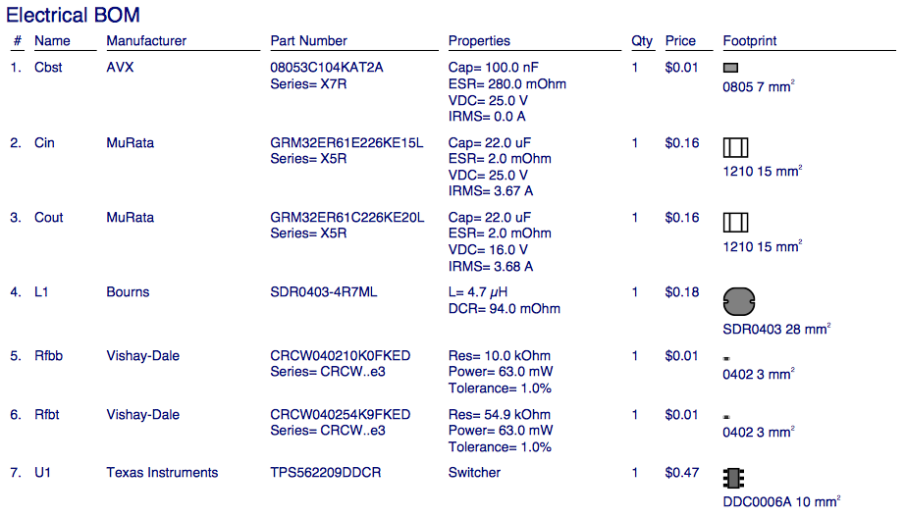
Table 5.7: BOM for Voltage Regulator Circuit

5.2.5 Sensors

Sensors and their interaction with the microcontroller are vital to this project. A signal is sent from the MCU to each sensor. The sensors then measure their respective data types and then send those results back to the MCU to be interpreted and stored. This section describes the requirements and specifications for the sensors chosen for the Autobott. These sensors include PH, Temperature and Humidity, EC, Water Level, and CO2.

5.2.5.1 PH Sensor

The pH sensor interacts with the Hydroponic subsystem. It measures the pH, or level of acidity, of the water in the reservoir used for the plants. Measuring the pH level at consistent intervals allows for any corrections to be made if it falls out of the acceptable range of values. As mentioned previously, the acceptable range of values for various kinds of plants lies between a pH level of 5.5-6.5.

The pH sensor will be connected to an I/O pin of the microcontroller. The microcontroller's I/O pin will be programmed to recognize the pH meter and receive a voltage that signifies the water's pH level. This value will be compared to the program's range of accepted values, and if the found value falls out of range, the program will notify that the pH is either too low or high and action will be taken to correct it.

The probe must be able to be submerged for extended periods of time while accurately providing readings. As previously mentioned, glass diode pH probes are the most effective in measuring the pH level over these extended periods. The probe also must be able to accurately measure pH at varying degrees of water temperature. To calibrate the pH sensor for accurate readings, the electrode probe must be placed into a standard solution whose pH value is 7.00, or neutral.

Table 5.8 shows the specifications of the Analog pH Meter Kit manufactured by DFRobot.These specifications fit the requirements for a pH sensor, as listed above.

Module Power | 5.00 V
Measuring Range | 0 - 14 PH
Measuring Temperature | 0 degree C - 60 degree C
Accuracy | ± 0.1pH (25℃)  Note: More accurate readings will occur with a voltage as close as possible to 5V.
Response Time | ≤ 1min
Table 5.8: Specifications for pH Sensor
The Analog pH Meter Kit measures pH between the temperatures of 32 and 140 degrees Fahrenheit, which is within the temperature ranges of the grow environment.The module is low power at 5 Volts, and provides accurate readings of the pH level. It also has a relatively fast response time of less than a minute.

The pH probe is interfaced with a secondary circuit before the sensor readings reach the microcontroller. This concept is shown in the schematic for the kit is shown below in Figure 5.22.

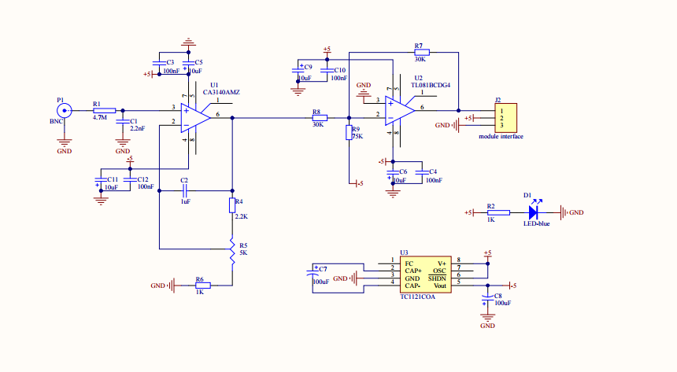
Figure 5.22: Schematic of the DFROBOT Analog pH Meter Kit. (Consent to reproduce figure requested)

5.2.5.2 Temperature and Humidity Sensor - The function of the temperature and humidity sensor is to allow the hydroponic system to have knowledge about how hot or cold it is, as well as how much water is in the air. These pieces of information are vital to a plant's growth. As previously mentioned, the sensor is very small and will be placed below the light and around the plant canopy to ensure that the readings are accurate for the immediate surrounding area. The chosen sensor is the DHT11 Temperature and Humidity Sensor, which features a calibrated digital signal output. The specifications of the DHT11 are shown below in Table 5.9.

Measurement Range | 20 - 90% RH @ 0 - 50℃
Temperature Accuracy | Min: ±1℃  Max:±2℃
Humidity Accuracy | Condition: 25℃  ±4%RH  Condition 0℃-50℃  Max: ±5%RH
Humidity Response Time | Condition: 1/e(63%)25℃， 1m/s Air  Min: 6s  Typical: 10s  Max: 15s
Temperature Response Time | Condidtion: 1/e(63%)  Min: 6s  Max: 30s
Table 5.9: Specifications for the DHT11

The temperature and humidity sensor will connect to the I/O pins on the microcontroller. Figure 5.x (featured below), shows how the circuit between the DHT11 sensor and microcontroller. The sensor will measure both the temperature and humidity and send a signal back to the microcontroller with the values. These values will be compared to the acceptable range of values. If they fall outside of that range, the program will notify that the temperature and/or humidity is either too high or too low and actions will be taken to correct them. Figure 5.23 below shows how a DHT11 is typically hooked up to the MCU.

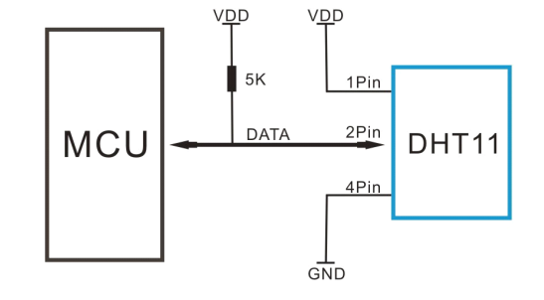
Figure 2.23: Circuit Diagram of DHT11 and (Arduino) Microcontroller. (Consent to reproduce figure requested)

5.2.5.3 Electrical Conductivity (EC) Sensor - The electrical conductivity (EC) sensor, like the pH sensor, is inside a probe which is inserted into the water reservoir for the plants. It measures the total dissolved nutrients in the water, which includes ions from dissolved salts, acids, and bases. The unit of measure for conductivity is Siemens per meter (S/m). The reading from by the sensor is first measured as a current, and then the total dissolved measurement will be interpreted from the conductivity value based on knowledge of the nutrients being supplied.

The electrical conductivity sensor will be connected to the analog I/O pins on the microcontroller and interact with the program written for the microprocessor. It will measure the conductivity of dissolved nutrients in the water and compare it to the accepted range of values of nutrients for those plants. If the conductivity is outside of the accepted range, the program will notify that the conductivity is either too low or too high and action will be taken to correct it.

Like the pH probe, the EC probe must be able to accurately measure the electrical conductivity of the water after being submerged for extended periods of time. It also must be able to operate under varying temperatures. For accurate measurements, the probe must first be inserted into a test solution. Then, the probe should be used to stir the solution, letting the conductive portion of the electrode have full contact with it. When the temperature and conductivity are both stable, then a value can be measured.

Table 5.10 below shows the specifications of the two EC sensors considered for this project.

 | DFRobot Analog Electrical Conductivity Meter | Atlas Scientific Conductivity K 1.0 Kit
Operating Voltage | +5.00 V | +3.3V - 5V
Measuring Range | 1ms/cm - 20ms/cm | 11µs/cm to 92,000µs/cm
Operating Temperatures | 5 - 40℃ | (-20℃) - 125℃
Accuracy | <±10% F.S (specific accuracy depends on the accuracy of calibration solution)  Note: More accurate readings will occur with a voltage as close as possible to 5V. | +/- 5µs/cm
Table 5.10: Specifications of the Analog Conductivity Meter

While the Atlas Scientific Conductivity K 1.0 Kit is more accurate and operates at a wider range of temperatures, it is also very costly. Compared to the DFRobot Analog Electrical Conductivity Meter ($69.90), the Atlas Scientific kit sells for $206.99. For the scope of the project, it is not required for readings to be that accurate. The expected temperatures of the grow environment will also not exceed the ranges of the DFRobot sensor. Therefore, we have opted to use the DFRobot EC meter.

The schematic for the DFRobot meter is shown below in Figure 5.24.

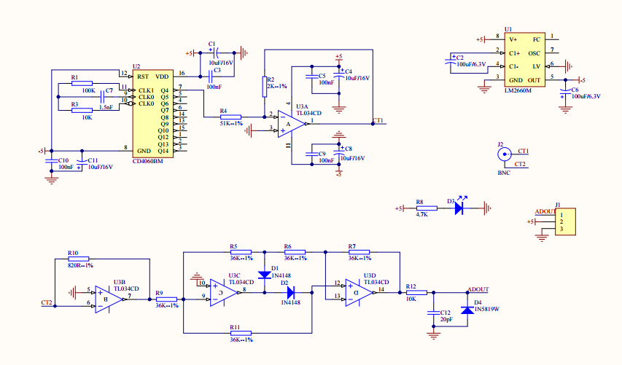
Figure 5.24: Schematic of DFROBOT Analog Electrical Conductivity Meter. (consent to reproduce figure requested)

5.2.5.4 Water Level Sensor - The water level sensor measures the amount of water in the reservoir beneath the plants. If it runs too low, more water will have to be added to so that the plants can absorb the correct amount of nutrients. Water level sensors usually either float on top of the water or are partially submerged and provide alarms for when the water level drops below a certain threshold. The sensor must be small enough to fit in the reservoir without disrupting any of the other sensor's activities, but large enough to accurately measure the water level. The sensor must also be able to accurately operate at various temperatures. Table 5.11 shows the specifications for a liquid level sensor that we have chosen.

Sensor Length | 14.2" (361mm)
Active Length | 12.4" (315mm)
Actuation Depth | Nominal 1.0" (25.4 mm)
Sensor Width | 1.0" (25.4 mm)
Resolution | < 0.01" (0.25mm)
Power Rating | 10V
Temperature Ranges | (-9℃) - 65℃
Table 5.11: eTape Standard Liquid Level Sensor (12-inch)

The eTape sensor has an active length of 12.4 inches, which allow the full length to be submerged vertically in the reservoir with some extra space left. It will sense the hydrostatic pressure applied by the water to the portion of the sensor that is submerged. The sensor operates at a very wide range of temperatures, which will be helpful in dealing with a wide variety of plants. It can be mounted to the side of the reservoir so that is does not interfere with the EC and pH sensors. Figure 5.25 below shows the top of the eTape sensor, and where adhesive can be applied to it to mount it. When mounting, the pins need to be completely insulated because very humid environments may damage the crimp-flex pins.
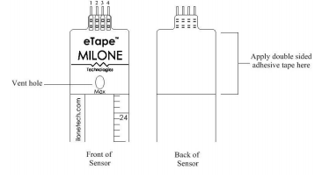
Figure 5.25: eTape Sensor Layout
5.2.5.5 Carbon Dioxide Sensor (was not used in final design) - Plants need varying amounts of CO2 throughout the day. During the light hours, they require much more CO2 than during the evening when there is less or no light. To help regulate the amount of CO2 in the enclosure, a CO2 sensor is needed. The sensor will be placed around the same level as the temperature and humidity sensor, and will measure whether CO2 levels are too high or too low for the plants being grown throughout the day. The specifications for a CO2 sensor supplied by DFRobot are shown below in Table 5.12.

Operating Voltage | +5.00V
Interface | Analog
Temperature Range | Onboard heating circuit
Table 5.12: CO2 Sensor Specifications

Even though the operating voltage is prorated at 5V, the onboard heating circuit boosts the internal power to 6V for best performance. Because of the onboard heating, it lowers the dependency on the temperature and humidity so it can more accurately measure the amount of CO2. The layout for the CO2 sensor is shown below in Figure 5.26.

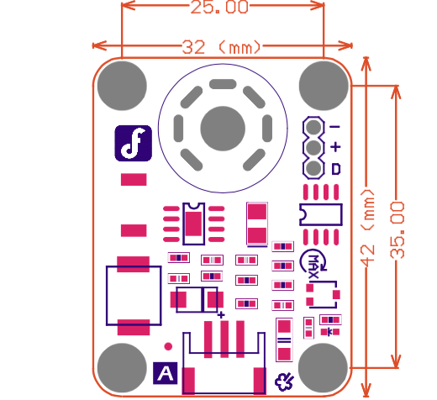
Figure 5.26: CO2 Board and Sensor Layout (consent to reproduce figure requested)

5.2.6 Physical Enclosure - The physical enclosure design was a result of our hydroponics system and objective of the project. The hydroponics system will pump water from the back of the plant trays and drain in the front of the enclosure. We knew that the physical enclosure would look like traditional furniture in the house because we could fit the whole system in a cabinet size and make it look aesthetically pleasing. The physical enclosure consists of a double door on top that opens up to the enclosed environment, a drawer door on the bottom that folds down, and the side panel door that detaches entirely from the enclosure. The double doors will have knobs on both doors the enable the user to open them simultaneously. The doors will also have weather stripping around the perimeter to create an enclosed environment that is sealed shut from the outside air. The weather stripping will be black high-density rubber foam weather strip tape made by Frost King and will be lined around the doors edges. This design will essentially look like a wooden cabinet that one would find in a dining room or living room, where blankets, video tapes, or maybe even china would be stored, except will have noticeable features like weather stripping and a Plexiglas window into the environment that will give it away as something different than an ordinary wooden cabinet. The Plexiglas window will be explained in further detail below. Below is the physical enclosure design and model of prototype in Figure 5.27.

Figure 5.27: Picture of the physical enclosure

The physical enclosure will be fully constructed from lumber, including, plywood, two-by-fours, and other lumber pieces. The main panels that will cover the front, back, sides, top, bottom, and dividers will be made from plywood. The plywood that will be used is oriented strand board that measures 7/16 inches in depth by 4 feet wide by 4 feet long. There are two dividers inside the physical enclosure that plywood will be used for. The first divider separates the enclosed environment from the hydroponics system below it. This divider will have a few holes drilled into it because the tubes or pipes from the water pump and for the drain need to have access from the hydroponics system to the plant trays inside the environment. The holes will be large enough to support the size of the pipes going in and out, and will also be sealed off with an adhesive solution or cocking paste. The cocking will ensure that none of the air from the hydroponics system affects the air inside the environment. We want the environment to be as secluded and independent as possible, so keeping it sealed off from the public environment is important. The second divider will be used to separate the side panel enclosure where the electronics will be from the environment. Same concept applies here when placing the sensors into the environment. There will be small holes drilled so that the wires and cabling can reach the sensors inside the environment. Furthermore, the back panel will have a hole drilled into it to allow the main source of power go from the system to the wall in a users home. The outlet simply plugs straight into a normal outlet in a residential home or standard facility. The two-by-fours will be used to support any of the components that may be too heavy for the plywood to support. Also, the two-by-fours will also be the support on the very bottom of the physical enclosure to screw in the wheels. The wheels will make the Autobott more portable, which will be easier on the user to move it from room to room in their house. The extra lumber parts will be much smaller, thinner, and lighter. These specific parts will be used to mount the sensors in the enclosed environment and also mount the electrical components in the side panel. During the prototype stage when the Autobott is being built and assembled, scrap wood will be handy to ensure that all of the components line up correctly and do not put stress on each other. Unaligned tubes with their corresponding pumps can cause cracks and kinks in the tubes that the water flows through and can cause a malfunction, so aligning components its essential to a working system.

An interesting and unique feature that will be implemented to the Autobott is the Plexiglas window on the front panel, on one opening doors. Although, the design concept of this project is a fully enclosed environment with no outside interaction, we still wanted the user to be able to look inside the enclosure. We wanted this feature because people enjoy seeing progress their garden has made and will also reassure them that the system is working. The Plexiglas will be a simple polystyrene sheet that is 8 inches by 10 inches large. This is sufficient amount of window space to view the plants inside the enclosure from outside. This will also let in minimal sunlight and no air whatsoever, keeping the conditions on the inside of the enclosed environment as optimal and independent as possible. Not only will the viewing window serve as a functional use, but will also make the Autobott look more high tech from the outside.

The last part of the physical enclosure that makes it a high tech system is the Mylar the lines the inside of the enclosed environment. Mylar is a form of polyester resin used to make heat-resistant plastic films and sheets. In simpler words, Mylar is simply a plastic-like sheet that reflects heat efficiently. The main use of Mylar for the smart garden is to reflect the unused light given off by the LED lights back to the center of the environment. No light and heat will be wasted in this environment and will reflect all of this energy onto the plants. Mylar has many benefits aside from reflection. Another benefit for using Mylar inside the enclosure is it acts as a vapor barrier. This will help keep the humidity stable and accurate. The Mylar almost acts as insulation towards the humidity condition. In conclusion, the system and physical enclosure is designed to be high tech and look like a nice piece of furniture.

5.3 Software Design
A large portion of the functionality of this project relies on software. This section will cover the different subsystems of the software. This includes the system (microcontroller and sensor interactions), the web server, the website, and the database.

5.3.1 System Software Design - Of the two microprocessor coding environments, Code Composer Studio and Arduino IDE, Arduino IDE was chosen to be used for this project. TI boards do not support Wi-Fi modules as easily as Arduino based PCBs. The Arduino IDE contains more features as well as an infinite coding space compared to the free version of CCS, and is also open source which means there are extensive amounts of libraries that are relevant to the use of the Autobott. Another advantage of Arduino IDE over CCS is that it is object-oriented, basing its code from C++. CCS uses either C or Assembly language, which limits functionality and is harder to code for.

The activity diagram shown below in Figure 5.28 will help in describing how the software will execute between the microcontroller and sensors.
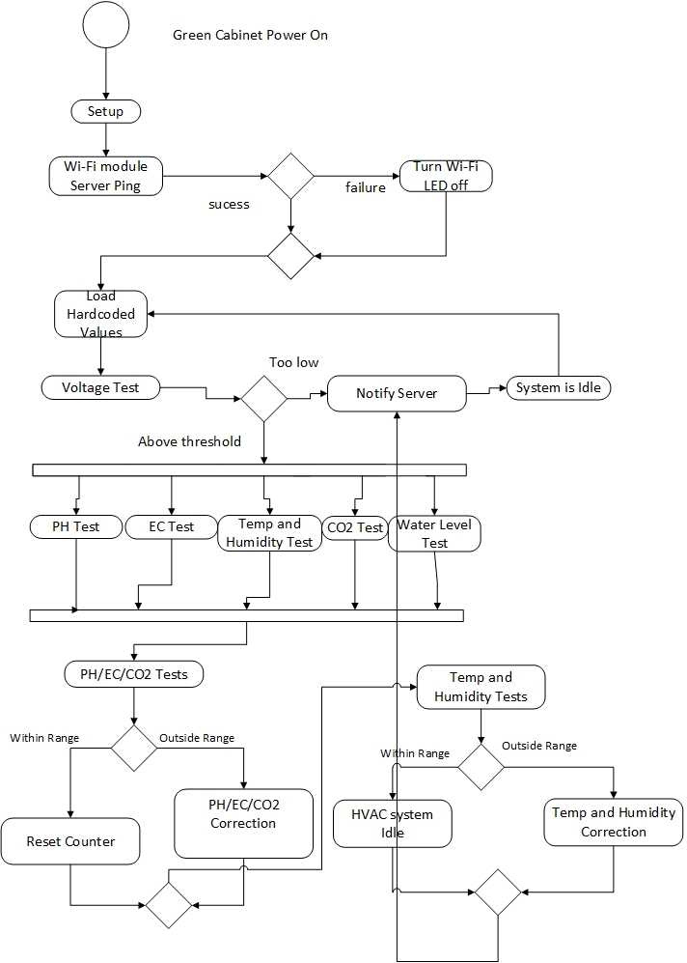

Figure 5.28: Activity Diagram for System Design

The system starts when the Autobott is powered on. Once on, the initial start up processes begin. Power is sent to all active components such as the water pump, nutrients and pH pumps, and any LEDs to show the initial status of the system. The next step of this phase includes checking the EC levels of the water before nutrients are added. This will ensure for more accurate readings once different EC readings need to be obtained once the plants are added. Finally, all the Wi-Fi settings are configured so that it may automatically connect to a network on start up. Settings include the SSID, passphrase, and connection type (WEP, WPA, WPA-2).

After the setup state, the system will attempt to ping the server to verify its connection. If the server responds that the ping is successful, the hardcoded values stored in system memory are loaded. If not, the power LED for the Wi-Fi module is turned off to show that the connection was unsuccessful. The hardcoded values include threshold values for all sensor readings. They are stored as variables and can be edited through input via the website. If the user chooses a specific plant, they will already have pre-loaded values for all the sensor readings. If the user does not input any values, the loaded ones are transmitted to the system for use in the sensor checks.

After the loaded values state, the system checks the voltages being sent to all the sensors on the board. If any of the sensors are receiving a voltage that is too low, the system sends a notification to the server telling it that a specific sensor is not receiving a high enough voltage. The server then continues to the idle state until the next set of tests begin (which should be thirty minutes from initial start up). It will then continue this loop until the correct voltages are applied to the system.

The next state is the testing states. Every sensor will be signaled to test for values. Sensor tests for pH, EC, temperature and humidity, CO2, and water level will be performed. The sensor values are then translated into usable values that are compared to the threshold values. The translation requires sensor calibration before the system is powered on. When the pH, EC, and CO2 sensors are tested, if their translated values are measured to be within their thresholds, the system does not need to do any adjustments, so it sends the updated values to the server. When the pH, EC, or CO2 sensors are not within their thresholds, the system is instructed to dispense the corrected amounts for each and increment a counter. After the fifth time the system corrects one of these values the counter for it resets. This is because the system assumes after the fifth correction a message is sent to the user to check on the amount left and to restock if necessary. The temperature and humidity tests compare the enclosure's values against the threshold values for the plants, When the values fall inside the threshold, the system remains idle until the next set of tests since it does not need to correct these values. Otherwise, the system notifies the HVAC system to turn on the fan or open a vent. The last test is for the water level sensor. This test checks to see if the water level of the reservoir fits the threshold value for water needed in the system. If more water is needed, the system sends a message to the user telling them to refill the reservoir. Otherwise, the system remains idle until the next set of tests.

The system state is also important to the system. Figure 5.29 is shown below and shows how the different states interact with each other.

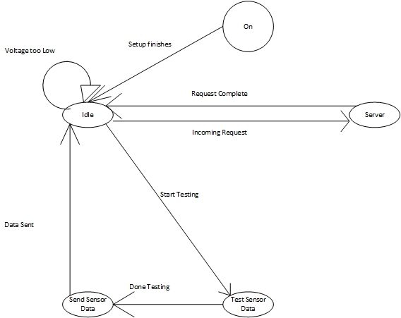
Figure 5.29: State Diagram

Once the system is turned on and the setup is complete, it goes into an idle state. From the idle state a request can be given from the server or the system can begin sensor testing. Requests from the web server include creating new test values for the sensors and changing which plant is being grown. After the sensor testing is finished, the data is sent back to the system, which then continues to remain idle until another test begins or another request from the server is made.

5.3.2 Web Server - The web server chosen for the project was Apache HTTP server. It was chosen because of the initial design decision to use an SQL database and having prior experience with PHP. Even though there was mild familiarity with a MEAN stack, group members did not feel comfortable enough with the technologies to complete the project using one. The use of these technologies ensures that the webpages are relatively static, with only the sensor values and plant types changing.

Figure 5.30 below summarizes the server activity while it is in an idle state.
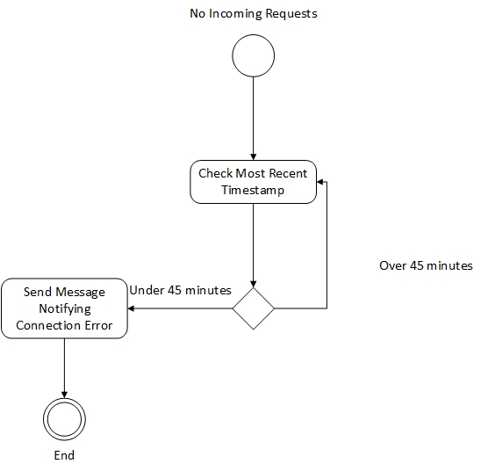
Figure 5.30: State diagram of idle server
To ensure that the user knows whether the cabinet is functioning properly or not, the user may be notified of a potential problem with the system through connection loss.When the server is idle, it doesn't receive any signals. When it is idle for forty-five minutes without receiving a request, the server notifies the user that the cabinet may have lost connection or another problem has occurred..

Figure 5.31 below illustrates how a server interacts with the main system to perform different functions when it receives an HTTP post request.

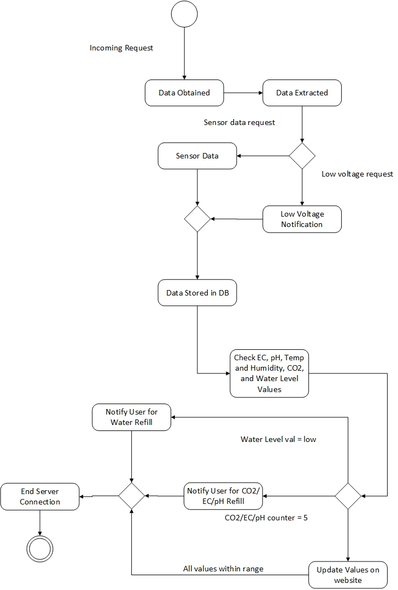
Figure 5.31: Web Server Activity Diagram for Incoming Requests

The first step for the web server is to receive an incoming request. Once this request is received by the server it must interpret the data and display it as a measurable variable. A timestamp is added to to the interpreted request so it may be updated later. After this step the server checks to see if the cabinet is conducting tests or not. If the voltage being supplied to a sensor is too low a notification will be sent to the user that the voltage is too low to power the sensor.

If the voltages are in check, once the sensor data is in variable form it is stored in the database. Next, a comparison is made for each of the sensor values. If the user did not specify any specific values, default values will be loaded. When the water level value reads too low, a message will be sent to the user to refill the reservoir. When the CO2, EC, or pH counters reach five, this means there have been five corrections. At this point the server sends a message to the user telling them to check and refill all the pumps or tanks. If all the sensor readings are within range, then the values are just updated on the website to reflect the most current timestamp. Once the request has been completed, the server ends communication with the cabinet until the next post request.

Figure 5.32 below shows a state diagram when the server is handling requests.
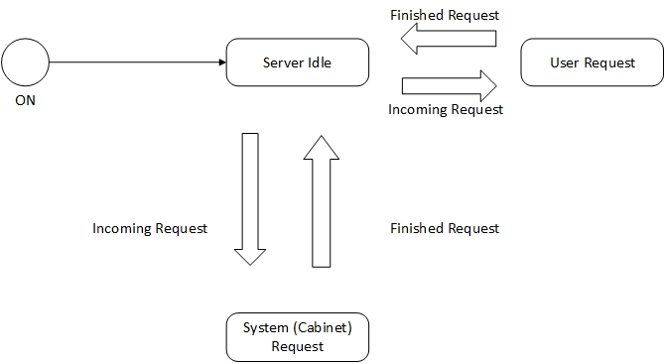
Figure 5.32: Server Request state diagram

Messages - Messages must be periodically sent to the user to ensure the system is being maintained properly. Table 5.13 summarizes the different messages that may be sent to a user on the website.

Message | Description
Low Voltage | There is not enough voltage being supplied to one of the components of the system. Please check the connection and make sure the correct voltages being used.
Refill Nutrient Liquid | The nutrients have been dispersed five times without being checked. Please check the nutrients tank level and refill if necessary.
Refill pH Liquid | The pH has been adjusted five times without being checked. Please check the pH liquid tank and refill if necessary.
Refill Water Reservoir | The sensor indicates the water level is low. Please add water to the reservoir as soon as possible.
Network Loss | The server has failed to reach a connection with the Autobott. Please check that the cabinet's Wi-Fi network is active and the system is plugged in.
Refill CO2 Tank | The CO2 levels in the Autobott have been adjusted five times and the CO2 tank has not been checked. Please check the CO2 tank and refill it necessary.
Table 5.13: Summary of Messages Sent to Users

5.3.3 Website - The website design deals with the front end portion for user interaction with the Autobott. Users will interact with the cabinet through an HTML web page using an Apache HTTP server. The website will use a client-server model, where the user sends a request to the server where it is then handled. Each user will create an account on the website to view sensor data from the system. Figure 5.33 shown below gives an activity diagram, detailing the application and functions of different features of the website.

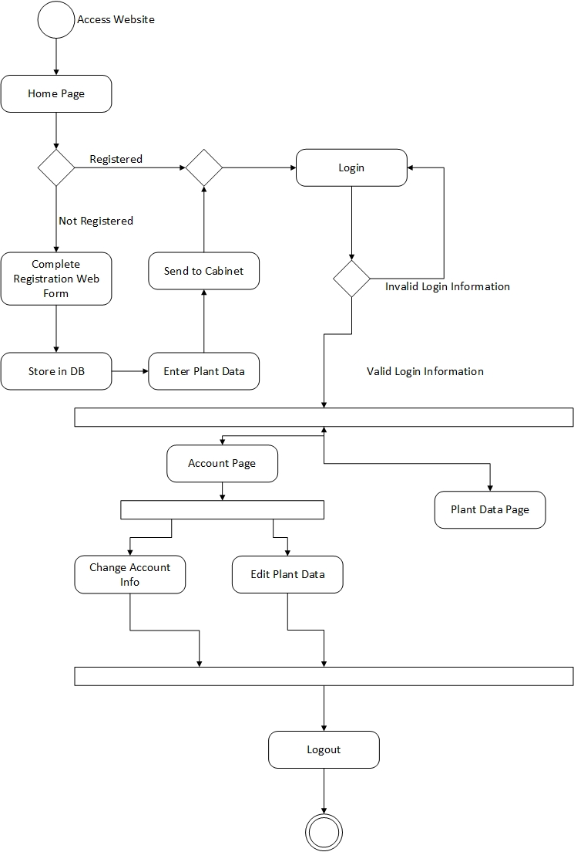
Figure 5.33: Activity Diagram of Website Functions

The website will initially be accessed by a user through a web browser. Users will be brought to the home screen where a brief summary describing the website is displayed and links are provided to either login or register. If the user is not registered, they will click the register link and be redirected to the registration page. On this page the user will be asked to enter their name, e-mail, and password. Once the user information has been entered it is stored in the database as a new user. The user is then brought to a page where they will enter their initial plant data. Users will have the option to skip this step if they do not wish to fill it out immediately. After this step any information entered by the user is stored to the database. If the user chooses a plant that already exists in the database, the values being tested will set to the ones for that given plant. If the user does not enter any information or the plant does not exist in the database, the server will load the default values for the system. After this step the user will be redirected to the home page where they will be asked to login or register once again.

Registered users will press the login link on the home page. They will enter their e-mail address and password. This information is checked against that stored in the database. If the information is incorrect, the user will be asked to enter it again. If correct, the website will log the user in and redirect to the plant data page. On this page users will be able to view all the most recent sensor reading values for their plants. This also includes any notification messages pertaining to the enclosure. On this page there will be options to logout and visit the account page. The account page is bound to a specific user, and it lets each user edit plant data or change their account information (such as e-mail or password). When a user is finished using the website they will press the logout button which will log the user out. This ends the activity flow of the server.

5.3.4 Database - Databases are extremely important in storing and sharing data with many users of an application. The Autobott will be using an SQL database structure to support the back end of the web application with attributes of plants and the resources users need to grow plants in their environment. SQL is a programming language that is used for querying and modifying data and managing relational databases. The core of SQL is formed by a command language that allows somebody to retrieve, insert, update, and delete data. SQL can also be used for administrative purposes and for management functions which is important when a level of permission is being used to distinguish users, administrators, etc. Finally SQL includes a call-level interface (CLI) for accessing and managing data and databases remotely.

SQL is a specialized language used to manage and manipulate databases, so if learned correctly it can be very powerful and useful. It has many advantages to certain applications and also disadvantages because it is so unique that it cannot be used as often as other database languages. The main advantages that will be covered about SQL language is its high speed in data processing, its well defined standards, no coding required, and its emergence with ORDBMS. SQL is high speed because it is able to retrieve large amounts of information from a database quickly and efficiently. In a large database such as the one that will be implemented in the Autobott, it is imperative that users can access what they want quickly without a long waiting time. Another advantage of SQL is its well defined standards that are being adopted by ANSI and ISO. This is a unique feature because it makes SQL more of an international language, allowing many different professions able to work with it. Of course there is code required to create fixtures and relations between tables, but this can be done in a visual diagram where one does not have to explicitly code by hand. The code can be manufactured by the diagrams definition and then altered as needed for the required application. The last advantage to using SQL language is its emergence with Object Oriented DBMS, which extends object storage capabilities to relation databases. Before SQL was the same to a relational database which was not visually object oriented with tables that can be joined and manipulated according to the uses requirements.

The main disadvantages of SQL language is its difficulty in interfacing, its lack of cross-platform portability between vendors, inappropriate handling of missing data, and its complex and somewhat misunderstood query language. To interface SQL, it takes a server to host a domain name that can be imported to an HTML file. From here, many lines of code have to be implemented so that the correct data and queries will be referenced to by the user through the webpage. It is more difficult to do this with SQL language than it is with another database language. The next disadvantage is its lack of cross-platform portability between vendors. Some databases go straight for the proprietary extensions instead to ensure vendor lock-in. SQL conforms to certain standards which limit its ability to move between platforms and vendors that are competitive against each other. Finally, the query language used to retrieve, update, insert, and remove data from a database in rather unambiguous. One command can do many things but only with the right prefix and parameters attached to it. This is where knowing code and syntax matters because SQL is very picky about this. When a query is made incorrectly, data can be lost in the resultant table and output. SQL has a tendency to be almost too specific, in which case it does not retrieve all of the information the user is looking for and leaves out results.

The database behind the Autobott first serves as a component that helps keep the environment stable. It is a reference module that will advise the user to set the conditions of their environment based on what they decide to grow. The database will guide and educate the users along their journey of growing plants in their Autobott. Most of the guidance and education is based on the experience level the user has as well. For example, a beginning gardener will need to inquire about temperatures and humidity levels about a plant they want to grow. Through the web application, they will be able to access the database and this kind of information will be available to them. The database will contain information about many different types of plants and the unique environment they need to thrive. The parameters and attributes about each plant in the database will be: the air temperature and humidity levels that it takes for a specific plant to thrive, the amount of lumens (from the LED lights) it needs, and the water quality levels, such as, the pH level, the electrical conductivity levels, and the watering cycle time.

Furthermore, the beginner gardener will find that the database behind the web application is very educational and will help teach them faster about different types of plants. The database will open them up to a variety of plants and help them gain knowledge in the gardening as a whole. Also, since the database is available to all members of the Autobott, that means more experienced gardeners can see what beginners can. The privilege experienced gardeners have over beginners is they are able to edit, update, and insert into the tables in the database. This process works as a request the user makes to Autobott’s database administrator. Through further research, the administrator can determine if the user is credible and will insert or update the information where requested. This gives users the capability to experiment with optimal condition environments and have fun with their indoor smart garden. The initial database, however, will have pre-researched optimal conditions for plant growth and that is what will be used when the Autobott makes its debut.

The Autobott will have a web application where users can access the database. This next section gives details about the coding languages that this project will use to link the database to the front end application. The first step is to gather information about the SQL database, which entails knowing the server name, the web hostname of the server to hook up the IP address, and also the username and password to access the database as an administrator. Setting a username and password to access the database as an administrator is essential to security of information and setting permissions to different account types. The next step is to use a suitable programming language to attach the database to the web page. In this case, we will be using PHP because it is commonly used in webpages like HTML, and is paired well with the open source MySQL database. This will allow us to display our database in a presentable and visually pleasing manner on the webpage where our application will be created. From this point, we will write and implement the necessary code into our web page that will format the database into our application. The user will be able to retrieve, update, insert, or remove elements in the database tables.

6. Project Prototype Construction and Coding
The project prototype construction and coding is a very important part to the final design and construction of the project. In this phase of the project, the group members will be finalizing the list of parts that will be purchased for the project. These parts will have to be in sync with each other to create a flawless and fully functional system. Furthermore, through prototyping, the group will learn if the initial design will work or need to be modified. If the initial design must be modified to meet certain requirements, then the final design will change and also will the final parts in the system, the budget, and the overall design of the entire system. The next paper that will be conducted in senior design 2 will include the final design changes.

6.1 Parts Acquisition and BOM
The bill of materials (BOM) can be understood as the shopping list and recipe of creating a product. The BOM contains every part, item, assembly and sub-assembly that can exist in a given final product. The Autobott composes of essentially three subsystems, the enclosed environment, the hydroponic system, and the electronics system. There is a specific way in the steps to assemble them all separately and then finally assemble them all as one product. Below is the overall final assembly table, Table 6.1, and another more specific BOM table that contains every part that is accounted for in the Autobott. Table 1 is the final assembly BOM for the Autobott in its first prototype phase. Table 2 is the full list of items and parts that are clearly labeled with their own part number, unit of measure, unit cost, and quantity. After discussing the parts in Table 6.2, there will be an in depth instruction on how the parts are assembled in their sub-assemblies first and then the overall assembly with that sub-system or entire system. The following step-by-step instructions will obtain the final product that will lead to the final step of simply plugging in the main power chord that boots up and initializes the Autobott. At this time the product is ready to sell on the market.

Bill of Materials for the Autobott
Assembly Name: |  | Prototype 1
Pieces: |  | 46
Total Cost: |  | 849.61
Table 6.1: Final Assembly

Category | Part # | Part Name | Qty | Unit of Measure | Unit Cost | Cost
Environment System | 30510 | LED Lights | 1 | each | $98.95 | $98.95
Environment System | 30010 | HVAC | 1 | each | $25.00 | $25.00
Environment System | 30020 | De-Humidifier | 1 | each | $44.35 | $44.35
Hydroponics System | 20011 | 20 Gal Reservoir | 1 | gallon | $30.00 | $30.00
Hydroponics System | 20021 | Water Pump | 1 | each | $12.50 | $12.50
Hydroponics System | 20031 | Air Stone | 1 | each | $5.42 | $5.42
Hydroponics System | 20040 | Nutrient Pump | 3 | each | $9.99 | $29.97
Hydroponics System | 20312 | Grow Pots | 4 | each | $5.99 | $23.96
Hydroponics System | 20322 | Plant Trays | 3 | each | $8.00 | $24.00
Infrastructure | 10011 | Oriented Strand Plywood | 8 | inch | $7.14 | $57.12
Infrastructure | 10021 | Nails, Screws | 2 | each | $2.98 | $5.96
Infrastructure | 11510 | Glue, Tape, Cocking | 1 | each | $15.00 | $15.00
Infrastructure | 10210 | PVC Pipes | 1 | inch | $25.00 | $25.00
Infrastructure | 10032 | Plexi Glass | 1 | inch | $2.97 | $2.97
Infrastructure | 10042 | Wheels | 1 | each | $9.80 | $9.80
PCB | 51510 | MCU | 1 | each | $10.00 | $10.00
PCB | 50010 | Solid State Relays | 4 | each | $1.00 | $4.00
PCB | 50020 | Darington Driver 8 Channel | 1 | each | $9.99 | $9.99
PCB | 50030 | Wifi Module | 1 | each | $34.95 | $34.95
PCB | 51520 | Power Materials | 1 | each | $23.99 | $23.99
PCB | 50040 | Misc.PCB Components | 1 | each | $20.00 | $20.00
Sensors | 40210 | pH Sensor Kit | 1 | pH | $34.00 | $34.00
Sensors | 40220 | EC Sensor Kit | 1 | EC | $75.00 | $75.00
Sensors | 40230 | Water Level Sensor | 1 | each | $14.99 | $14.99
Sensors | 40310 | Air Temperature Sensor | 2 | degrees F | $4.00 | $8.00
Sensors | 40320 | Humidity Sensor | 1 | percent | Included w/above | Included w/above
Table 6.2: Full BOM
The first assembly is the infrastructure of the physical enclosure. The items included in this assembly are lumber, screws and nails, plexi glass, and the wheels. The lumber that will be used is plywood that is bought off the shelf at Home Depot. Eight units of common oriented strand board plywood will be bought with the dimensions of 4 feet by 8 feet by 7/16 inches in thickness. The eight pieces of plywood will have to be cut as follows to create the skeleton infrastructure of the Autobott: two units of plywood will be cut into pieces of 6 feet by 2 and half feet, three units will be cut into pieces of 3 and half feet by 2 and half feet, one unit will be cut into a piece of 6 feet by 3 and half feet, one unit will be cut into two pieces of 4 and half feet by 2 feet and 10 inches and another piece of 4 and half feet by 8 inches, and last unit will be cut into 4 and half feet by 2 and half feet. The pieces of lumber can then be assembled into the cabinet-like model the Autobott resembles by using the screws and nails to firmly hold together the shelves and walls of the infrastructure. At this point, the product is built and can begin the final touches on the outside of the model. The finishing touches are the wheels that will enable the enclosure to be easily portable and the viewing window on the front door. The wheels are made from Reliable Hardware Company and are 2 inch in diameter and swivel from a top plate that is screwed in at the bottom of the enclosure. These wheels, RH-9005-Set-A, can be found on Amazon in a set of four. Also, the last bit of assembly on the infrastructure will be the viewing window on the front door. The viewing window will be a cut out of the piece of lumber that measures 4 and half feet by 2 feet and 10 inches. The cut out will be 7 and half inches by 9 and half inches, and will be replaced by a plexi glass sheet that measures 8 inches by 10 inches. The plexi glass sheet is sold at Home Depot and is bought off the shelf. To create the viewing window, strong adhesive glue will be used to glue the plexi glass sheet over the cut out of the plywood. This completes the physical enclosure assembly.

The next subsystem that can be assembled is the hydroponic system. Since this portion of the Autobott has a lot of bulky hardware items, it is easier to implement it earlier on in the assembly process. The first step before inserting the water reservoir into the bottom drawer of the infrastructure is to insert the water pump and air stone into the bottom of the reservoir. Place the water pump in a corner of the reservoir and direct the tube of the pump to the deepest part of the reservoir, assuming it is not a flat bottom, to pull the water up from. This will ensure that even when the water runs low that the pump is still sucking water instead of air. Next, place the air stone as close to the middle of the reservoir as possible to make sure that all of the water has a chance to be aerated. Once these devices are in place, then put the reservoir into the bottom of the infrastructure, where it will remain when it is put on the market. Before moving onto the next sub-assembly in the hydroponics system, holes for the tubes need to be drilled into the shelf above bottom drawer. The holes need to be made for the tubes that will come from the water pump into the environment where the plant trays will be and also for the drains on the plant trays that need to drain water back into the reservoir. After these holes are made in the appropriate places, plastic tubes and PVC pipes will be assembled from the reservoir into the environment. The ends of these pipes and tubes will be connected from the water pump and the reservoir to the plant trays in the environment. This leads into the next sub-assembly, which are the plant trays in the enclosed environment. The plant trays will need to be modified to support tubes pumping in water from one end and tubes leaving the other end to drain the water. The plant trays will be angled just slightly to allow the water to naturally flow downwards into the drain. The draining system will consist of PVC pipes and a blockage medium that slows the draining of water from exiting the plant trays. The last portion of the hydroponic assembly is to add in the peristaltic pump. This pump contains two servo motors that pull nutrients from two separate and smaller containers, and push them into the reservoir when the water quality is not right. The two pumps are small and can easily be mounted in an optimal location so that it does less work to pump the nutrients into the reservoir. This concludes the assembly of the hydroponic system in the infrastructure of the Autobott.

The simpler subsystem that can be assembled after the hydroponics is the enclosed environment. In this system, the only devices that need to be implemented are the LED lights, the HVAC system, and the humidifier. First, the LED lights will be installed on the inside at the top of the enclosure. They will be mounted so that they can be lowered or risen based on the height and size of the plants. The lights will be able to do this because a string will be attached to the end of the light and will have enough slack to be fully adjustable in the environment. For now, the LED light’s wire will hang free until the next sub-assembly, where the wires will also be long enough to lower if necessary. This sub-assembly basically is just an addition to the physical enclosure that requires fixating devices onto the inside of the enclosed environment. The next two pieces of hardware going into the enclosed environment is the HVAC system and the humidifier. The HVAC system will be mounted onto the side of the enclosure, opposite of the electronics panel. This allows the HVAC to pull fresh air in from the outside and filter into the environment. The humidifier is mounted in a similar way on the inside of the enclosed environment. The humidifier is implemented in a unique way to the Autobott. The water that is gathered from the moisture in the air will drain directly into the water reservoir at the bottom. This acts as a self-maintaining system that helps the user be more hands-free from their garden. The rate at which water is collected from the moisture in the air should replenish the water that evaporates in the reservoir, keeping the system running and automated. The make up of this sub-assembly is ends the implementation of large hardware pieces and the next steps are to hook up the electric and sensor components to the system.

The next phase is to implement the sensors in all of the appropriate areas. This phase acts much like the previous assembly in a sense the it only requires the implementation of sensors and fixating them where they are needed. First, it makes sense to assemble the sensors that will run in the hydroponics system because all of the sensors are going to the same place, so it will be easier to complete this task first. The pH sensor, the electrical conductivity (EC) sensor, and the water level sensor will be placed into the hydroponics system. All three of these sensors detect the water quality in the reservoir, therefore, they will be placed in the reservoir. The pH and EC sensors are able to be fully submersible into the water, so they can hang off the side of the mouth of the opening into the reservoir. The water level sensor is supposed to be extremely accurate in notifying the user when the water is reaching low levels. This sensor will be placed on the inside of the reservoir mounted to the side of it by a suction cup. All of the wires that will run to these sensors will run through a water resistant tube keeping the electrical aspect from malfunctioning and keeping the system reliable. Also, the two sensors that will be mounted into the enclosed environment are the humidity sensor and the air temperature sensor. These two sensors will be mounted to the back wall as close to the center as possible. This ensures that the sensors are not getting false data from being too high up on the wall where they will be affected by the heat of the LED lights and not towards the bottom where the moisture and coolness from the water and plants are giving it false data. A similar fashion to both sensors in two different subsystems is that holes in the plywood will need to be drilled out for the wires to reach the electrical panel. Since the enclosed environment is supposed to be sealed off from the outside area, cocking and adhesive mixture will close off the gaps between the wires and the hole in the plywood.

The final assembly is made up of the PCB and the power supply. This step is somewhat simple because every component is in place and the only thing left to do is wire them up and give them power. The sub-assembly of the PCB, relays, and power modules are difficult however. The first step is to assemble the PCB with the correct amount of relays for each component that needs one. Then extend the wires to their appropriate length so they will be able to reach the component they are designated for. All of the electronics, wires, PCB, relays, power supply, and even some pipes and tubes will pass through the side panel that will hold this entire system. The main board will be mounted directly on the plywood in the side panel and will easily give access to other sub-assemblies in the Autobott. This design made it easy to distinguish systems and their parts, as well as, make it easy for the user and manufacturer to fix something electronically through the side panel if something malfunctioned. Furthermore, the last step is to ensure that every wire that is connected to the PCB extends to its appropriate location and component. Once this task of wiring the electronic is completed, the next step is to ensure that the power supply of the pumps, LED lights, HVAC, and humidifier are connected. Once they are, the machine may be turned on by plugging the main power chord into the wall. At this point, the Autobott will be fully assembled and ready to initialize and operate.

6.2 PCB Vendor and Assembly
We decided to download and use EAGLE PCB for our printed circuit board designs. Being free and having many libraries available for download online for free as well, this software was recommended and most desirable to use. Eagle also allows for a bill of materials to be created and gerber files for PCB vendors to print and mount the board for us.

We researched and found two possible PCB fabrication and assembly websites we are considering on using. We went for low cost as well as quick turn around time, we need plenty of time to test and make sure the board functions, as we need it to.

Expresspcb offers fabrication and assembly starting at $60 and with a formula generates a final cost based on board size and mounting and $10 on two boards to anywhere in the US. Using the software provided on their website to design the PCB, it will generate the manufacturing cost of the board.

4PCB offers PCB fabrication and assembly with the upload of CADsoft eagle files at an affordable price with guaranteed shipping time. Quoting for a 2 layer board at $33 and 4 layer boards for $66 each with maximum size of 60 square inches. This sire offers students with a discount as well, and also removing the minimum quantity required to order.

6.3 Project Operation
Unpacking and hardware check - The Autobott is a single unit that is shipped with all parts attached. The user of this product will not have to assemble any large items together and will only have to unpack the product from the packaging and make small adjustments to get everything specific item set in place. The two subsystems that the user will have to assemble and check are the enclosed environment and the hydroponics system. Since the Autobott must be shipped in some cases long distances, many of the items are tied down and secured from shifting around while moving. The user will have to release all of the products and place them in their appropriate location. Since hydroponics is used in this system, water will have to be added to the reservoir before anything else. Add water into the reservoir until the water level reaches two inches from the top. There must be a little room left over in the reservoir for the water pump, air pump, and sensors to be placed into the reservoir without the water overflowing. Following this step, place the water pump off center at the bottom of the reservoir, all the tubes and wires should be in the correct place already. Next, place the air pump (air stone) off center on the opposite side of the water pump at the bottom of the reservoir. All components should be plugged into the power strip, so there is no need to worry about that. The last steps of setting up the reservoir is to place the pH and EC sensors into the water. To do this, the Autobott has supplied foam flotation devices inside the bottom drawer to attach to the sensors. This will ensure that the sensors remain floating at all levels in the reservoir. This will also keep all of the electronics out of harm’s way of getting wet and possibly destroying the sensor kit.

The next step in this process is to assemble the items in the enclosed environment, which consists of, unpacking the items from shipping fasteners. The enclosed environment consists of four major parts, the LED lights, the HVAC system, the dehumidifier, and the grow trays. The first step is to hang the HVAC system in the top corner of the cabinet. The mounting bracket will already be screwed into the support beams of the cabinet and the user only will need to screw the HVAC into the mounting bracket with the corresponding screws associated with this device. Next, the LED lights will have to be hung by four wires to the top of the cabinet. Four hooks should already be screwed into the wood support beams at the top of the cabinet, so the user must only place the loops of the wires around the hooks. Below is a picture, Photo 1, of the HVAC system and the LED lights once hung, so your AutoBott should look something like this after these are assembled.

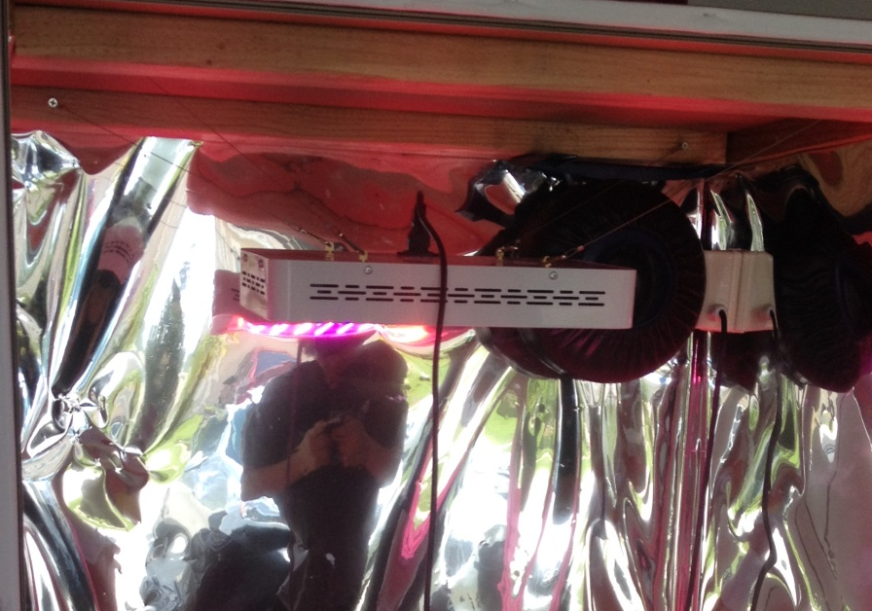
Photo 1: LED light and HVAC assembled

The last major item is the dehumidifier, which is the simplest piece to assemble because it will simply sit on the shelf where the plant trays are. The only necessary action the dehumidifier needs is to place the tube coming up on the side of the cabinet into the holding container. This is the special feature included into the Autobott that keeps the system more sustainable and autonomous because the dehumidifier will drain its contents back into the reservoir. Finally, the user will unpack and assemble the plant trays. To do this, the user must place the pipes coming up from the reservoir into the holes that are in the back of the plant trays. Likewise, the drain pipes will need to be inserted into the bottom front portion of the plant trays to ensure that the water drain back into the reservoir once cycled through the trays. To test that the water fills up the grow trays enough, turn on the water pump and allow the grow trays to fill with water. Once the water begins to drain back into the reservoir, pull out one of the pots from the tray and feel that it is wet. This means that the roots of the plants will reach far enough to get water and thus this level of water in the grow trays is enough. The assembly of the physical hardware components of the Autobott should be complete at this time.

At this point, everything should be attached, mounted, and plugged in so it is time to plug in the main power chord to the outlet. Below is a photo, Photo 2, of what the power strip looks like when it is on. Every outlet in the power strip should be filled and the red light should be on.

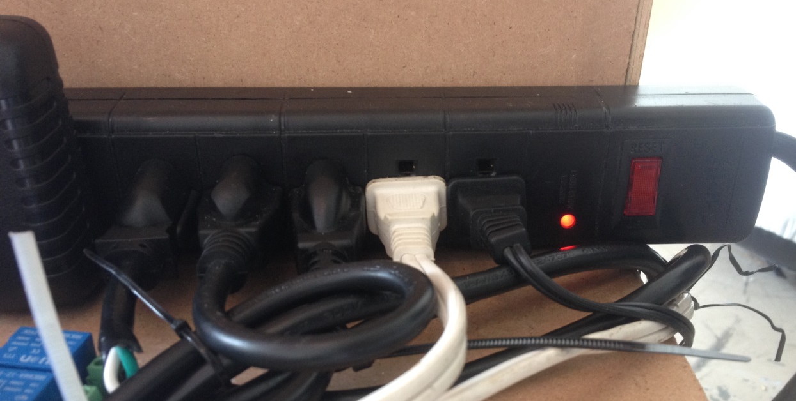
Photo 2: Power strip once AutoBott is plugged into outlet

The hardware items inside the Autobott will turn on and initialize, which means, that the water pump will begin pumping water into the plant trays sitting in the enclosed environment, the HVAC and dehumidifier will turn on, and the sensors will initialize by reading what is programmed on the MCU. Standby to check that the water filling the water trays is not overflowing them because the rate at which the trays are being filled need to also match the rate at which they are being drained. This check verifies that the plant trays will always have the appropriate level of water in them and also not overflow. Below are pictures of the pH meter and EC meter circuits when powered on, Photos 3 and 4 respectively.

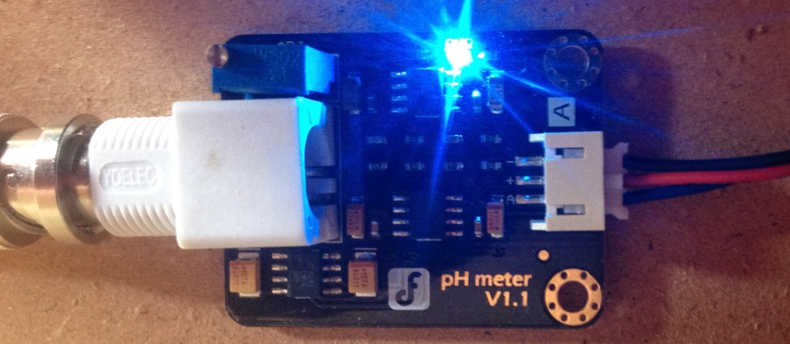
Photo 3: pH meter circuit powered on

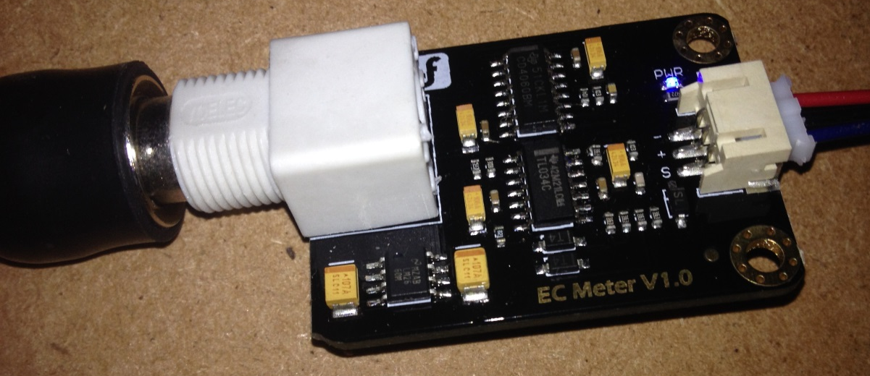
Photo 4: EC meter circuit powered on

If the door is shut and the HVAC is running, make sure that the backdraft damper behind the AutoBott is folded open. This is important because the AutoBott pulls in fresh cool air by creating a vacuum inside the enclosure. The HVAC system is located at the top of the enclosure, where it pulls out the hot air. The backdraft damper is located at the bottom of the enclosure, where it will pull in cooler air once the HVAC is on. This flow of air allows enough carbon dioxide to get into the system and then filter out the oxygen during a cycle. Also, open the cabinet door and the bottom drawer to ensure that everything is running, including the air pump and the electronics boards. The printed circuit board (PCB) should be distributing the power correctly to everything, thus powering on all of the components. It should also be powering on the Arduino board and the Wifi Module, also attached to the Arduino. The Arduino board and the Wifi Module have small LED lights on them that will show you that they are on. Below is a photo, Photo 5, demonstrating just that.

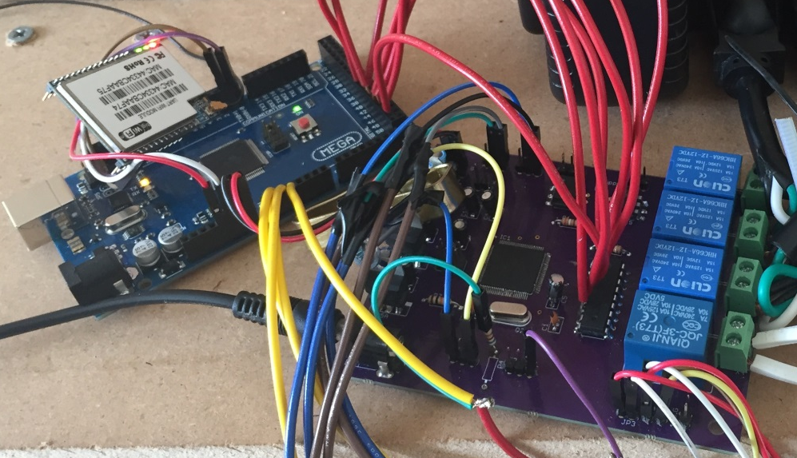
Photo 5: PCB, Arduino, and Wifi Module powered on

Software initialization – The sensors will initialize by running their first checks of the environment they are placed in. A connection will need to be established with your WiFi module to the home router. Since the sensor data readings are sent to the localhost machine of the home router, the WiFi module must be set up as an access point to transfer data over the router. First, go to a computer and type the following into the top bar of a browser, 192.168.12.254. This IP address is the default address of the WiFi module. Then the user will need to configure the module to become an access point to their own router. Below is a picture, Photo 6, that shows an example of a configuration already set up. Follow the structure of this configuration to successfully get your AutoBott wireless.

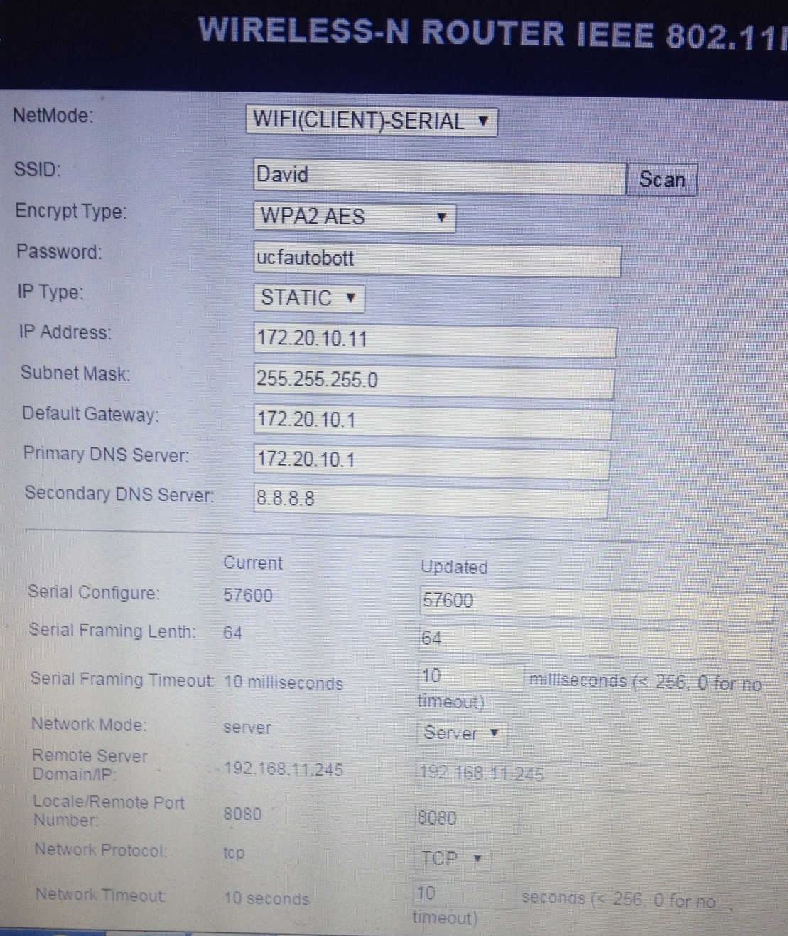
Photo 6: Wifi module configuration
Open the web application through a computer, tablet, or handheld smart phone by accessing the URL localhost. Once you have successfully connected to the web application, you should be able to see readings from the sensors in the system. There should be four sections, Water Level, pH, EC, and Temperature and Humidity. This tab will be in two different locations based on the size of the screen on your device. Usually, a handheld smart phone will have an icon that has three horizontal lines stacked on top of each other in the top right corner of the screen. Click on this once and a drop down menu will appear with the appropriate tab. A larger screen usually given to a computer or a tablet will just have the navigation bar located at the top of the web page. The readings page should display the sensor readings that are currently taken from the AutoBott system. If a sensor reading has no data displayed after one hour, then that specific item may be malfunctioned. In this case, a replacement will be supplied by the manufacturer. If the sensor data displayed in the page seems to be completely wrong, then allow for a few hours for the sensor to get an accurate reading and if the sensor still is not accurate then the same process will be taken for a replacement.

The next step in initializing the software used in the AutoBott system is to navigate to the database and check the list of plants that the user wants to grow. The database will consist of a full database of every plant that has been grown in the AutoBott and their corresponding optimal growing conditions. Any user can submit their own version of what they think the optimal conditions are for a certain type of plant and the administrator of the AutoBott database will approve or refuse the application. The database administrator is in place for security reasons to keep the web application representable and stable. To access the database, simply navigate to the “Database” tab in menu bar. Here, a user will be able to insert their own version of a plant and the specific parameters, update a plant’s parameters, or remove it from the database completely.

7. Project Prototype Testing
The testing process ensures that the prototype functions properly while maintaining the specifications set forth by the group. The testing phases were broken up into three different groups: Hardware Tests, Software Tests, and Integration Tests.

7.1 Hardware Test Environment
Testing each hardware component before final construction is important to ensure that the Autobott is providing an ideal environment for the plants inside. Each component must be tested for functionality and accuracy and will be tested separately as well as together.

7.2 Hardware Tests
Individual component testing will ensure we have all working components before constructing or testing a circuit. The LED light will be tested two ways, one to measure the heat given off and the other to determine all diodes will function if left on over 24 hours. the light will be hung and left on for 24 hours, surface temperature before and after will be measured and each diode will be checked to ensure they are all on.

The HVAC system's fan will also be hung and left on for 24 hours. Temperatures will be measured to determine how much heat the fan releases. Once connected to the Autobott the fan will be turned on to be sure that enough negative pressure builds to opne the backdraft dampers on the lower portion.

Water pump and air pump will be tested for flow. The water pump must be able to push water up and into the growing chamber, the air pump must be on all day to supply constant oxygen to the plants roots. Again, we will test for a 24 hour period.

Before mounting the relays onto the PCB, we will test to make sure the relay triggers on or off with a high or low signal. Each relay controls a vital part of the Autobott and each must be tested to ensure proper operation. Figure 7.1 below shows the fully populated board after hardware testing.

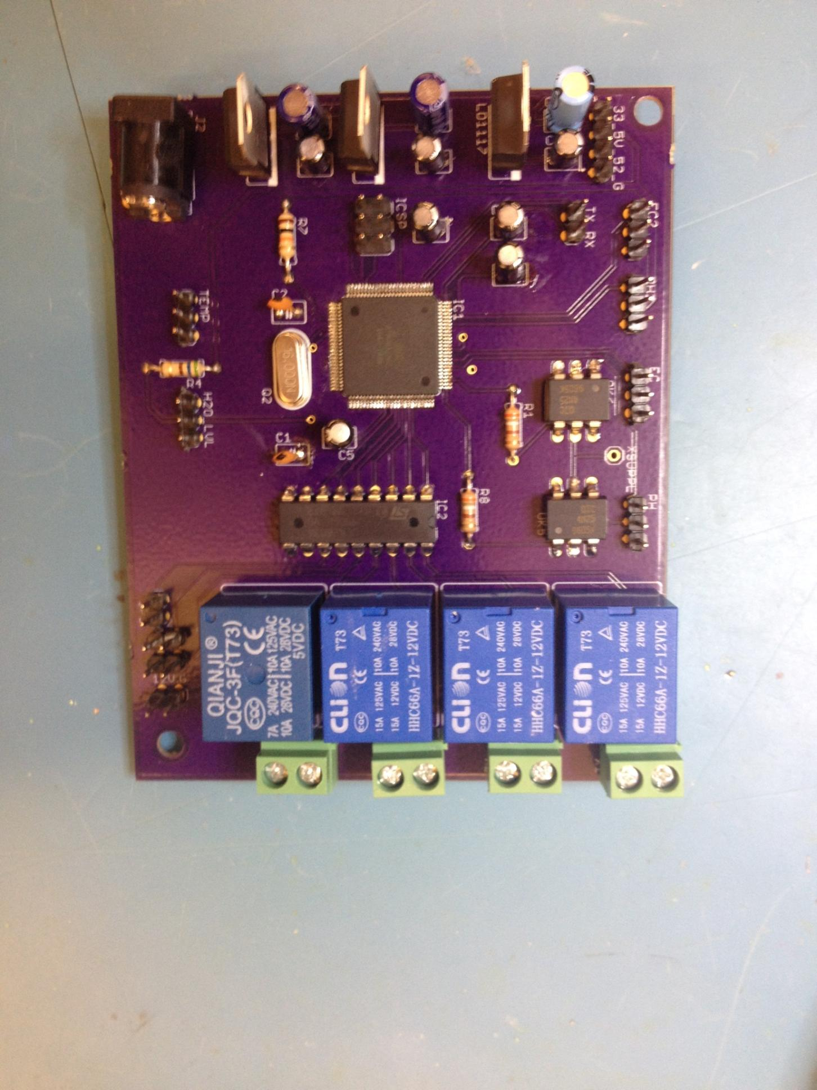
Figure 7.1: Populated PCB after testing
After testing the board and trying to isolate a problem for days, we concluded that the GPIO pins were mapped incorrectly compared to the datasheet and were unable to fix this problem. However, we were able to use the I/O pins from another board using the same ATMega 2560 MCU. Everything was powered from board correctly.
7.3 Software Tests
Software is the driving factor for many features being implemented in this project. Testing is a very important task to ensure accurate functionality of sensors and their data being transmitted. As long as the Wi-Fi module is working and there is a functional network connection, software testing is possible under any environment. The main software components to be tested include the actual system, the server, the website, and the database.
7.3.1 System Testing - System testing is the most important kind of testing that must be done. The system should be able to run autonomously whether it is connected to the internet or not. The system must also be able to operate correctly when it is initially connected to the internet and then loses its connection. This includes skipping the function calls that send information to the network so there is no stalling or crashes.
Unit testing will be done between both the Arduino ATMEGA 2560 and the final custom PCB board. Sensor tests will be conducted every thirty minutes to ensure proper functionality, and this will remain consistent with the timing of the final product’s sensor tests. All tests will be handled concurrently without interruption. For testing, it is assumed the server is functional and test values can be sent to it. The server will get the data and display the values on a console. These values will be compared to ensure accuracy. Below, the unit tests are described in more detail.

Setup Testing - Initial setup begins when power is introduced and the system turns on. First, startup Wi-Fi settings will be tested. These are hardcoded and include such settings such as the port number and server IP within the Wi-Fi module. Once all the settings are checked, a ping will be sent to the server. If the ping is successful, the system will turn on the pin associated with the Wi-Fi LED. This can be checked by verifying whether the light is lit up or not and whether the cabinet is connected to the server or not. Next, we will test the Wi-Fi settings with both the system and server turned off. All the Wi-Fi settings are reloaded and an attempt to ping the server is made. The Wi-Fi module will show that a successful connection has been made but there has been an error in the ping request by a blinking LED five times. The last test includes shutting down the Wi-Fi network and the system. The system will check for a network connection and indicate a connection failure by blinking the LED for three times. These tests are to confirm whether the system is connected to a network and a server and settings can be verified.

Sensor Threshold Testing - Sensor Threshold testing is important because it ensures that proper temperature, CO2, pH, and EC threshold values are being measured and analyzed. There will be a default threshold for each sensor hardcoded into the system’s memory, but these values can be changed during system set up. The user will also be able to change the threshold values through the server when they are connected to the website. The website allows to pick a plant with default values already stored on the database, but depending on how the plants are growing those values may be changed at any time. Originally the default values hardcoded into the system will be run. When a user changes any values from the website, the user’s values will be compared against the current values. If any values are different, they will be updated to reflect the user’s values. To test this process, the system will be run using the hardcoded values. There will then be a post request that asks to verify the values. Next, each sensor value will be changed manually without the use of the website. This ensures that the comparison is made directly. After the comparison, if the values are different then they are sent to the server to be changed.

Voltage Tests - Voltage tests are used to ensure that the correct voltages are being set to all the board components. In order to run power tests, all sensor and server interactions must be disabled. This will allow for more accurate results to show the system is functioning properly. Default voltage values will be hardcoded into the system’s memory based on the sensor’s voltage specifications. When the system is powered on, the default values will be compared with the actual voltage value running through the circuit. If the value is above the threshold, the system will continue sensor testing, but a light for the sensor will blink five times. If the voltage is below the threshold, a message will be sent to the server indicating that the voltage is too low.

PH and EC Testing - Because both the pH sensor and EC sensor are immersed in the water reservoir below, they operate similarly. Testing is similar to the Voltage tests, where EC and pH threshold values are first hardcoded to system memory. When the water is drained into the reservoir, the EC and pH values of the water are compared to the existing values. If within the range of values, nothing needs to be corrected. If either of the values falls outside of the acceptable threshold, a call will be made to the EC and pH correction functions and an LED will blink ten times to indicate that a correction has been made.
During this entire a process, there is a counter for both the pH and EC functions. The counter starts at zero and is incremented by one every time a value is out of threshold range and needs to be corrected. After every five corrections a notification will be sent to the server notifying the user to check on the nutrients or pH fluid to ensure their pumps are not empty. To test these processes, if either values are below their threshold, their respective LED light will blink five times. A message will be sent saying the counter for that function has been set to one. The same process will be dealt with for the exceeding threshold, except the LED will blink ten times to denote a difference between the two thresholds.
Finally, we will test the counter functionality. A value outside of the threshold will be defined and the EC and pH functions will be looped five times. On the fifth iteration, the counter should be five. A message should be sent the server and the counter set to zero. To test this, every iteration of the loop should send a message to the server with the counter number and the EC or pH value.
Temperature and Humidity Tests - Both the temperature and humidity sensor, or DHT 11, is placed within the enclosure around plant level, which leads their testing process to be similar. Temperature and humidity thresholds will be coded into the system memory. When the system is powered on it will check the enclosure temperature and humidity levels and compare them with the existing values. If they fall outside of range, a call will be made to one of the HVAC functions to turn on the fan until the temperature is within acceptable ranges again. To verify these tests, the values will be sent to the server before and after correction. The same is done for the humidity. If the humidity falls outside of the range of acceptable values the dehumidifier will turn on or the vent will open to allow the enclosure to become more or less humid.
EC and PH Correction Tests - These tests differ from the original EC and pH tests. The nutrients and pH are added to the water through pumps, and these functions are only called on if the EC or pH was outside of an acceptable threshold. In order to find how much the adjustment to the water is needed, an equation must be derived that includes the amount of solution in the reservoir, the solution mixing ratios, level of adjustment based on available liquid. Once this equation is found, the correction functions will call on the pipes to disperse nutrients or pH balancing liquid. While the pipes are active, the LED for the sensor will remain lit.
To test for accuracy, we will introduce a test solution with EC and pH values outside of their respective thresholds. The pumps will turn on, and a stopwatch will be used to time how long it takes for the solution to return to normal levels. This will be compared with the calculated values. If the calculated time values from the equations are within 1.5 standard deviations, it is viewed as a pass. Otherwise, recalculating will need to be done.
7.3.2 Server Testing - The server needs to be tested to ensure that the system is functioning correctly. The sensor data that is sent to the server from the system must be analyzed and displayed properly on the website. It also deals with displaying error messages for certain sensors.

Testing the server is much easier than testing the system itself. This can be done throughout the entire development process. Every time a new function is added it can be tested individually and then concurrently with other functions to see if there are any problems. Testing will take place on a local server from one of the member’s laptops or smart phones. In order to run tests, all that is needed will be the web server and a database to retrieve sensor value information. Below are specific functional units that will be tested independently.

Data Interpretation - The data from each sensor must be analyzed and interpreted. Analyzing and interpreting data from the sensors is an easy process, but it is very important. To test that data is being sent to the server, custom values can be input through a web browser. These values are then sent in a post request to be analyzed an interpreted. If interpreted correctly, the values will be displayed on the console in the same way they were given in the web browser.
Notification Testing - Messages are very important in keeping the user up-to-date with the current health of the system. Whenever there is an error, whether it be a sensor value being out of its range or the system losing its network connection, the user will be notified through a notification on the website. To test if notifications are successfully created and sent, manual testing was be used. This was used for the water level sensor, which issued a notification to refill the reservoir when the water level in it was too low along with its reading.
7.3.3 Website Testing - The website itself is an integral part of the project. All sensor readings are displayed on the website. The website is directly linked to the web server and its main units will be tested individually. The main functional units are described below.
Index Page – The Home Page was created using HTML, CSS, and JavaScript. To test the home page and its functionality, each group member visited the website on their phones and computers. Every link was clicked and checked to ensure they worked and were hyperlinked correctly. Figure 7.2 below shows the Index page for our website, located at http://www.ucfautobott.com.

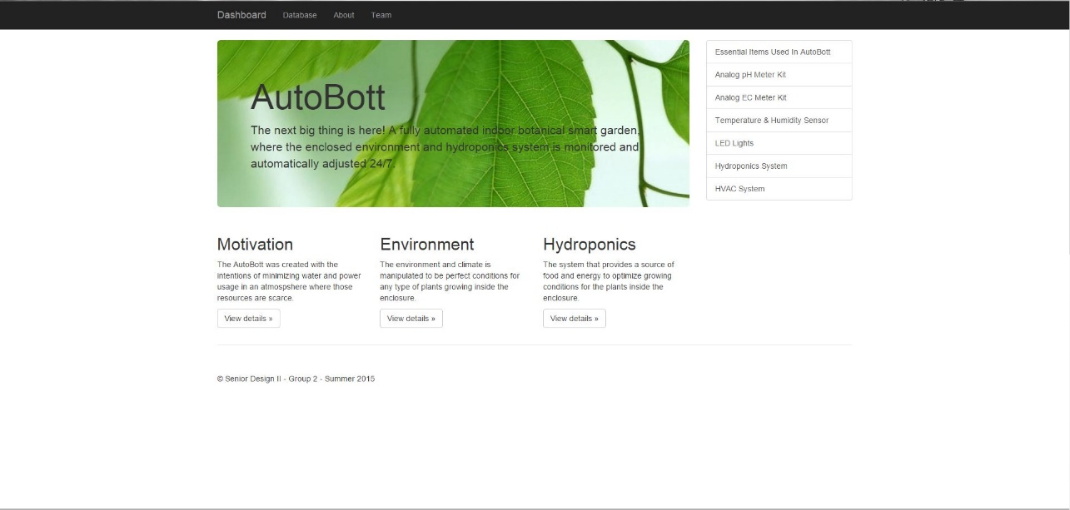
Figure 7.2: Website view of Index.
Automatic Sensor Refreshing - To test the website to make sure the page was automatically updating the sensor readings, we connected to the website via Hotspot and checked the website for sensor readings. We manually coded the refresh rate to be five seconds. After five seconds the page refreshed with new sensor readings for the sensors. We tested this multiple times to ensure accuracy for all sensors.
7.3.4 Database Testing - The database is required to store various users’ information, as well as threshold values for a variety of plants. The database should be able to have elements both added and deleted from it. The data should also be stored in the correct format. To test that all data is displayed correctly, the database can be checked manually to see how it is populated. A test script will be written that creates and populates a database. This will be then checked to ensure that the format and entry is correct. Shown below is the website view of the database for plants before (Figure 7.3) and after (Figure 7.4) adding Potato under Plant Name and removing Garlic afterwards (Figure 7.5).

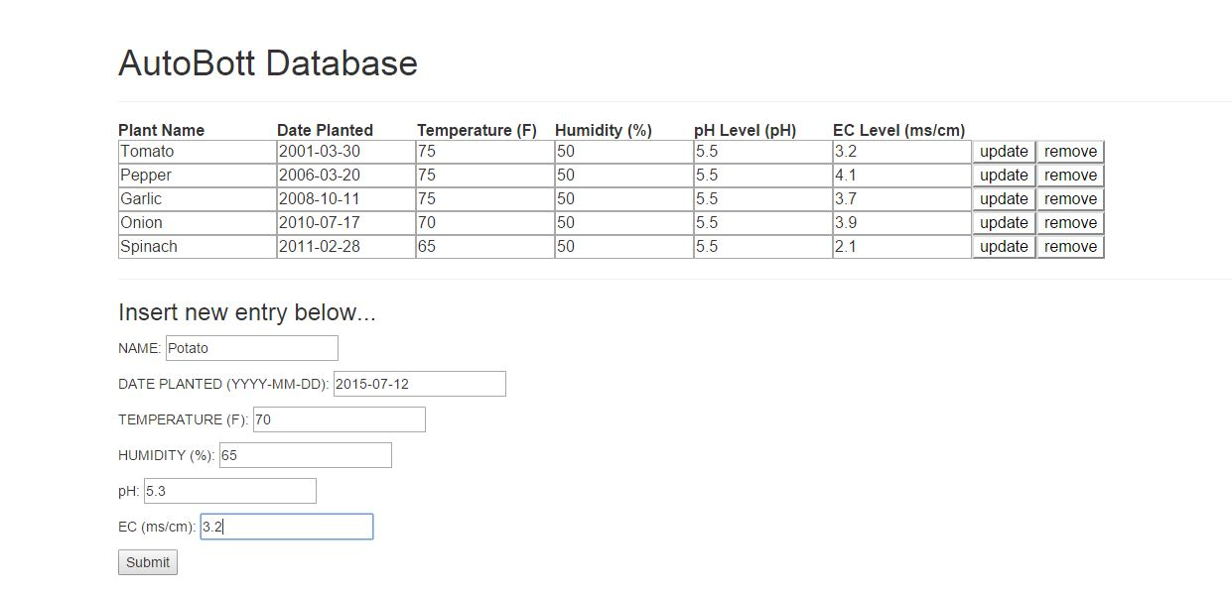
Figure 7.3: Original database before adding Potato.
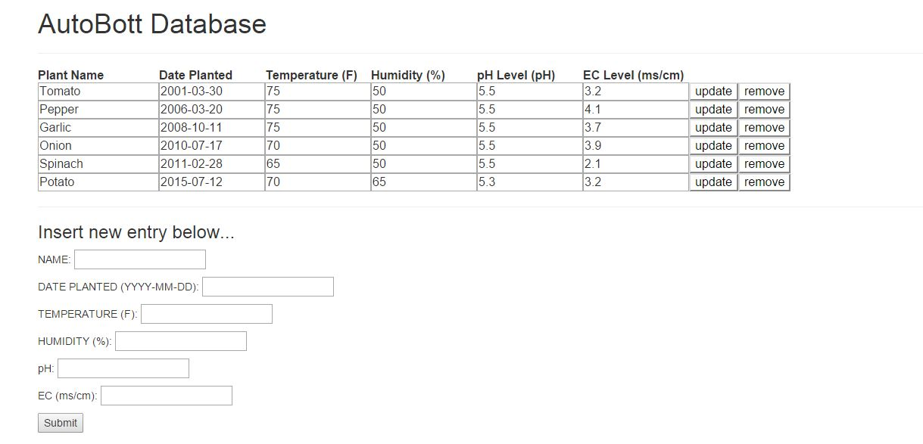
Figure 7.4: Database after Potato is added.
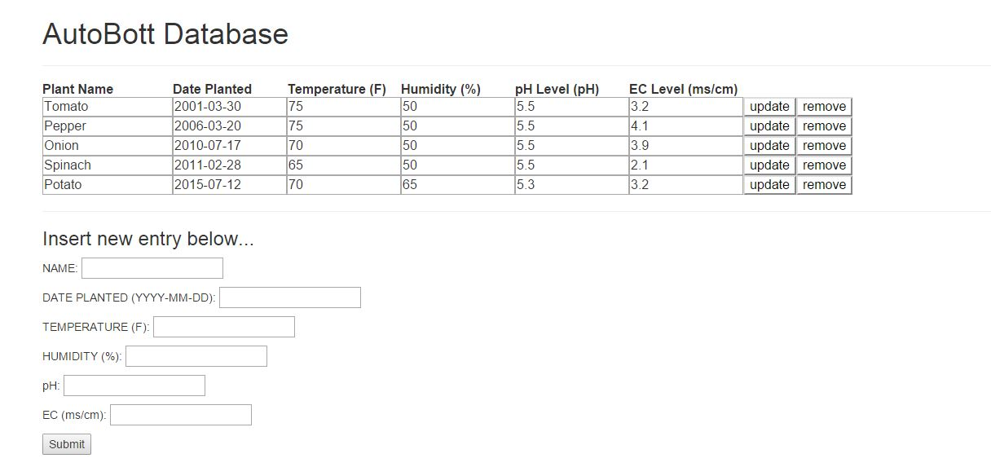
Figure 7.5: Database after Garlic is removed.
7.4 Integration Testing
Integration testing begins after every subsystem has been tested independently and proven to succeed. The system will be assembled and interfaced as one unit. This type of testing will test the hardware functions concurrently with the software functions for full system functionality.
The first main test deals with is making sure the sensors are interfaced correctly with the microcontroller and can perform tests during the timed data testing. When each sensor is connected to the microcontroller it will be tested for power manually through the sensor's LED. After sensors are confirmed to be powered the sensors will be loaded with test values and made to take readings. If each sensor passes the test, the next test can be conducted.
When every sensor is proven to work correctly, the next test ensures that the microcontroller is able to send its data over a Wi-Fi signal to display correctly on the website. After each test the most recent values should be updated and sent to the website. This will be checked manually through the website once data sensor readings are done.
The last major integration test is used to determine whether the microcontroller is accurately operating the pumps for dispersal in the enclosure and reservoir. This will be tested by loading values out of range for each of the sensors that uses a pump. While the corrections take place, each pump will be checked to make sure they are dispensing their contents correctly. Before the water is sent back to the enclosure from the reservoir, the EC and pH levels will manually be checked against the threshold values to make sure the pumps are dispensing accurately. Figure 7.6 below shows the final cabinet after all integration testing has been completed.

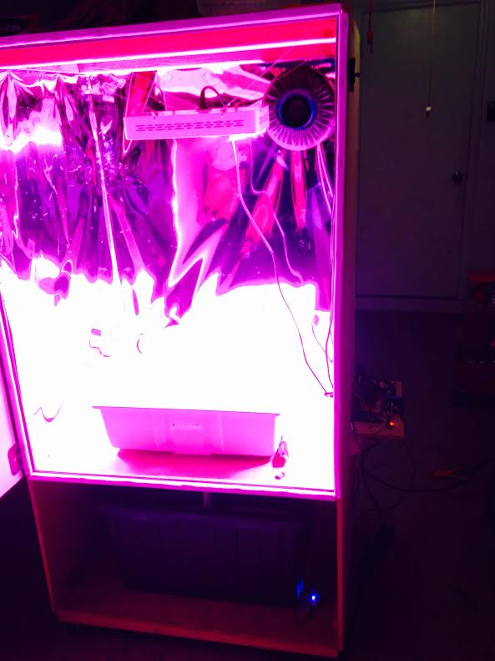
Figure 7.6: Cabinet after integration.
8. Administrative Content
This section discusses all factors not directly related to designing and implementing the Autobott. This includes the group's milestones, assignment of responsibility, and a discussion of the budget and finances used for the project.

8.1 Milestone Discussion
This section is dedicated to the objectives the group has achieved in the duration of this project. A milestone isn’t just a decision that is made by the group that, but rather a decision and an action dedicated towards achieving the task. The milestone topics that will be covered in this section represent the moments where the group and project as a whole made a leap in progress towards the final report and design of the Autobott. These moments do not have to be tangible, they can represent a design issue that the group was stuck on and finally overcame by making a compromise between a few ideas or simply just figuring out the issue and acting on it. Since the Autobott has many different systems that it makes up, there were many times where the group was faced with a big decision to make that would impact the progress of the project. The longer it took to find a solution for that given problem, the longer the project would be delayed. Below are the major milestones that had a significant impact on the progress this project has had so far and future milestones that we will face in the building and construction phase.

In the design phase, many of the problems we ran into were design decisions. The design decisions consisted of the infrastructure of the system, the hydroponics system, and the PCB layout for power distribution and maintaining all of the sensors. The first major milestone in this project was finalizing the design for the infrastructure of the Autobott. To begin with, this was very important because it was the skeleton design that would hold all of our components, the entire system for the project. We needed this design to be functional within the requirements of the project and also appealing to the target market this product would sell to. After a lot of research online, much of the similar existing projects had a modern and simple look. These specific products, such as, the Urban Cultivator and Grove Labs, did not permit access to the hydroponics design of their system, so it was hard to decide how we wanted to design the infrastructure of the Autobott to work the best with a certain hydroponics system. After brainstorming about the goal we wanted to achieve through this product, we came to a conclusion that we would make the environment the plants grew in as large as possible. With this mindset, we simply designed one large enclosure, with the majority of it given to the environment that the plants would grow in and the rest to the hydroponics system and most of the electrical components. This design kept it easy to build and manufacture, while also keeping it appealing and simple for the users to work around inside their indoor smart garden system. Finalizing this plan for the project enabled us to move forward with the design of the other components that would fit and operate inside the enclosure.

The next milestone that we achieved was the design and implementation of the hydroponics system. This was the most important subsystem in our project, so it took a lot of research to figure out which hydroponic approach would work the best inside the enclosure. At first, we decided to go with the Ebb-Flow system and later found that a constant cycle of water would fit best. Basically, we placed all of the hydroponic items down in the storage compartment, which was located below the enclosed environment area. In this compartment, would hold the reservoir, all of the pumps that were needed to create a fully functional hydroponics system, and the rest of the materials used in this process. This decision made a simple approach to feeding the plants in the environment and also made it easy for the user to get inside the storage drawer and add more water or nutrients to the system when they were low. We wanted to keep all of the subsystems cooperate adjacent to each other while keeping a distinguished barrier between them. We wanted to limit the clutter between subsystems and keep the design very simple for manufacturing purposes and the users. After we had finalized our hydroponics design, the project started to come together very quickly. At this point, all that was left was to find parts and begin the design of the low power distribution and the electrical components that would make the Autobott high tech.

Further along in the design phase, the milestones became less significant and easier to solve. There was a period of time where the decisions we were making for the project were individual since most of the group members had their own responsibilities. It wasn’t until the point where the project reached the full PCB design that the next milestones appeared. The next two milestones are directly dependent on each other so they will be talked about side-by-side in this paragraph. The two milestones are the PCB design and the microcontroller or microprocessor (MCU) that we were going to use to control the entire system. To begin the PCB, Eric used Eagle which is a program that aids in designing the PCB by easily selecting parts from the provided library and drawing the wires as a schematic diagram from part to part. Eagle also allows us to print the schematic of the PCB and send it to be manufactured. Before we Eric could start the PCB design, he first needed to know the MCU that would be used for this project. A lot of research and time went in to selecting a MCU because we needed one that was easily compatible with sensors and automation, had enough memory and pins to maintain at least size sensors, and had Wifi compatibility. The group, with little knowledge about MCU’s, selected the Atmega28 chip which is used from the Arduino boards. This had all of the system requirements we needed to build the PCB board. Once the MCU was determined, our next challenge was to figure out how the power circuit would be designed. We wanted the Autobott to be low power and be able to run many different components on demand. From the research we conducted in this area, we found a do-it-yourself item online that we reassembled to fit our project that allows us to plug in many items to one power strip. This enables us to only use one plug that goes to the outlet in the wall. After the final design of the PCB, the hardware aspect of the project was coming to end which was good because this gave us an upper edge before going into the building stage.

At this point in the project, the design phase (Senior Design I) was wrapping up and we still have not found every part, in specific, that we needed to begin the building phase of the Autobott. This was a huge road block for us because it meant that we did not think about all of the specification requirements that were needed within individual components. For example, the water pump needed to have a certain rate at which it pumped water into the plant trays since the hydroponics system was going to be a continuous flow of water. Furthermore, we needed to make sure that the draining system worked in unison with the rate at which water was funneling into the plant trays so that the plant trays or reservoir would not overflow with water. Cases like this were very important to note and keep track of when listing and ordering parts. Another thing was the price of these components and ensuring that they would be on the shelf from three months from the time we bought them in case we would need another. Ordering parts was a milestone that took time to accomplish, but would significantly impact the progress of the project because once we knew the parts and items we wanted to order, it was time to purchase them and beginning running prototype tests. Also, while focusing on ordering parts for the physical design of the project, we noticed that we had not paid much attention to the software aspect of our project. This was a smaller milestone that just needed to be covered for documentation reasons, as well as, beginning code for the front end of the project. Steven was heavily responsible for the research and development idea in this area, so he was able to come forth in a timely manner with solutions on what would be included in our web application. This also shed light on the direction of the product and what it will offer to the users. At this point in our project, we were confident that we were heading in the right direction and had accomplished our goals from the beginning of the design phase.

The next phase is the design phase and is when our group will begin to construct the Autobott, beginning with the skeleton of the infrastructure. Our group decided that during this phase, there would be two milestones that would be significant in completing this project successfully and according to the design. The first milestone that would help our group is sponsorships towards the Senior Design project. During the design phase, we did were unable to land any sponsorships from third party companies. This includes, funding the project financially with money or donating parts we needed for a discount sale or no cost. Many of the items we found that would be included in the Autobott were not expensive, so it was not quite necessary to seek financial support. On the other hand, some of the items that were specialized, such as, the carbon dioxide sensor (optional in the design of the Autobott), the pH and EC sensor, and the LED lights, were on the pricy side. These individual items also were made by specialized companies that could sponsor our group by giving the product to us or discounted, however, this has not happened. Obviously, our group will focus harder on finding a sponsor or more than one, during the building phase of our project since we will begin ordering parts and spending money. The second future milestone that our group predicts is the use of prototyping. We believe that attempting to build the full system without trial and error will set us back rather than help us. With this mindset, prototypes will be a huge factor in testing and completing the subsystems before bringing them all together. Through the milestone discussion, our group is well prepared for adapting and overcoming any future road blocks that may occur. We also have conducted enough research that will guide us in problem solving through future milestones this project has to offer.

8.2 Areas of Assigned Responsibility
This section provides information regarding the responsibilities that were given to each individual in the group project. The scope of the project consists of many topics that not one or two people could undertake by themselves in Senior Design, so work was delegated easily to all of the members and every individual received an equal amount of work. To begin with, the Autobott contained four main subsystems, the hydroponics, the enclosed environment (actual gardening aspect), the electronics, and the software behind the project. Each subsystem consisted of their own design issues and implementations because they were complex in themselves and nobody in the group really knew how to design and work with this smart garden technology. After the first meeting with the group, it was clear who specifically was interested in certain areas, so it was easy to give them that research and work. Below are the specifics shown in Table 8.1, on the tasks that the four individuals in the group, Eric, David, Antonio, and Steven, conducted research on and developed designs for this project.

Assigned Responsibility
Eric | David | Antonio | Steven
Power Circuit | Administrative Content | Hydroponics | Sensor Interaction
LED Lights | Database | Mechanics of System | Front End Programming
PCB | MCU Programming | Hardware Requirements | Software Diagrams and Related Work
Sensor Interaction | Budget and Financing | Infrastructure Design | Software Platform Research
Table 8.1: Assigned Responsibility
As you can see, Eric did a lot of his work on the electrical side of the project. He was very interested in power conservation and keeping this system low power, so the research he conducted revolved around low power components. He not only created and designed the PCB for this project, but also made sure that the power distribution was efficient in giving power to components that need it at all times and other components that only need it when conditions are not met. The LED lights were a huge low power component that is included in our project and will aid in distributing power elsewhere. David was in charge of some of the administrative content, such as, setting up the Dropbox and OneDrive, beginning and laying out most of the documentation for the project, and organizing the budget and finances. He also knew the most about databases, so he created the back end database for the project and will continue to keep it updated and functional. Finally, along with Steven, once beginning the development stage, David will begin to program the MCU alongside the sensors. This leads into Steven’s responsibilities. Steven conducted research on sensor interaction and most of the software related work. He will begin and create the front end web application that will be used for this project by the user. He also has done research on the software platforms that need to be used to connect and communicate all of the devices, and software layers that make up the Autobott. Finally, Antonio had a lot to do with the design of the infrastructure and hydroponics system. His responsibility revolved around the mechanics and hardware requirements for the entire system. With his creative mind and artistic skills, we were able to come up with an efficient design for the skeleton of the Autobott, the hydroponics, and the enclosed environment.

8.3 Budget and Finance Discussion
The Autobott is a product made up of many parts and items that help it run efficiently and reliably. This portion of the paper goes into detail about the costs involved to create and manufacture the Autobott in its current design. The associated cost can be modified once the building phase begins because our team could come up with a more low cost strategy to execute a particular section, or on the other hand, may not have accounted for things in the current design and will have to spend more money to make up for it. Below is the total budget of the Autobott, Table 8.2, with every item that is accounted for in the design this far. Note that some of the items are optional or may be interchangeable with similar items and so the total cost would change if this happens.

To begin with, one of the goals of this project was to keep this project low cost. Before any research of existing similar products, our mindset to the budget of this project was in the range of $300 to $600 after final assembly. After the semester has gone by, it appears that this range is out of the question considering the size of the product and the amount of material that is needed to just build the shell of the system. With this being said, it still does not even come close to the cost for other systems that target the same market as the Autobott. While the total cost of the initial design is $849.61, the next closest product cost as much as $2,500. In comparison to the quality and functionality of the two systems, the Autobott does everything that the other does and then some. The quality of items that go into building the Autobott, however, may not be as up to par as some of these other systems because we are scrapping your everyday parts from regular stores. In other words, nothing is custom made to fit perfectly and look shiny for this project. Many of the items that are used in the Autobott can be found in your local store or internet vendor, such as, The Home Depot, Amazon, and your local technical craft store. The discussion below will specifically describe parts that are interchangeable and may be modified once we reach the building stage. The total cost is variable at this point because it is all according to plan and the initial design of the project.

Subsystems | Parts and Materials |  |  |  | Quantity | Unit Cost | Cost
Sensors | pH sensor |  |  |  | 1 | $38.00 | $38.00
 | EC sensor |  |  |  | 1 | $76.00 | $76.00
 | Water level sensor |  |  |  | 1 | $43.00 | $43.00
 | Air temp. and humidity sensor |  |  |  | 1 | $7.00 | $7.00
Infrastructure | Oriented Strand Plywood |  |  |  | 5 | $25.00 | $125.00
 | Door Hinges |  |  |  | 1 | $8.00 | $8.00
 | Wires, cables, tubing |  |  |  | 1 | $16.00 | $16.00
 | Wheels |  |  |  | 1 (set) | $9.80 | $9.80
Components | MCU’s (ATMega2560) |  |  |  | 2 | $24.00 | $48.00
 | Arduino Dev Board |  |  |  | 1 | $16.00 | $16.00
 | Solid State Relays |  |  |  | 4 | $1.00 | $4.00
 | Darington Driver 8 Channel |  |  |  | 1 | $9.99 | $9.99
 | Wifi module |  |  |  | 1 | $50.00 | $50.00
 | LED lights |  |  |  | 1 | $98.95 | $98.95
 | Power circuit materials (power strip) |  |  |  | 1 | donated | $0.00
 | Air stone |  |  |  | 1 | donated | $0.00
 | Water pump |  |  |  | 1 | $29.00 | $29.00
 | HVAC |  |  |  | 1 | $65.00 | $65.00
 | De-humidifier |  |  |  | 1 | $41.00 | $41.00
 | Reservoir |  |  |  | 1 | 1 (disc.) | $12.00
 | Nutrient pump |  |  |  | 4 | $10.00 | $10.00
 | Grow pots |  |  |  | 5 | $1.20 | $6.00
 | Plant trays |  |  |  | 3 | $8.00 | $24.00
Extra | Nutrients |  |  |  | 4 (set) | sponsored | $0.00
 | Mylar |  |  |  | 1 | $10.00 | $10.00
 | Grow rocks |  |  |  | 1 | $10.00 | $10.00
 | ICSP (programmer) |  |  |  | 1 | $43.00 | $43.00
 | Unaccounted materials |  |  |  | variable | n/a | $50.00
 |  |  |  |  |  | Total Cost | $895.74
Table 8.2: Budget and Total Cost of the Autobott
The infrastructure of the Autobott, which is the shell or skeleton of the entire system that will be filled with items that run the smart garden, will initially be made up of only plywood sheets. During the building phase of this project, plywood may not be enough to support the weight of some of the components, in which case stronger lumber will have to be acquired for reinforcements. Furthermore, if the structure is not fully stable by our design requirements, a redesign may be necessary, which again would result in the purchase of more materials. Keep in mind though, that not all materials that are accounted for and purchased will be used. This will actually make the final assembly cheaper and benefit the target market if we are able to keep the same functionality and quality. Also, the PVC pipes are a variable material, which means that until the building phase begins, we will not actually know how many fittings we will need to construct the design of the hydroponics system. The fittings are really the only part of the PVC budget that will be varied because the pipes will be cut from one large piece of PVC. The single PVC pipe that is sold at The Home Depot is long enough to make the required cuts to create the pipe system for the water to reach from the reservoir to the enclosed environment. The PVC budget includes the part of the system where the water is pumped up to the plant trays, as well as, the draining system when the water needs to leave the plants trays and go back into the reservoir.

The various components that make up the system are hardware for the hydroponics, electrical pieces for to control the power distribution between subsystems, and items for the enclosed environment. This section is probably the most stable in terms of pricing because all of the items are selected for their price. These items are pretty standard and can be found online and at selected manufacturers. The only reason that these items would vary in price is if we decided to go with a more expensive, higher quality, item instead of the one we have chosen already. Also, the items we have chosen now may not “fit” accordingly and that may change the tier in that specific product. The MCU is an item that can go one of two ways. We have still not chosen between the MSP430 and the Atmega28, which is a chip from the Arduino boards. The MSP430 would be free because as students at UCF, there is a required class dedicated to Electrical and Computer Engineer majors, where it is mandatory to purchase a MSP430 for the class. The Atmega28 will have to be purchased separately through the manufactures website. Another item that is variable at the moment is the miscellaneous PCB parts that we may need during and after manufacturing. The design and printing of the circuit board will cost us money, but we could also run into the problem of having to purchase, remodel, or add another item PCB.

The last bit of the budget is the sensors the extra components that will be needed to complete the product. The sensors are a key part to the functionality and high tech design of the Autobott. Due to the expense this project has already added up to, we decided to make the carbon dioxide sensor an optional purchase. We realized that we can still create an optimal environment for the plants to grow in without monitoring and tracking the levels of carbon dioxide in the air. This feature would be nice because we would be able to make the environment even more perfect than without it, however, the solution we came up with makes up for the lack of this device. Our strategy is to cycle fresh air through the environment using an HVAC system, so the carbon dioxide build up in the enclosure will naturally be filtered appropriately. Also, two items in the extra components effect the price of the total cost significantly. The mylar is another optional item that can be placed inside the enclosed environment for better performance and growth by the plants. The mylar is high cost for a small sheet, so maybe this can be an option that the client can select if this product was put on the market. The other extra items are literally any extra pieces that we may need and have forgotten about to build the Autobott. This budget has been allocated $50, but could more or less depending on how efficient the design is. In regular manufacturing, this part of the budget would not exist because the system would be final in design, items, and building accessories.

Finally, the financial status of this project has only been supported by the members in the group. Our goal in the beginning of the semester was to seek sponsorships from outside companies who work in the similar industry. We have no sponsors at this time, however, we know of companies that we want to target in the future once we begin building the Autobott. To be more specific, the only items that we really are considering to get donated to this project as a sponsor are the very specialized and expensive, such as, the EC sensor, the pH sensor, and the LED lights. Other than having items donated to the cause of our project, the other type of sponsorships we would like to look into are straight up funding. Many companies will fund senior design projects if they pertain to a certain of study. In this case, we have tried to make the Autobott as low power as possible between all of the individual components, so an energy company would be the target here.

8.4 Conclusion
The Autobott is a wonderful product to own if say the geographic living conditions are not suitable for an outside garden. This product will allow the user to grow almost anything inside the enclosure and give positive results. The Autobott can be used for produce, flowers, or any assortments that are desirable. The physical enclosure design targets what looks like a piece of furniture to suit even the residential households. With the growth and future of this product, more designs are sure to come with a more modern look, pertaining to many different stereotypes. All in all, the system does the same thing just looks different. The fully automated indoor hydroponics smart garden is the future with resources being more limited and water scarce. In conclusion, the full design of this product is one of high tech and the future of gardening.
9. Appendices

9.1 Appendix A – Abbreviations/Acronyms

9.2 Appendix B – Datasheets

9.3 Appendix C – References

Apache HTTP Server Version 2.4 Documentation. The Apache Software Foundation, 1999. Web. 5 March 2015. < http://httpd.apache.org/docs/2.4/>.

Arduino Development Environment. Arduino. Web. 3 March 2015. <http://www.arduino.cc/en/Guide/Environment>

Beal, Vangie. 802.11 IEEE wireless LAN standards. Webopedia. Web. 12 April 2015. <http://www.webopedia.com/TERM/8/802_11.html>

Better Homes and Gardens, Ellen Zachos. Choosing Plant Grow Lights. http://www.bhg.com/gardening/houseplants/care/choosing-plant-grow-lights/

Bucknell staff.. Exploring Engineering. http://www.facstaff.bucknell.edu/mastascu/eLessonsHTML/Sensors/TempR.html

Carbon Dioxide Comfort Levels. The Engineering Toolbox. Web. <http://www.engineeringtoolbox.com/co2-comfort-level-d_1024.html>

Chris Woodford. pH Meters. 6 Aug. 2014 http://www.explainthatstuff.com/how-ph-meters-work.html

Code Composer Studio (CCS) Integrated Development Environment. Texas Instruments. Web. 3 March 2015. <http://www.ti.com/tool/CcStudio>

Daycounter INC. Linear Regulators. 2004. http://daycounter.com/LabBook/Linear-Regulator-Thermal-Design.phtml

Frances Elliot. Ecology Research. http://www.rbgsyd.nsw.gov.au/science/Evolutionary_Ecology_Research/

Hayden, Anita L. "Growing Tomatoes Hydroponically." University of Arizona. Zyver9
Multimedia, n.d. Web. 28 Apr. 2015.
<http://ag.arizona.edu/hydroponictomatoes/nutritio.htm>.

Hochmuth, George J., and Robert C. Hochmuth. "Nutrient Solution Formulation for
Hydroponic (Perlite, Rockwool, NFT) Tomatoes in Florida." Horticultural Sciences
Department, UF/IFAS Extension: 1-11. Print.

HTML & CSS. W3C. 1998. Web. 5 March 2015. <http://www.w3.org/standards/webdesign/htmlcss>

Industry Expert. CO2- Natures Plant Supplement. http://www.thegrowscene.com/posts/2013/01/the-grow-scene-8/co2-natures-plant-supplement.aspx

Jac, ed. "What is Head?" Pump Fundamsals. N.p., n.d. Web. 28 Apr. 2015.
<http://www.pumpfundamentals.com/what%20is%20head.htm>.

Kitronik LTD. How a Power Supply Workds. https://www.kitronik.co.uk/blog/how-a-power-supply-works/power supply

Jac, ed. "What is Head?" Pump Fundamsals. N.p., n.d. Web. 28 Apr. 2015.
<http://www.pumpfundamentals.com/what%20is%20head.htm>.

MIKEGRUSIN. Serial Peripheral Interface (SPI). SparkFun. Web. 7 March 2015. < https://learn.sparkfun.com/tutorials/serial-peripheral-interface-spi>

Plug, Socket, & Voltage by Country. World Standards. 22 Feb. 2015. Web. 10 April 2015. < http://www.worldstandards.eu/electricity/plug-voltage-by-country/>

Pothuganti, Karunakar, and Anusha Chitneni. Advance in Electronic and Electric
Engineering. Vol. 4. N.p.: Research India Publications, 2014. Print.

SFUPTOWNMAKER. I2C. SparkFun. Web. 7 March 2015. <https://learn.sparkfun.com/tutorials/i2c>

The tech Forum. Humidity sensors TECH faq. 7 July 2014 http://www.tech-faq.com/humidity-sensors.html

Waterson, Kevin. Basic Login Authentication with PHP and MySQL. PHPro. Web. 10 April 2015. < http://www.phpro.org/tutorials/Basic-Login-Authentication-with-PHP-and-MySQL.html>

wblock. Serial and UART Tutorial. FreeBSD. 29 April 2014. Web. 7 March 2015. < https://www.freebsd.org/doc/en_US.ISO8859-1/articles/serial-uart/>

What is PHP?. PHP. 5 March 2015. <http://php.net/manual/en/intro-whatis.php>

9.4 Appendix D – Requests for Figure Consent





